Barnwell Middle School
Shephall Green
Stevenage
Hertfordshire
SG2 9XT

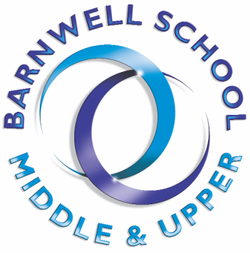
Transition - What do we do?
In 2020 with Covid19 restrictions and Lock Down

Meeting the students in their own schools…
We would normally visit ALL of our feeder primary schools during the summer term and meet every student that has been allocated to Barnwell School. This year we will have to do this slightly differently… During these conversations we do our best to find out as much as we can about the students, who their friends are, what they are interested in, what they enjoy about school and on the flip side, what they are worried about. We have sent out an online survey to glean as much of this information as possible. Obviously, nothing beats a face to face conversation, so if there is any chance we can make these happen during the summer term, we will do.
We also talk to the teachers and get ‘the lowdown’ on every student. Again, more difficult this year, but we are surveying all the year 6 teachers in much the same way with an online form and will meet (albeit virtually or over the phone) with your year 6 teachers.
We use all this information to help us set up teaching groups and form groups, but are always very aware that Secondary School is a very different place to Primary School and can be an excellent opportunity for some for a fresh start if needed.

The Ones…
Again, this could be very difficult to organise whilst we are in lockdown but we would normally, during the summer term, run The Ones Club this is a weekly opportunity for all those students that are joining us from a school where there are less than four students joining us in Year 7. During these clubs, we run a series of different activities with the purpose of the students getting to know each other, getting to know us and getting to know their way around school. These weekly activities include: Art, PE, Technology, Cooking and Science. If there is any chance of organising some of these sessions when we return to school, we will do and will be in contact with all relevant students and parents.

New Intake Evening…
Fingers crossed that things are back to vague normality by July, and that this event can go ahead as normal. We are currently hoping to run this event as normal, but obviously we will need to work within the restrictions of government guidance.
This is the evening where our new intake Year 7 students and their parents come into our middle school to meet their potential form tutors, college staff and the other students that will be joining them in their colleges and form groups in September. It is a really good opportunity to get a bit more of a look around the campus and begin to get settled into life at Barnwell School. This is the first time the students and their parents find out their colleges and form groups.

New Intake Day…
Again, hopefully this will run as normal. This is a Stevenage wide day where students move onto their new schools. We start the day with an assembly in our main hall followed by a series of lessons with students moving around the campus as they will be in September. In the afternoon, students compete in their colleges for the first time, taking part in an inter college PE activity and gaining points for their new college to be.

First Day in September…
We have to hope that things have basically completely settled by September and schools are back to normal and everything is running as it should…
This year, when students return to school in September, we will be running a ‘Fresher’s Week’ style first week for our new Year 7s. Over these first few days of the Autumn Term we will run a series of different activities in and around some lessons to give our new Year 7 students an opportunity to really acclimatise to Barnwell, the buildings, the systems, to get to know the key staff and to start to get to know each other.

Year Seven Adventure…
Before the October half term we take the vast majority of our Year 7 students on a residential trip. This is a subsidised trip, our aim being to keep the cost as low as possible to allow every single Year 7 student to join us. This is an excellent opportunity for students to get to know each other and the staff, is really good fun and something that will create lasting memories.

