Barnwell School
KS3 English Department Y6 Transition Project
Telling
Stories

Telling Stories
A Y6 Transition Project from Barnwell School
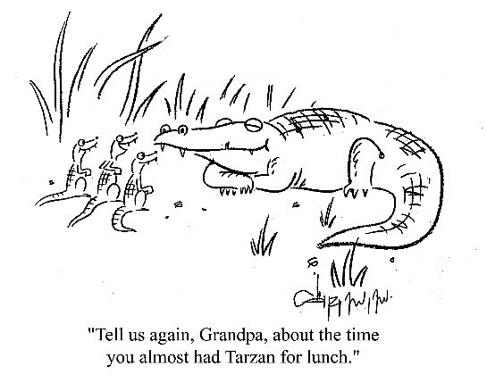
Storytelling has been the foundation of cultures across the world for centuries. We use stories to make sense of our world and to share that understanding with others. Stories are an essential part of your study of English when you move up to secondary school. This unit will help you think about the different ingredients a good story might have, and you might just have a little fun along the way.

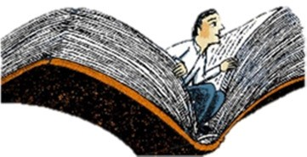
Read and enjoy the extracts to get you thinking.
Use these
symbols to guide
Think – use the questions to develop your ideas. you through each activity.

Write – put your creative ideas down on paper!

Activity One: Magical Doorways
Read the extract below from The Lion, the Witch and the Wardrobe. The extract describes the moment Lucy discovers a portal into another world: Narnia.

Lucy Looks into a Wardrobe
And shortly after that they looked into a room that was quite empty except for one big wardrobe; the sort that has a looking-glass in the door. There was nothing else in the room at all except a dead blue-bottle on the window-sill.
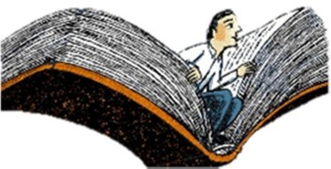
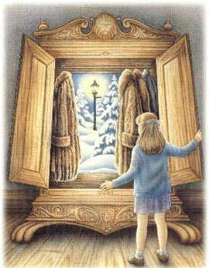
"Nothing there!" said Peter, and they all trooped out again—all except Lucy. She stayed behind because she thought it would be worth while trying the door of the wardrobe, even though she felt almost sure that it would be locked. To her surprise it opened quite easily, and two mothballs dropped out.
Looking into the inside, she saw several coats hanging up—mostly long fur coats. There was nothing Lucy liked so much as the smell and feel of
fur. She immediately stepped into the wardrobe and got in among the coats and rubbed her face against them, leaving the door open, of course, because she knew that it is very foolish to shut oneself into any wardrobe. Soon she went further in and found that there was a second row of coats hanging up behind the first one. It was almost quite dark in there and she kept her arms stretched out in front of her so as not to bump her face into the back of the wardrobe. She took a step further in—then two or three steps—always expecting to feel woodwork against the tips of her fingers. But she could not feel it.
"This must be a simply enormous wardrobe!" thought Lucy, going still further in and pushing the soft folds of the coats aside to make room for her. Then she noticed that there was something crunching under her feet. "I wonder is that more moth-balls?" she thought, stooping down to feel it with her hands. But instead of feeling the hard, smooth wood of the floor of the wardrobe, she felt something soft and powdery and extremely cold, "This is very queer," she said, and went on a step or two further.
Next moment she found that what was rubbing against her face and hands was no longer soft fur but something hard and rough and even prickly. "Why, it is just like branches of trees!" exclaimed Lucy. And then she saw that there was a light ahead of her; not a few inches away where the back of the wardrobe ought to have been, but a long way off. Something cold and soft was falling on her. A moment later she found that she was standing in the middle of a wood at night-time with snow under her feet and snowflakes falling through the air.
Lucy felt a little frightened, but she felt very inquisitive and excited as well. She looked back over her shoulder and there, between the dark tree-trunks, she could still see the open doorway of the wardrobe and even catch a glimpse of the empty room from which she had set out. (She had, of course, left the door open, for she knew that it is a very silly thing to shut oneself into a wardrobe.) It seemed to be still daylight there. "I can always get back if anything goes wrong," thought Lucy. She began to walk forward, crunchcrunch, over the snow and through the wood towards the other light.
In about ten minutes she reached it and found that it was a lamp-post. As she stood looking at it, wondering why there was a lamp-post in the middle of a wood and wondering what to do next, she heard a pitter patter of feet coming towards her. And soon after that a very strange person stepped out from among the trees into the light of the lamp-post.
He was only a little taller than Lucy herself and he carried over his head an umbrella, white with snow. From the waist upwards he was like a man, but his legs were shaped like a goat's (the hair on them was glossy black) and instead of feet he had goat's hoofs. He also had a tail, but Lucy did not notice this at first because it was neatly caught up over the arm that held the umbrella so as to keep it from trailing in the snow. He had a red woollen muffler round his neck and his skin was rather reddish too. He had a strange, but pleasant little face with a short pointed beard and curly hair, and out of the hair there stuck two horns, one on each side of his forehead. One of his hands, as I have said, held the umbrella: in the other arm he carried several brown paper parcels. What with the parcels and the snow it looked just as if he had been doing his Christmas shopping. He was a Faun. And when he saw Lucy he gave such a start of surprise that he dropped all his parcels.
From The Lion, The Witch and the Wardrobe by CS Lewis

Lucy finds her way into Narnia through a wardrobe. Other stories use different devices to take their readers into a different world. Harry Potter catches a magical train from Platform 9 ¾, Alice falls down a rabbit hole and Coraline goes through the door in her living room.
What other magical doorways or portals can you think of from other stories you know?
What portal would you choose if you were the writer?

Now draw your portal and explain how to use it to get to your new world.

Activity Two: Building Settings
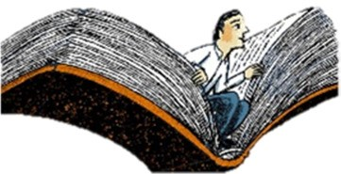
Read the two extracts below, from The Wolf Wilder and The Hobbit.

Once upon a time, a hundred years ago, there was a dark and stormy girl.
The girl was Russian, and although her hair and eyes and finger nails were dark all of the time, she was stormy only when she thought it absolutely necessary. Which was fairly often.
Her name was Feodora.
She lived in a wooden house made of timber taken from the surrounding forest. The walls were layered with sheep’s wool to keep out the Russian winter, and the inside was lit with hurricane lamps. Feo had painted the lamps every colour in her box of paints, so the house cast out light into the forest in reds and greens and yellows. Her mother had cut and sanded the door herself, and the wood was eight inches thick. Feo had painted it snow blue. The wolves had added claw marks over the years, which helped dissuade unwelcome visitors.
It all began – all of it – with someone knocking on the snow- blue door.
Although ‘knocking’ was not the right word for this particular noise, Feo thought. It sounded as though someone was trying to dig a hole in the wood with his knuckles.
From The Wolf Wilder By Katherine Rundell
In a hole in the ground there lived a hobbit. Not a nasty, dirty, wet hole, filled with the ends of worms and an oozy smell, nor yet a dry, bare, sandy hole with nothing in it to sit down on or to eat: it was a hobbit-hole, and that means comfort.

It had a perfectly round door like a porthole, painted green, with a shiny yellow brass knob in the exact middle. The door opened on to a tube-shaped hall like a tunnel: a very comfortable tunnel without smoke, with panelled walls, and floors tiled and carpeted, provided with polished chairs, and lots and lots of pegs for hats and coats - the hobbit was fond of visitors. The tunnel wound on and on, going fairly but not quite straight into the side of the hill - The Hill, as all the people for many miles round called it - and many little round doors opened out of it, first on one side and then on another. No going upstairs for the hobbit: bedrooms, bathrooms, cellars, pantries (lots of these), wardrobes (he had whole rooms devoted to clothes), kitchens, dining-rooms, all were on the same floor, and indeed on the same passage. The best rooms were all on the left-hand side (going in), for these were the only ones to have windows, deep-set round windows looking over his garden and meadows beyond, sloping down to the river.
From ‘The Hobbit’ by JRR Tolkien

These extracts describe settings in detail so the reader can imagine the world the writer is trying to create. We can imagine the rough walls of Theodora’s house, surrounded by wild woods, and protected by the thick door covered in wolf marks. We imagine a place of protection, made bright with coloured lights. In contrast, the hobbit’s house is unusual but neat, tidy and welcoming.
What are your favourite story settings? Can you think of a few different ones?
What sort of setting do you think would hook your reader if you were a writer? What details would you need to tell them about?

Now write a description of the setting we see when we go through the magical portal you designed in activity one. A good tip is to use the senses to bring it to life for your reader: what can we see, hear, smell? The word bank might help you!

 | Word Bank
wooded gloomy  shadowy  still  soggy  ancient crisp | luminous  overgrown  shimmering lustrous  glinting vast roaring |  | whispering  crunching crackly  pounding howling echoey swishing | pungent  malodorous putrid  aromatic acrid  lemony perfumed

Activity Three: World Building
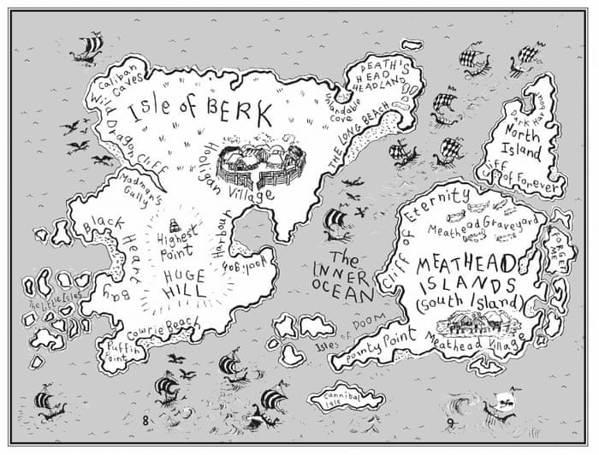
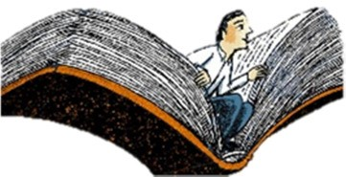 Look through the different maps taken from fantasy novels below.

From ‘How to
Train your
Dragon’ by
Cressida Cowell

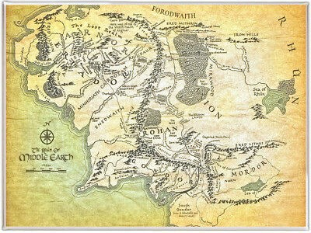

From ‘Lord of the
Rings’ by JRR
Tolkien

Writers often produce a map of their imagined world to help their readers. The map should include places like the portal, significant landmarks and where dangers may lurk. What places might exist in your imaginary world? Make a list of all the places you can imagine.

Now create your own map of your fantasy world. You will have to label it with names and features, and you could even design a key.

Activity Four: Villains!

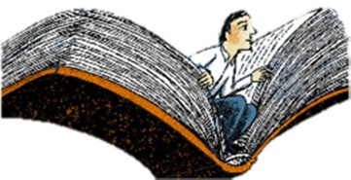
A good story needs a good villain. Read the extracts on the next page showing different villains in action. You might recognise them!

"Speak, vermin!" she said again. "Or do you want my dwarf to find you a tongue with his whip? What is the meaning of all this gluttony, this waste, this self indulgence? Where did you get all these things?"
"Please, your Majesty," said the Fox, "we were given them. And if I might make so bold as to drink your Majesty's very good health - "
"Who gave them to you?" said the Witch.
"F-F-F-Father Christmas," stammered the Fox.
"What?" roared the Witch, springing from the sledge and taking a few strides nearer to the terrified animals. "He has not been here! He cannot have been here! How dare you - but no. Say you have been lying and you shall even now be forgiven."
At that moment one of the young squirrels lost its head completely.
"He has - he has - he has!" it squeaked, beating its little spoon on the table. Edmund saw the Witch bite her lips so that a drop of blood appeared on her white cheek. Then she raised her wand. "Oh, don't, don't, please don't," shouted Edmund, but even while he was shouting she had waved her wand and instantly where the merry party had been there were only statues of creatures (one with its stone fork fixed forever half-way to its stone mouth) seated round a stone table on which there were stone plates and a stone plum pudding.
"As for you," said the Witch, giving Edmund a stunning blow on the face as she re-mounted the sledge, "let that teach you to ask favour for spies and traitors. Drive on!" And Edmund for the first time in this story felt sorry for someone besides himself. It seemed so pitiful to think of those little stone figures sitting there all the silent days and all the dark nights, year after year, till the moss grew on them and at last even their faces crumbled away.
From The Lion, The Witch and the Wardrobe by CS Lewis
"I said, bow," Voldemort said, raising his wand – and Harry felt his spine curve as though a huge, invisible hand were bending him ruthlessly forward, and the Death Eaters laughed harder than ever.
"Very good," said Voldemort softly, and as he raised his wand the pressure bearing down upon Harry lifted too. "And now you face me, like a man... straight-backed and proud, the way your father died...."
"And now — we duel."
Voldemort raised his wand, and before Harry could do anything to defend himself, before he could even move, he had been hit by the Cruciatus curse. The pain was so intense, so allconsuming, that he no longer knew where he was... white-hot knives were piercing every inch of his skin, his head was surely going to burst with pain; he was screaming more loudly than he’d ever screamed in his life...
And then it stopped. Harry rolled over and scrambled to his feet; he was shaking as uncontrollably as Wormtail had done when his hand had been cut off; he staggered sideways in to the wall of watching Death Eaters , and they pushed him away, back towards Voldemort.
"A little break," said Voldemort, the slit-like nostrils dilating with excitement, "a little pause...
That hurt, didn't it, Harry? You don't want me to do that again, do you?"
From The Goblet of Fire by JK Rowling

Which enemy is the best character, in your opinion? What characteristics does a good story villain have?
What kind of villain inhabits your fantasy world? Would your villain be human or a creature of some sort? Weapons? An interesting back story? What can defeat your villain?
Draw your villain and label the significant features.

Activity Five: A Trusty Companion
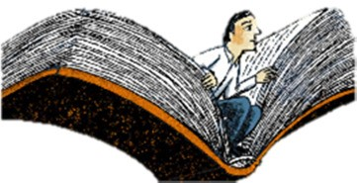
The hero often has a companion they can rely on. One of the best story companions is Samwise Gangee, from The Lord of the Rings. Read the extract below describing how he insists on accompanying Frodo to Mordor to face the enemy and complete their quest. You can also watch the scene here:
https://www.youtube.com/watch?v=k6C8SX0mWP0

'I don't like anything here at all.' said Frodo, `step or stone, breath or bone. Earth, air and water all seem accursed. But so our path is laid.'
'Yes, that's so,' said Sam. `And we shouldn't be here at all, if we'd known more about it before we started. But I suppose it's often that way. The brave things in the old tales and songs, Mr. Frodo:
adventures, as I used to call them. I used to think that they were things the wonderful folk of the stories went out and looked for, because they wanted them, because they were exciting and life was a bit dull, a kind of a sport, as you might say. But that's not the way of it with the tales that really mattered, or the ones that stay in the mind. Folk seem to have been just landed in them, usually - their paths were laid that way, as you put it. But I expect they had lots of chances, like us, of turning back, only they didn't. And if they had, we shouldn't know, because they'd have been forgotten. We hear about those as just went on - and not all to a good end, mind you; at least not to what folk inside a story and not outside it call a good end. You know, coming home, and finding things all right, though not quite the same - like old Mr Bilbo. But those aren't always the best tales to hear, though they may be the best tales to get landed in! I wonder what sort of a tale we've fallen into? '
`I wonder,' said Frodo. 'But I don't know. And that's the way of a real tale. Take any one that you're fond of. You may know, or guess, what kind of a tale it is, happy-ending or sad-ending, but the people in it don't know. And you don't want them to.'
'No, sir, of course not. Beren now, he never thought he was going to get that Silmaril from the Iron Crown in Thangorodrim, and yet he did, and that was a worse place and a blacker danger than ours. But that's a long tale, of course, and goes on past the happiness and into grief and beyond it - and the Silmaril went on and came to Eärendil. And why, sir, I never thought of that before! We've got - you've got some of the light of it in that star-glass that the Lady gave you! Why, to think of it, we're in the same tale still! It's going on. Don't the great tales never end? '
'No, they never end as tales,' said Frodo. `But the people in them come, and go when their part's ended. Our part will end later - or sooner.'
'And then we can have some rest and some sleep,' said Sam. He laughed grimly. 'And I mean just that, Mr. Frodo. I mean plain ordinary rest, and sleep, and waking up to a morning's work in the garden. I'm afraid that's all I'm hoping for all the time. All the big important plans are not for my sort. Still, I wonder if we shall ever be put into songs or tales. We're in one, or course; but I mean: put into words, you know, told by the fireside, or read out of a great big book with red and black letters, years and years afterwards.
And people will say: "Let's hear about Frodo and the Ring! " And they'll say: "Yes, that's one of my
favourite stories. Frodo was very brave. wasn't he, dad?" "Yes, my boy, the famousest of the hobbits, and that's saying a lot."'
`It's saying a lot too much,' said Frodo, and he laughed, a long clear laugh from his heart. Such a sound had not been heard in those places since Sauron came to Middle-earth. To Sam suddenly it seemed as if all the stones were listening and the tall rocks leaning over them. But Frodo did not heed them; he laughed again. 'Why, Sam,' he said, 'to hear you somehow makes me as merry as if the story was already written. But you've left out one of the chief characters: Samwise the stout-hearted. "I want to hear more about Sam, dad. Why didn't they put in more of his talk, dad? That's what I like, it makes me laugh. And Frodo wouldn't have got far without Sam, would he, dad? " '
`Now, Mr. Frodo,' said Sam, 'you shouldn't make fun. I was serious. '
`So was I,' said Frodo, 'and so I am. We're going on a bit too fast. You and I, Sam, are still stuck in the worst places of the story, and it is all too likely that some will say at this point: "Shut the book now, dad; we don't want to read any more." '
From The Two Towers by JRR Tolkien

What characteristics do you think the hero’s companion needs to have? Have a look at this list and choose the qualities you would like in your hero’s companion.
trustworth friendly determined extraordinary
y funny chirpy selfless clever kind short moral
loyal attractive resourceful | considerate imaginative steadfast | strong  dowdy  ordinary | gentle

Now design a companion for your hero. What characteristics and skills would your character have? Draw your character in the centre and fill the boxes with your ideas.

Physical Features

Qualities

Skills | Weaknesses

Activity Six: Your Adventures
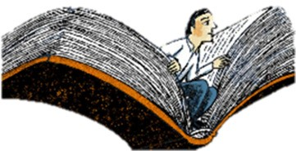
Read the extract below from Assassin’s Apprentice. It is written in first person, which means one of the characters is telling the story.
My memories reach back to when I was six years old. Before that, there is nothing, only a blank gulf no exercise of my mind has ever been able to pierce. Prior to that day at Moonseye, there is nothing. But on that day they suddenly begin, with a brightness and detail that overwhelms me. Sometimes it seems too complete, and I wonder if it is truly mine. Am I recalling it from my own mind, or from dozens of retellings by legions of kitchen maids and ranks of scullions and herds of stable boys as they explained my presence to each other? Perhaps I have heard the story so many times, from so many sources, that I now recall it as an actual memory of my own. Is the detail the result of a six-yearold’s open absorption of all that goes on around him? Or could the completeness of the memory be the bright overlay of the Skill, and the later drugs a man takes to control his addiction to it, the drugs that bring on pains and cravings of their own? The last is most possible. Perhaps it is even probable. One hopes it is not the case.
The remembrance is almost physical: the chill greyness of the fading day, the remorseless rain that soaked me, the icy cobbles of the strange town’s streets, even the callused roughness of the huge hand that gripped my small one. Sometimes I wonder about that grip. The hand was hard and rough, trapping mine within it. And yet it was warm, and not unkind as it held mine. Only firm. It did not let me slip on the icy streets, but it did not let me escape my fate, either. It was as implacable as the icy gray rain that glazed the trampled snow and ice of the gravelled pathway outside the huge wooden doors of the fortified building that stood like a fortress within the town itself.
The doors were tall, not just to a six-year-old boy, but tall enough to admit giants, to dwarf even the rangy old man who towered over me. And they looked strange to me, although I cannot summon up what type of door or dwelling would have looked familiar. Only that these, carved and bound with black iron hinges, decorated with a buck’s head and knocker of gleaming brass, were outside of my experience. I recall that slush had soaked through my clothes, so my feet and legs were wet and cold. And yet, again, I cannot recall that I had walked far through winter’s last curses, nor that I had been carried. No, it all starts there, right outside the doors of the stronghouse, with my small hand trapped inside the tall man’s.
Almost, it is like a puppet show beginning. Yes, I can see it thus. The curtains parted, and there we stood before that great door. The old man lifted the brass knocker and banged it down, once, twice, thrice on the plate that resounded to his pounding. And then, from offstage, a voice sounded. Not from within the doors, but from behind us, back the way we had come. “Father, please,” the woman’s voice begged. I turned to look at her, but it had begun to snow again, a lacy veil that clung to eyelashes and coat sleeves. I can’t recall that I saw anyone. Certainly, I did not struggle to break free of the old man’s grip on my hand, nor did I call out, “Mother, Mother.” Instead I stood, a spectator, and heard the sound of boots within the keep, and the unfastening of the door hasp within.
One last time she called. I can still hear the words perfectly, the desperation in a voice that now would sound young to my ears. “Father, please, I beg you!” A tremor shook the hand that gripped mine, but whether of anger or some other emotion, I shall never know. As swift as a black crow seizes a bit of dropped bread, the old man stooped and snatched up a frozen chunk of dirty ice. Wordlessly he flung it, with great force and fury, and I cowered where I stood. I do not recall a cry, nor the sound of struck flesh. What I do remember is how the doors swung outward, so that the old man had to step hastily back, dragging me with him.
From Assassin’s Apprentice by Robin Hobb

Because the story is written in first person, we get a detailed version of what the character sees, experiences and feels. It is a bit like reading a diary or journal as he tells us what he recalls.
Imagine you are the hero of your story. What happens to you on your quest across your strange and wonderful land? Look back at your map and plot a route that will take you from your portal through many adventures. What difficulties must you overcome? What enemies do you face? What friends do you make along the way?

Now write three journal entries describing three of your adventures as you travel across your map. Remember to write in first person and bring events to life for your reader, like the extracts you’ve been reading.

Activity Seven: The Final Battle
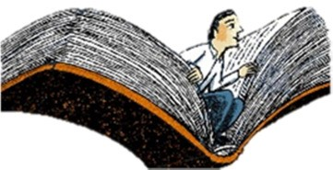
Read the extract from The Lion, the Witch and the Wardrobe on the next page. In the extract, Peter fights, and defeats, a great wolf.

For a moment Peter did not understand. Then, when he saw all the other creatures start forward and heard Aslan say with a wave of his paw, "Back! Let the Prince win his spurs," he did understand, and set off running as hard as he could to the pavilion. And there he saw a dreadful sight.
The Naiads and Dryads were scattering in every direction. Lucy was running towards him as fast as her short legs would carry her and her face was as white as paper. Then he saw Susan make a dash for a tree, and swing herself up, followed by a huge grey beast. At first Peter thought it was a bear. Then he saw that it looked like an Alsatian, though it was far too big to be a dog. Then he realised that it was a wolf—a wolf standing on its hind legs, with its front paws against the tree-trunk snapping and snarling. All the hair on its back stood up on end. Susan had not been able to get higher than the second big branch. One of her legs hung down so that her foot was only an inch or two above the snapping teeth. Peter wondered why she did not get higher or at least take a better grip; then he realised that she was just going to faint and that if she fainted she would fall off.
Peter did not feel very brave; indeed, he felt he was going to be sick. But that made no difference to what he had to do. He rushed straight up to the monster and aimed a slash of his sword at its side. That stroke never reached the Wolf. Quick as lightning it turned round, its eyes flaming, and its mouth wide open in a howl of anger. If it had not been so angry that it simply had to howl it would have got him by the throat at once. As it was—though all this happened too quickly for Peter to think at all—he had just time to duck down and plunge his sword, as hard as he could, between the brute's forelegs into its heart. Then came a horrible, confused moment like something in a nightmare. He was tugging and pulling and the Wolf seemed neither alive nor dead, and its bared teeth knocked against his forehead, and everything was blood and heat and hair. A moment later he found that the monster lay dead and he had drawn his sword out of it and was straightening his back and rubbing the sweat off his face and out of his eyes. He felt tired all over.
Then, after a bit, Susan came down the tree. She and Peter felt pretty shaky when they met and I won't say there wasn't kissing and crying on both sides. But in Narnia no one thinks any the worse of you for that.
"Quick! Quick!" shouted the voice of Aslan, "Centaurs! Eagles! I see another wolf in the thickets. There—behind you. He has just darted away. After him, all of you! He will be going to his mistress. Now is
your chance to find the Witch and rescue the fourth Son of Adam." And instantly with a thunder of hoofs and a beating of wings a dozen or so of the swiftest creatures disappeared into the gathering darkness.
Peter, still out of breath, turned and saw Aslan close at hand.
"You have forgotten to clean your sword," said Aslan.
It was true. Peter blushed when he looked at the bright blade and saw it all smeared with the Wolf's hair and blood. He stooped down and wiped it quite clean on the grass, and then wiped it quite dry on his coat.
"Hand it to me and kneel, Son of Adam," said Aslan. And when Peter had done so he struck him with the flat of the blade and said, "Rise up, Sir Peter Fenris-Bane. And, whatever happens, never forget to wipe your sword."
From The Lion, the Witch and the Wardrobe by CS Lewis

The final battle is the climax of a story. We hope our hero will triumph and order will be restored. What sort of a battle will you have with your villain? Hand to hand combat? Or something more devious? Perhaps you’ll lay a trap, or perhaps your villain will get the better of you…? Plan out some ideas for your final battle.

Write the final battle of your story. Think about how to use the senses to bring it to life for your reader, with exciting vocabulary and lots of detail.

We hope you’ve enjoyed working through these activities and thinking about what makes a good story. We would love to see your work in September. Until then, have a great summer and KEEP READING!
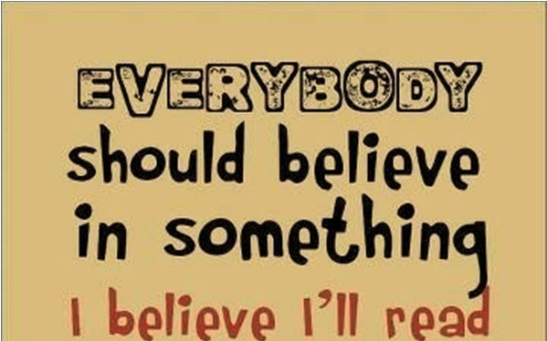
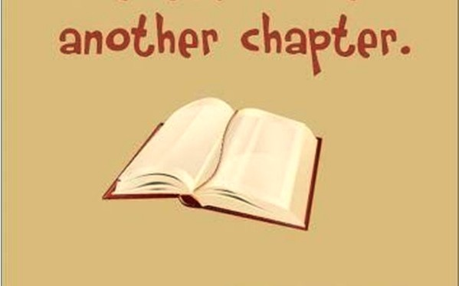
If you’ve enjoyed these extracts you might like:
The Lion, The Witch and the Wardrobe series by CS Lewis
The Hobbit and The Lord of the Rings series by JRR Tolkien
His Dark Materials series by Philip Pullman
The Inheritance series by Christopher Paolini
The Spiderwick Chronicles series by Holly Black and Tony DiTerlizzi
The Chronicles of Ancient Darkness series by Michelle Paver The Artemis Fowl series by Eoin Colfer

