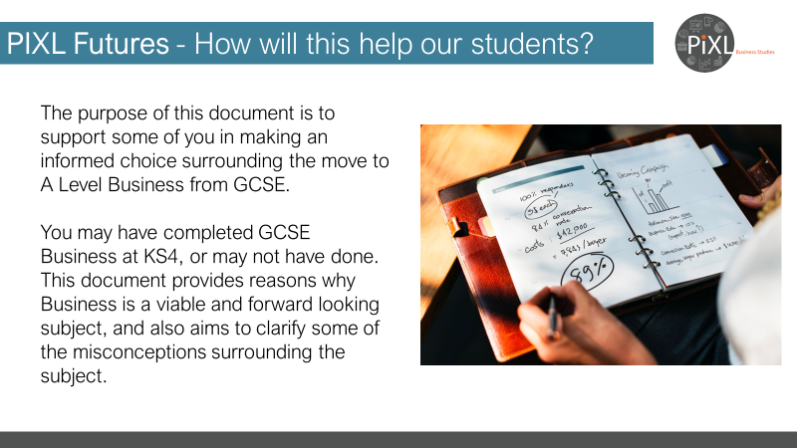
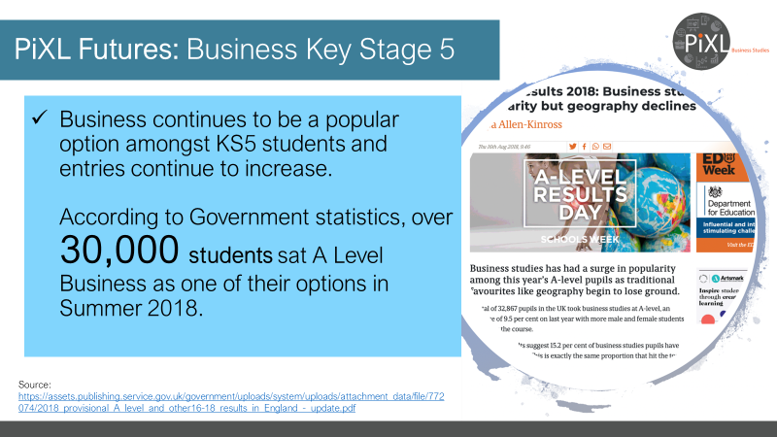
https://assets.publishing.service.gov.uk/government/uploads/system/uploads/attachment_data/file/772074/2018_provisional_A_level_and_other16-18_results_in_England_-_update.pdf
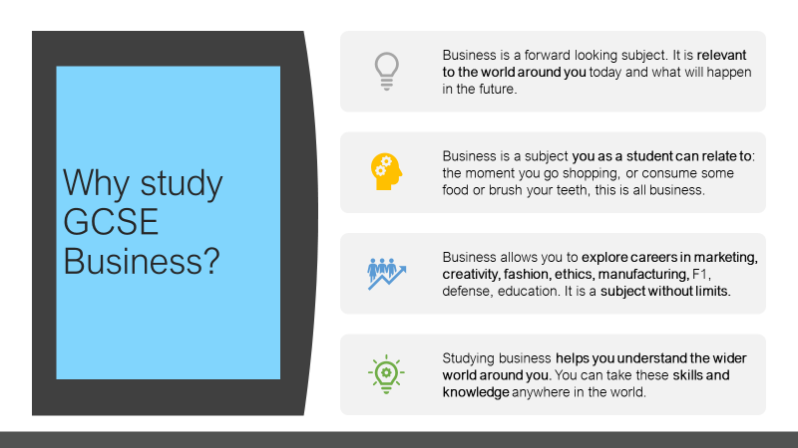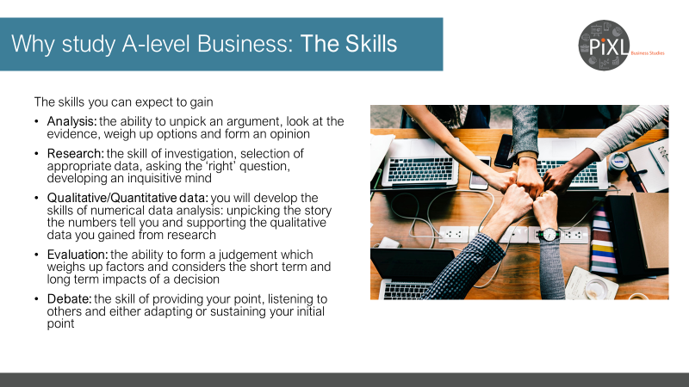
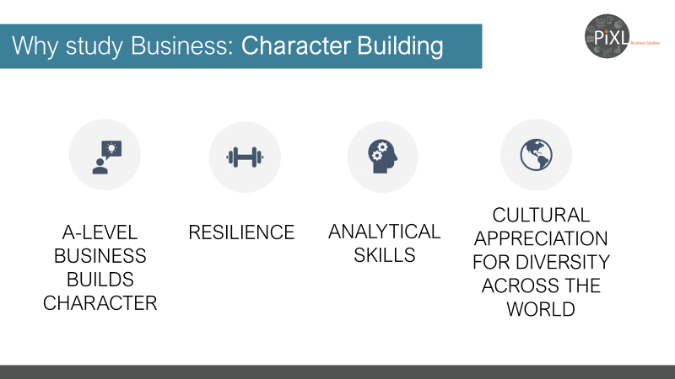
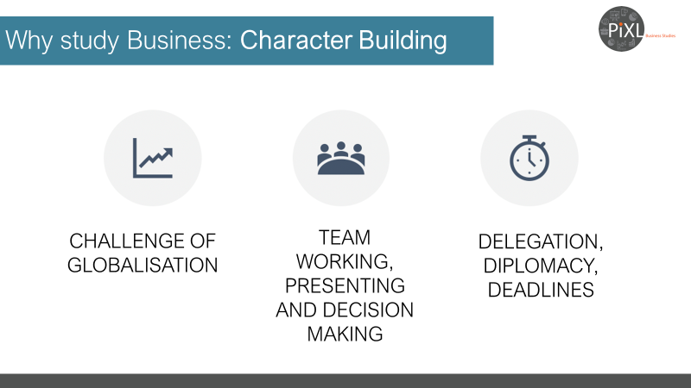
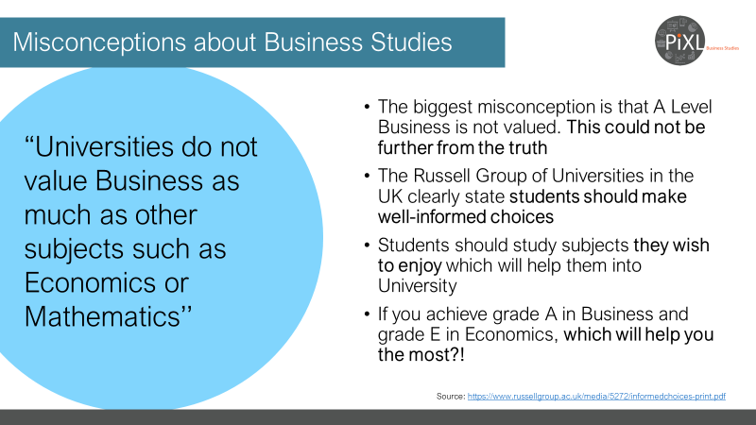
https://www.russellgroup.ac.uk/media/5272/informedchoices-print.pdf
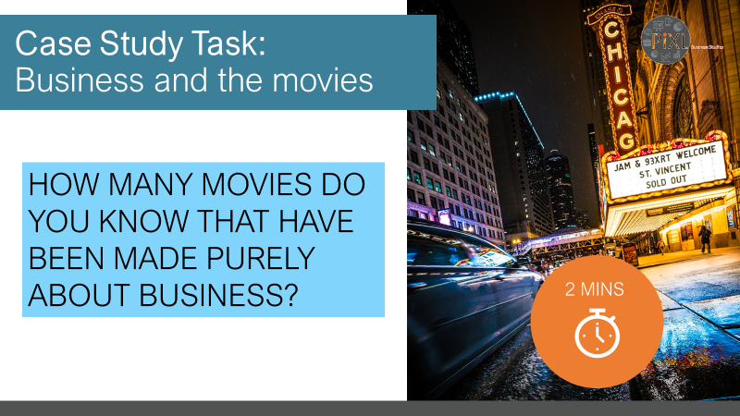
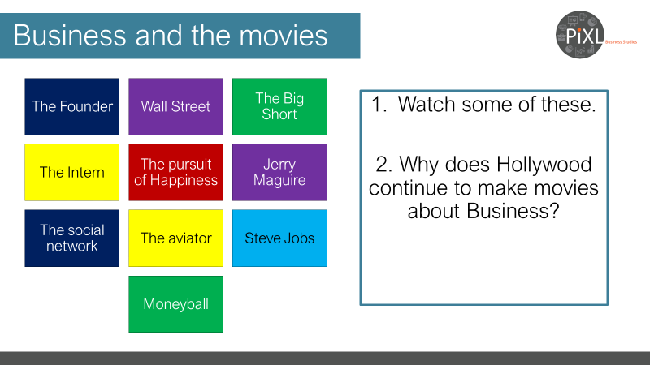
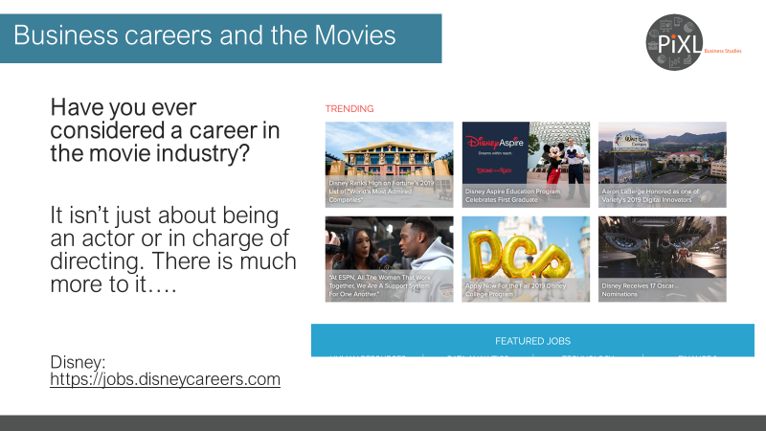
https://jobs.disneycareers.com
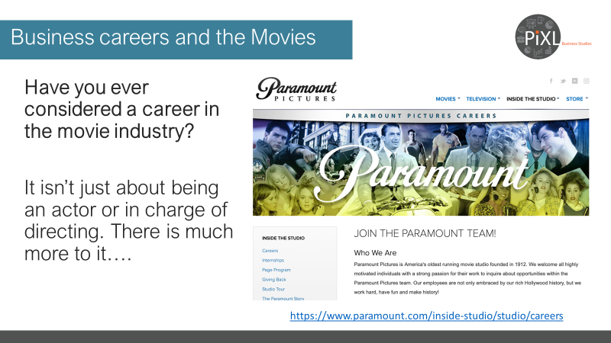
https://www.paramount.com/inside-studio/studio/careers

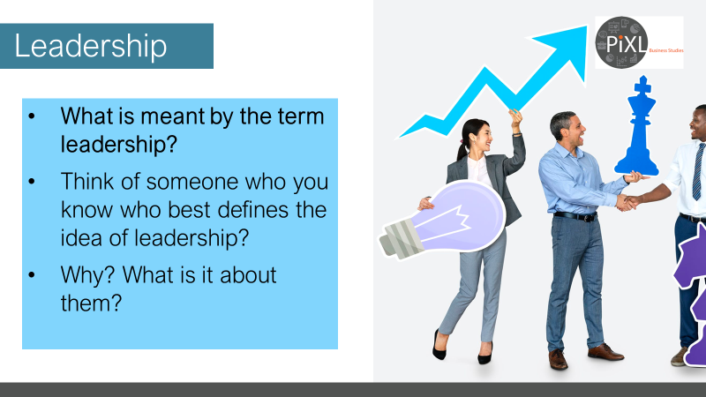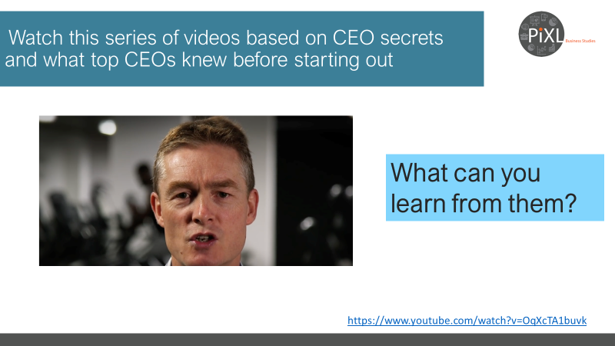
https://www.youtube.com/watch?v=OqXcTA1buvk

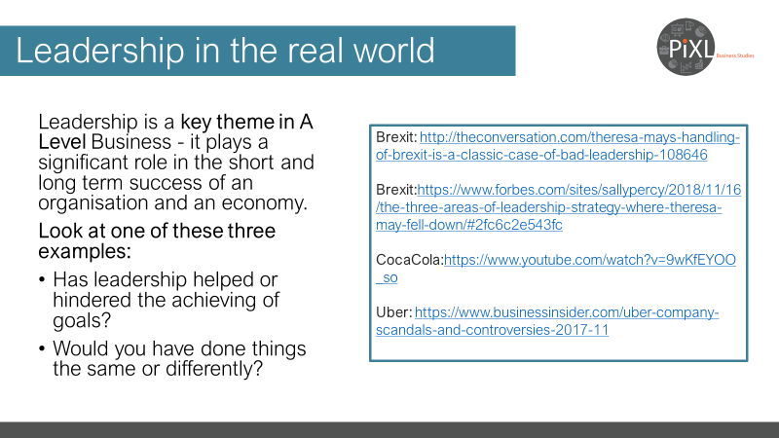
Brexit: http://theconversation.com/theresa-mays-handling-of-brexit-is-a-classic-case-of-bad-leadership-108646
Brexit:https://www.forbes.com/sites/sallypercy/2018/11/16/the-three-areas-of-leadership-strategy-where-theresa-may-fell-down/#2fc6c2e543fc
CocaCola:https://www.youtube.com/watch?v=9wKfEYOO_so
Uber: https://www.businessinsider.com/uber-company-scandals-and-controversies-2017-11

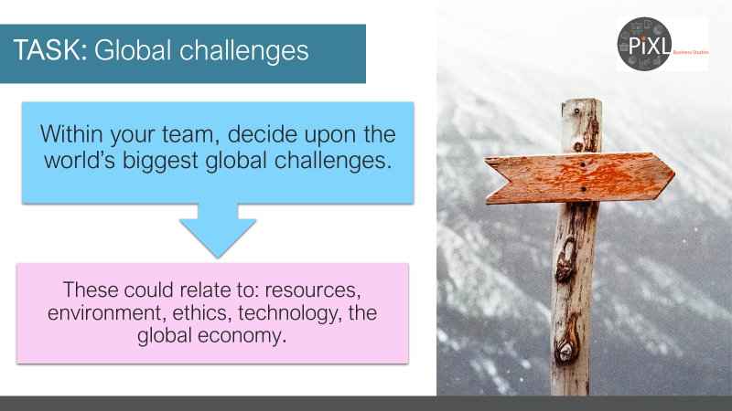
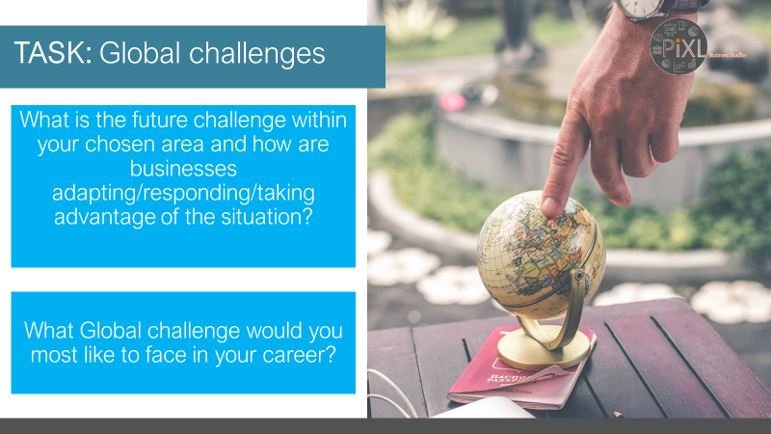
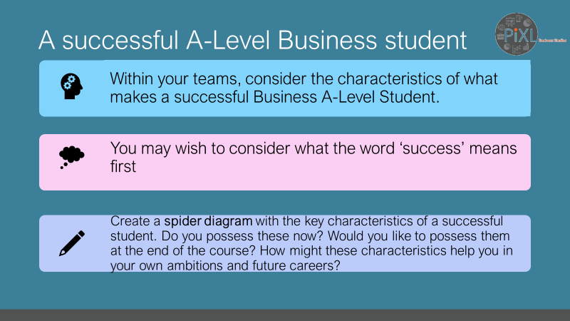
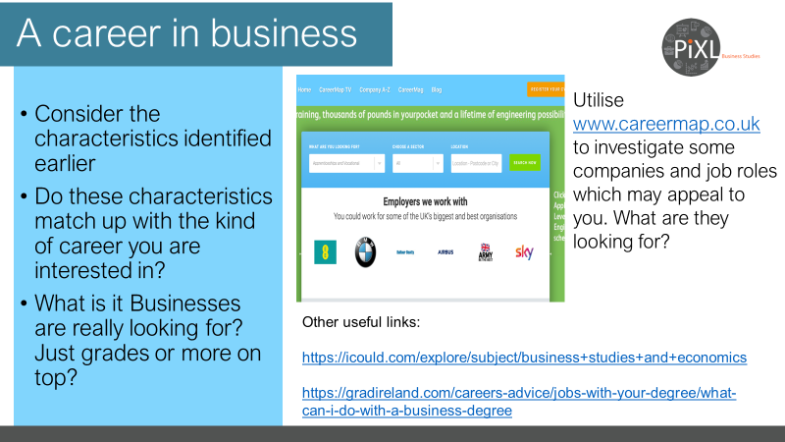
www.careermap.co.uk
https://icould.com/explore/subject/business+studies+and+economics
https://gradireland.com/careers-advice/jobs-with-your-degree/what-can-i-do-with-a-business-degree
