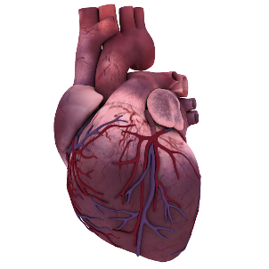
A-level Biology Edexcel A
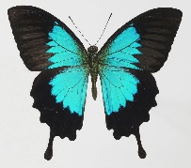
How to revise A-level Biology

Paper | Topics | Length | Date
1 | 1-Lifestyle, Health and risk  2-Genes and Health  3Voice of the genome  4 Biodiversity and natural resources  5 On the wild side  6- Immunity, infection and forensics | 2 hours, 100 marks | 6.6.19  AM
2 | 1-Lifestyle, Health and risk  2-Genes and Health  3Voice of the genome  4 Biodiversity and natural resources  7 Run for your life  8 Grey matter | 2 hours, 100 marks | 13.6.19 AM
3 | All topics  Pre-release paper  Practical skills | 2 hours, 100 marks | 17.6.19 AM
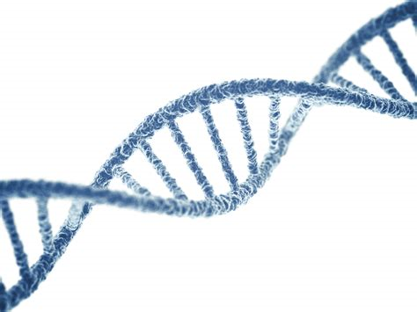
When is it?
Self-Quizzing
Write questions from your notes so you can quiz each other and self-test at a later date
Five, Four, Three
- Describe what happens in five bullet-points;
- Find four key words that sum up the main theme of the piece of text;
- Predict three different possibilities for what will happen next in the story
Quizlet
Create your won quizzes and test yourself (and your friends) on your Biology knowledge!
https://quizlet.com/latest
Remember, Remember…
Read a paragraph, turn the page over and then to write down as much as you can remember.
Compare your writing to the original paragraph; have you missed anything out?

Flash Cards
Create a series of flash cards for each topic, include only small amounts of information and key facts.
Test yourself or find a friend to test you
Memory Aids
How to start: Get organised!
- Know which topics are being tested on each paper
- Create a vocabulary list for each topic
- Familarise yourself with each of the 18 CPAC practical’s, create a flash card for each
- Create a revision schedule for the topics you need to cover before your exam

Date | Unit | Topic
18.2.19 | 1-Lifestyle, Health and risk | CV System and Disease, Diet
25.2.19 | 1-Lifestyle, Health and risk | Biological Molecules
4.3.19 | 2-Genes and Health | Gas exchange, cell membranes and transport
11.3.19 | 2-Genes and Health | Proteins, Genetics and inheritance
18.3.19 | 3Voice of the genome | Cell Structure, Stem cells and differentiation
25.3.19 | 3Voice of the genome | Cell division, Mitosis, Meiosis, Variation
1.4.19 | 4 Biodiversity & natural resources | Biodiversity and classification
8.4.19 | 4 Biodiversity & natural resources | Resources from plants
15.4.19 | 5 On the wild side | Ecosystems, Climate change and global warming
22.4.19 | 5 On the wild side | Evolution and Speciation, photosynthesis
29.4.19 | 6- Immunity, infection and forensics | Forensics inc. DNA profiling
6.5.19 | 6- Immunity, infection and forensics | Micro-organisms and immunity
13.5.19 | 7 Run for your life | Muscle Structure and respiration
20.5.19 | 7 Run for your life | Exercise
27.5.19 | 8 Grey Matter | Nervous system, Brain structure and Development, Medicine
3.6.19 | Unit 1-6 | All Units for Paper 1
10.6.19 | Unit 1-4, 7,8 | All Units for Paper 1
17.6.19 | Practical and Pre-release | Prepare the article and learn your practical’s
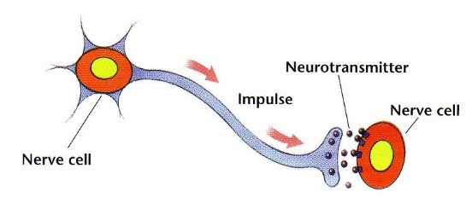
Revision Schedule
Use this as a guide to structure your revision timetable. Revision can include:
Mind maps
Exam Questions
Posters
Summarising Text
Posters and models
Quizzes

Useful Websites
https://s-cool.co.uk/a-level/biology
https://biologyguide.app/
https://biology-innovation.co.uk/
https://www.alevelnotes.com/notes/biology
https://www.revisely.co.uk/alevel/biology/edexcel/
https://qualifications.pearson.com/en/qualifications/edexcel-a-levels/biology-a-2015.html

