|  |
| --- |
| March 2018 |



|  |  |
| --- | --- |
|  | Mental Health and Wellbeing |

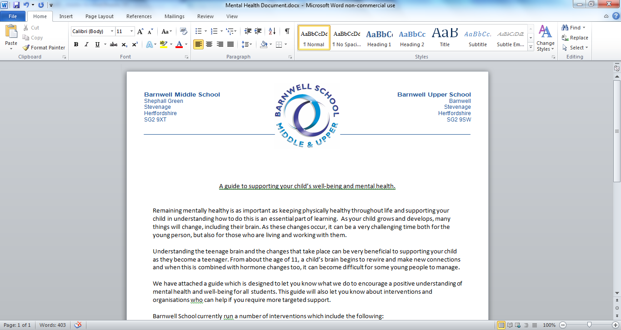

A guide to supporting your child’s well-being and mental health.

Remaining mentally healthy is as important as keeping physically healthy throughout life and supporting your child in understanding how to do this is an essential part of learning.  As your child grows and develops, many things will change, including their brain. As these changes occur, it can be a very challenging time both for the young person, but also for those who are living and working with them.

Understanding the teenage brain and the changes that take place can be very beneficial to supporting your child as they become a teenager. From about the age of 11, a child’s brain begins to rewire and make new connections and when this is combined with hormone changes too, it can become difficult for some young people to manage.

We have attached a guide which is designed to let you know what we do to encourage a positive understanding of mental health and well‐being for all students. This guide will also let you know about interventions and organisations who can help if you require more targeted support.

Barnwell School currently run a number of interventions which include the following:

* We have an emphasis on early intervention and students are taught through the curriculum about mindfulness and other strategies to manage anxious thoughts
* Our curriculum looks at developing resilience through the IThrive programme
* We work with the Public health department and have recently taken part in the delivery of the “Just talk” campaign which encourages males to be open about their issues
* Every year we hold a number of assemblies to raise awareness about the importance of developing positive well‐being and mental health strategies
* We have been a pilot school for IAPT (Improving Access to Psychological Therapies) and our pastoral team have been trained in using tools to help support the identification and early help for mental health issues
* Along with the resources which target all students, we have a range of targeted interventions for students who require extra support

In addition to these points, we have a range of resources we can send to support parents in understanding any specific mental health conditions. If you would like any further guidance and support, please contact your child’s Head of College or Head of Year.

Student Support

There may be times when students need external support to deal with issues, going on in or outside of school. At Barnwell we pride ourselves on our student focussed approach and have a variety of agencies that support the school.

If students cannot be supported in school, we are able to refer to more appropriate agencies. Please contact the pastoral team if additional support is required.

Below are a range of organizations that will provide information and advice on a range of topics that young people may experience whilst growing up.

|  |  |  |
| --- | --- | --- |
| Organisation | Areas of Expertise | Contact Details |
| General | | |
| Bullying UK | Offer advice if you or someone is being bullied. They also have a free, confidential helpline for parents | Open: Mon-Fri 9am-9pm, Weekends 10am – 3pm  Tel: 0808 800 2222 Web: [www.bullying.co.uk](http://www.bullying.co.uk) |
| Chat Health | A texting service for 11 – 19 year olds in Hertfordshire, where you can text your school nurse for guidance and support. | Open Mon – Fri 9am – 5pm  Text: 07480 635 050 |
| Health for Kids | Provides information for children on staying healthy and understanding feelings | Web: [www.healthforkids.co.uk](http://www.healthforkids.co.uk) |
| Health for Teens | Provides an advice website on all aspects of health for teenagers, provided by the NHS | Web: [www.healthforteens.co.uk](http://www.healthforteens.co.uk) |
| NHS 111 | If you need urgent medical advice but it is not an emergency | Call: 111  (In case of an emergency or life threatening situation call 999) |
| Online Safety | Learn about staying safe online and when forming relationships, using social media and sharing pictures | [www.thinkuknow.co.uk](http://www.thinkuknow.co.uk) |
| NHS Stop Smoking Service | If you would like advice and support in stopping smoking you can visit the website to find your closest service | Web: [www.nhs.uk/smokefree](http://www.nhs.uk/smokefree) |
| Rise above | Body image, exam stress, love life – Find out more about things that matter to you | [www.riseabove.org.uk](http://www.riseabove.org.uk) |
| Health Talk | Get information on health issues by listening to people’s real-life experiences | [www.healthtalk.org](http://www.healthtalk.org) |
| Crisis Support | | |
| Samaritans | Free confidential support 24/7 | Call: 116 123 |
| Child line | Free 24hr counselling service | 0800 1111 |
| HPFT Single Point of Access (SPA) | Take referrals for NHS mental health services | Call: 0300 777 0707 (8am – 7pm) |
| GP | Make an urgent appointment to discuss your mental health needs | Registered GP |
| Mental Health | | |
| Big White Wall | Online support network for 16+ years | Web: [www.bigwhitewall.com](http://www.bigwhitewall.com) |
| Healthy Young Minds in Herts | Provides information for children and young people on keeping mentally well and where to seek support | Web: [www.healthyyoungmindsinherts.org.uk](http://www.healthyyoungmindsinherts.org.uk) |
| Mind | Have information to better understand diagnoses and managing mental health on their website | Web: [www.mind.org.uk](http://www.mind.org.uk) |
| The Mix | Information and support for the under 15’s covering a range of topics including mental health. | Open 11am – 11pm daily.  Tel: 0808 808 4994  Web: [www.themix.org.uk](http://www.themix.org.uk) |
| Young Minds | Provide information about all things mental health, from medication to coping strategies | Web: [www.youngminds.org.uk](http://www.youngminds.org.uk) |
| Counselling | | |
| Child line | Offer free, confidential counselling for under 19’s through their helpline and web chat | Tel: 0800 1111  Web: [www.childline.org.uk](http://www.childline.org.uk) |
| Kooth | Provides free, anonymous online counselling for 10-25 year olds. You can IM counsellors Mon-Fri, midday – 10pm, and Sat – Sun 6pm – 10pm | Web: [www.kooth.com](http://www.kooth.com) |
| Tile house Counselling | Supporting young people with issues that they can’t cope with. | [www.tilehouse.org](http://www.tilehouse.org)  Telephone: 01462 440244 |
| Talk time | National counselling support | Telephone: 0300 100 1234 |
| The Living Room | Addiction and Counselling | [www.thelivingroom.me.uk](http://www.thelivingroom.me.uk)  Telephone: 01438 355649 |
| Family Support | | |
| DrugFAM | Provide support to families, friends and carers who are struggling to cope with a loved one’s addition to drugs or alcohol | Tel: 0300 888 3853  Web: [www.drugfam.co.uk](http://www.drugfam.co.uk) |
| Families First | Offer support to the whole family through a variety of organisations | Web: [www.hertfordshire.gov.uk/familiesfirst](http://www.hertfordshire.gov.uk/familiesfirst) |
| Hertfordshire Domestic Abuse Helpline | Confidential, free helpline for anyone affected by domestic abuse, Mon-Fri 9am-9pm, Weekends 9am – 4pm | Tel: 08 088 088 088 |
| The Hideout | A website with advice and information about domestic abuse | Web: [www.thehideout.org.uk](http://www.thehideout.org.uk) |
| Young Carers in Hertfordshire | Offer practical and emotional support to young people with caring responsibilities | Web: [www.ycih.org](http://www.ycih.org) |
| Hertfordshire Domestic Abuse Helpline | Domestic Abuse | Telephone: 08 088 088 088 |
| Frank | Drugs | [www.talktofrank.com](http://www.talktofrank.com)  Telephone: 0800 77 66 00 |
| A-Dash (Adolescent, Drug and Alcohol Service) in Hertfordshire | Drugs and Alcohol | Telephone: 01923 427288 |
| Drink Aware | Alcohol | [www.drinkaware.co.uk](http://www.drinkaware.co.uk)  Telephone: 0800 917 8282 |
| NHS Hertfordshire Stop Smoking Services | Smoking | [www.smokefreehertfordshire.nhs.uk](http://www.smokefreehertfordshire.nhs.uk)  Telephone: 0800 389 3998 |
| Sex, Sexuality and Gender | | |
| Herts Aid | Offers guidance and support about sexual health | Tel: 01923 803 440  Web: [www.hertsaid.co.uk](http://www.hertsaid.co.uk) |
| Mermaids | Provides support to young people who feel at odds with their birth gender, through their helpline. Mon – Fri, 9am-9pm. | Tel: 0344 334 0550  Web: [www.mermaidsuk.org.uk](http://www.mermaidsuk.org.uk) |
| Herts SARC | Offers support to those who have experienced sexual abuse/violence, either recently or in the past | [www.hertssarc.org](http://www.hertssarc.org) |
| Local Sexual Health service | Find your local sexual health service | [www.sexualhealthherfordshire.clch.nhs.uk](http://www.sexualhealthherfordshire.clch.nhs.uk) |
| Chlamydia Test | Get a free online Chlamydia Test (C-sure) | [www.c-sure.org.uk](http://www.c-sure.org.uk) |
| Disrespect nobody | Understand ‘what is consent?’ | [www.disrespectnobody.co.uk](http://www.disrespectnobody.co.uk) |
| Sexual Health | Know how to use a condom along with different forms of contraception | [www.hertfordshire.gov.uk/condoms](http://www.hertfordshire.gov.uk/condoms)  [www.hertfordshire.gov.uk/contraception](http://www.hertfordshire.gov.uk/contraception) |
| YC Hertfordshire | Have LGBTQ+ Support groups across the county | Tel: 0300 123 4043  Web: [www.youthconnextions-hertfordshire.org](http://www.youthconnextions-hertfordshire.org) |
| Young Pride in Herts | Run youth groups for LGBT 13-25 years | Tel: 07800 654518  Web: [www.youngprideinherts.org.uk](http://www.youngprideinherts.org.uk) |
| Young Stonewall | Provide information and support for young LGBTQ+ individuals across the UK | Web: [www.youngstonewall.org.uk](http://www.youngstonewall.org.uk) |
| Youth Connexions | Information, Advice and Guidance on careers  One Stop Shop – for all issues | [www.youthconnexions-hertfordshire.org](http://www.youthconnexions-hertfordshire.org)  [www.channelmogo.org](http://www.channelmogo.org)  Telephone: 01438 749147 |
| Dane Street Clinic | Contraception | Telephone: 01438 737784 |
| Brook Advisory service | Pregnancy | [www.brook.org.uk](http://www.brook.org.uk)  Telephone: 0808 802 1234 |
| Bereavement | | |
| Child Bereavement UK | Advice on managing grief and local services | Web: [www.childbereavement.org](http://www.childbereavement.org) |
| Cruse Bereavement Care Hertfordshire | Support the wellbeing of anyone ages 5 – 18 years who’s experiences the death of a loved one. Leave a message on their 24hr helpline and they will contact you back | Tel: 01707 264 293  Web: [www.cruse-hertfordshire.org.uk](http://www.cruse-hertfordshire.org.uk) |
| Stand By Me | Offer children and young people in North Herts and Stevenage group work bereavement support. Also offer advice to parents and professionals working with young children | Tel: 07469 255 163  Web: [www.stand-by-me.org.uk](http://www.stand-by-me.org.uk) |

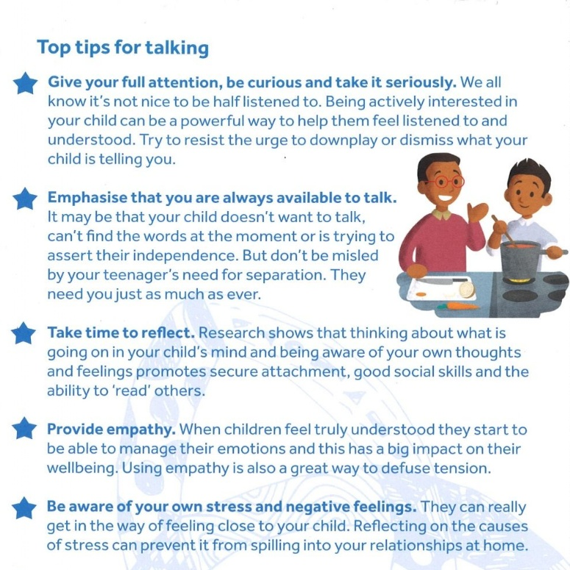

**Talking to your teen - 10 tips**

**for parents from young people**

Wondering how to start a conversation with your teen about their mental health?

A group of young people have given us their top tips on how they would like their parents to approach the subject.

**1. Let us know it is OK to talk to you about our worries and fears.**

**2. School and friendship pressures can be just as stressful for us as your lives are**

**3. Don't make assumptions about us - ask us.**

**4. When we have brothers and sisters we don't all turn out the same, let us know what you value about us.**

**5. Let us know you might not be able to make things right but that it will turn out OK.**

**6. Ask us what we would like you to do (are we telling you to get it off our chests or because we want your help)**

**7. Tell us what you are thinking when we have talked to you, if you feel sad it is better to tell us than be silent.**

**8. Please don't ignore it if you are worried about us, you can always leave us a note if you don't have the words.**

**9. If there are times you struggle with things let us know, it helps to know we aren't the only ones.**

**10. Sometimes we don't understand why we feel the way we do so we might not be able to explain it**

**Looking after mental health has never been more important.**

According to mental health charity Mind, 1 in 4 people in the UK will experience a mental health problem each year. Their data shows that 3.3 in every 100 people in England suffers from depression, with 6 in 100 reporting an anxiety disorder.

Below are a range of mental health apps which can be used to help manage problems such as stress, anxiety and depression.

