Year 12 and 13 Independent Learning and Private Study Guide

Please find the following information for each course in year 12 and 13:
- Recommended textbook/resources
- Recommended electronic resources and websites

Course / Subject | Recommended Textbook / Resources | Recommended Electronic Resources and Websites
Art | Fine Art:  Children's Book of Art: An Introduction to the World's Most Amazing Paintings and Sculptures (Dk) Hardcover – 1 Sept. 2009  DK (Author)  Watch the progression of artistic styles and techniques, such as oil painting, watercolour, pastels, and sculpture. Leonardo da Vinci, Claude Monet, Vincent van Gogh, Pablo Picasso, Frida Kahlo, Jackson Pollock, and Andy Warhol are just some of the big names from the past and present featured inside. Every talent's work is showcased through a signature piece supported by illuminating text, giving you a unique tour of each prestigious work of art.  Art: The Definitive Visual Guide  Author: Andrew Graham-Dixon  Discover the history of art movements from classical Greek art to the Italian Renaissance, the Pre-Raphaelites, and the masters of Impressionism with a brand new edition of this classic bestseller. Truly comprehensive in scope, Art shows you masterpieces from over 700 artists, including Leonardo da Vinci, Picasso, and Van Gogh. An invaluable reference book for any art lover, it showcases the works; everything from Italian baroque painting and African art to contemporary art history. Discover key facts about the most prominent artistic movements, including their origins and influences, and follow a timeline of the most famous works. Be inspired by the detail of each subject matter and methods each artist used to create their masterpieces, and explore centuries, cultures, and countries on the ultimate artistic journey across time.  Thinking About Art: A Thematic Guide to Art History by Peter Huntsman (2015)  What Are You Looking At? 150 Years of Modern Art in the Blink of an Eye by Will Gompertz (2016)  Think Like an Artist by Will Gompertz (2015)  Looking at Pictures by Susan Woodford (2018)  The Art Book by Tom Melick (2014)  The Art of Creative Thinking by Rod Judkins (2015)  100 Artists’ Manifestos from the Futurists to the Stuckists by Alex Danchev (2011) | Ted Talk by Alexa Meade- Your body is my canvas  https://www.ted.com/talks/alexa_meade?language=en#t-262476  Websites:  https://www.studentartguide.com/  https://www.theartnewspaper.com/  https://www.artforum.com/  http://www.artnews.com/  http://artreport.com/  http://www.tate.org.uk/art/artists/a-z  https://www.artsy.net/artists  https://artuk.org/discover/artists  https://www.tate.org.uk/art/art-terms/p/photography/a-z  https://www.complex.com/style/2012/03/the-25-photographers-you-should-know/18
Art Photography | Jeffrey, I & Phaidon (2000) - The Photography Book  Langford, M (1998 edition) - Story of Photography - For technical skills see Michael Longford’s series of books  Clarke, G (1997) - The Photography: A Visual and Cultural History  Farrell, I (2011) - A Complete Guide to Digital Photography | A Level:  https://www.aqa.org.uk/resources/art-and-design/as-and-a-level/art-and-design/plan/resource-and-support-guide  Links to articles and videos for inspiration:  https://www.thesun.co.uk/news/11317289/art-lovers-recreate-famous-paintings-coronavirus/; https://petapixel.com/2016/01/13/this-65-year-old-photographer-is-recreating-famous-paintings-as-self-portraits/  https://www.thetimes.co.uk/article/at-home-with-the-masters-xbj508xrk  Youtube - Masters of Photography – Select a Photographer and Research/Analyse/Take some Photos from their inspiration:  https://www.youtube.com/channel/UCLHyRIUyTszllmLGmgNqBHw  Masters of Photography – Sky Arts – Now Tv 348/Virgin 123/Sky 122/Talk Talk TV 303
Biology | The Chemistry of Life (Steven Rose)  Anything by the geneticist Steve Jones or biologist Richard Dawkins  Genome (Matt Ridley)  The Wisdom of the Genes (Wills)  Life on the Edge: Quantum Biology (Al-Khalili and MacFadden)  Hacking The Code of Life (Carey)  Life Ascending (Nick Lane)  The Revenge of Gaia (Lovelock)  50 Genetic Ideas You Really Need To Know (Henderson)  Zoobiquity (Horowitz and Bowers)  Creation: The Origin of Life (Rutherford)  The Sixth Extermination (Kolbert), Great Myths of the Brain (Jarrett)  The Gene – an Intimate History (Mukherjee)  How We Live and Why We Die (Wolpert)  Honeybee Democracy (Seeley)  Read journals such as Nature and New Scientist in particular, but all scientific journals will have biological items in them.  For biochemistry, a good Handbook of Biochemistry/Principles of Biochemistry textbook is useful for back-up reading as you do topics at A Level.  For genetics, familiarise yourself with sex-linked conditions, genetic ratios, gene editing and for population genetics the Hardy-Weinberg equilibrium and find out about case studies.  For zoology, look at taxonomy (the science of classification – what do ‘species’ and ‘genus’ mean?) and at such things as the place of primates within it.  Popular books for developing your understanding of Biology:  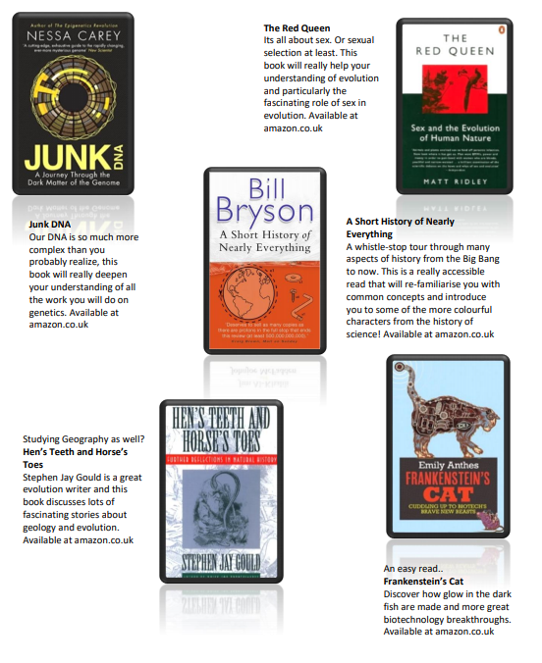 | www.arkive.org  http://www.ted.com/  www.thenakedscientists.com  TV programmes by David Attenborough and George McGavin are always of interest  There are some great TV series and box sets available too:  Blue Planet  Planet Earth I and II  Icarus  Blackfish  The Ascent of Man  Catastrophe  Frozen Planet  Life Story  The Hunt and Monsoon.  Movie Recommendations:  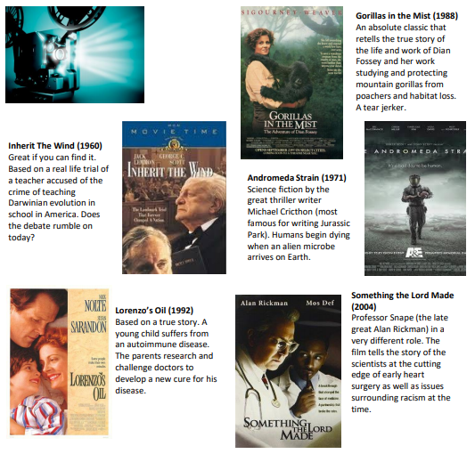  A New Superweapon in the Fight Against Cancer:  http://www.ted.com/talks/paula_hammond_a_new_superweapon_in_the_fight_against_cancer?language=en  Cancer is a very clever, adaptable disease. To defeat it, says medical researcher and educator Paula Hammond, we need a new and powerful mode of attack.  Why Bees are Disappearing:  http://www.ted.com/talks/marla_spivak_why_bees_are_disappearing?language=en  Honeybees have thrived for 50 million years, each colony 40 to 50,000 individuals coordinated in amazing harmony. So why, seven years ago, did colonies start dying en-masse?  What Doctors Don’t Know About the Drugs They Prescribe:  http://www.ted.com/talks/ben_goldacre_what_doctors_don_t_know_about_the_drugs_they_prescribe?language=en  When a new drug gets tested, the results of the trials should be published for the rest of the medical world — except much of the time, negative or inconclusive findings go unreported, leaving doctors and researchers in the dark.  Growing New Organs:  http://www.ted.com/talks/anthony_atala_growing_organs_engineering_tissue?language=en  Anthony Atalla's state-of-the-art lab grows human organs — from muscles to blood vessels to bladders, and more  DNA and the Genetic Code:  http://ed.ted.com/lessons/the-twisting-tale-of-dna-judith-hauck  http://ed.ted.com/lessons/where-do-genes-come-from-carl-zimmer  Evolution:  http://ed.ted.com/lessons/how-to-sequence-the-human-genome-mark-j-kiel  http://ed.ted.com/lessons/the-race-to-sequence-the-human-genome-tien-nguyen  Biodiversity:  http://ed.ted.com/lessons/why-is-biodiversity-so-important-kim-preshoff  http://ed.ted.com/lessons/can-wildlife-adapt-to-climate-change-erin-eastwood  Exchange and Transport:  http://ed.ted.com/lessons/insights-into-cell-membranes-via-dish-detergent-ethan-perlstein  http://ed.ted.com/lessons/what-do-the-lungs-do-emma-bryce  Cells:  https://www.youtube.com/watch?v=gcTuQpuJyD8  https://www.youtube.com/watch?v=L0k-enzoeOM  https://www.youtube.com/watch?v=qCLmR9-YY7o  Biological Molecules:  https://www.youtube.com/watch?v=H8WJ2KENlK0  http://ed.ted.com/lessons/activation-energy-kickstarting-chemical-reactions-vance-kite  Ecosystems:  https://www.youtube.com/watch?v=jZKIHe2LDP8  https://www.youtube.com/watch?v=E8dkWQVFAoA  Control Systems:  https://www.youtube.com/watch?v=x4PPZCLnVkA  https://www.youtube.com/watch?v=x4PPZCLnVkA  Energy for Biological Processes:  https://www.youtube.com/watch?v=00jbG_cfGuQ  https://www.youtube.com/watch?v=2f7YwCtHcgk
Business Studies | Brilliant Marketing (Hall)  The Advertising Concept Book (Barry)  Guerilla Marketing (Levinson)  The Strategy Book (McKeown)  Strategy (Harvard Business Essentials)  Adventures of a Global Entrepreneur (Branson)  Anyone Can Do It (Bannatyne) | APPS for Business:  News websites for Business:  The Guardian: https://www.theguardian.com/uk/business  The Independent: https://www.independent.co.uk  The FT: https://www.ft.com  Reuters: https://www.reuters.com/
Chemistry | The Chemistry of Life (Steven Rose)  Chemistry (Brock)  Principles of Biochemistry (White, Handler and Smith) as a backup to all your A Level topics  Chemistry for Changing Times (Hill, McCreary and Kolb)  Materials Science (Ramsden)  The Periodic Kingdom (Atkins)  Mendeleyev’s Dream – the search for the elements (Strathern)  Periodic Tables – The Curious Life of the Elements (Aldersty and Williams)  The Disappearing Spoon (Kean)  50 Ideas you really need to know about Chemistry (Birch)  The Periodic Table – a field guide to the elements (Parsons and Dixon)  Periodicals:  New Scientist  Nature  Chemistry World  Education in Chemistry | www.ted.com  www.thenakedscientists.com  www.isaacchemistry.org  Using Plastics in the Body  Available at: https://www.stem.org.uk/resources/elibrary/resource/382317/using-plastics-body  This Catalyst article looks at how scientists are learning to use polymers for many medical applications, including implants, bone repairs and reduction in infections  Catching a Cheat  Available at: https://www.stem.org.uk/system/files/elibrary-resources/2017/03/Catching%20a%20cheat.pdf  This Catalyst article looks at analytical chemists who are involved in many kinds of testing, including drug testing to catch cheats in sport  Diamond: More than just a gemstone  Available at: https://www.stem.org.uk/system/files/elibrary-resources/2017/02/Diamond%20more%20than%20just%20a%20gemstone.pdf  This Catalyst article looks at diamond and graphite which are allotropes of carbon. Their properties, which depend on the bonding between the carbon atoms, are also examined  The Bizarre World of High Pressure Chemistry  Available at: https://www.stem.org.uk/system/files/elibrary-resources/2016/11/Catalyst27_1_the_bizarre_world_of_high_pressure_chemistry.pdf  This Catalyst article investigates high pressure chemistry and discovers that, when put under extreme pressure, the properties of a material may change dramatically.  Microplastics and the Oceans  Available: https://www.stem.org.uk/system/files/elibrary-resources/2016/11/Catalyst27_1_microplastics_%20and_the_oceans.pdf  This Catalyst article looks at microplastics. Microplastics are tiny particles of polymer used in many products. They have been found to be an environmental pollutant especially in oceans.  Chemguide - This website is very detailed and identifies other resources which are sharing incorrect or outdated information and suggests the correct materials to use. The site also contains links to the syllabuses of many exam boards which means it is accessible and useful to all students  https://www.chemguide.co.uk/  DocBrown - a website dedicated to all three science subjects; physics, chemistry and biology. It provides the user with summarised notes (useful for making flash cards) and practice questions to further their knowledge and understanding.  http://www.docbrown.info/  Chemrevise - The site was first made to host revision guides that are written for AQA A-level Chemistry. These revision guides have already been circulating on the internet for a couple of years on places like student room. This will be the place for the most up to date versions of them. The site has now extended to cover other exam boards. (OCR and Edexcel)  https://chemrevise.org/  S-cool - The free revision website for students studying GCSE and Alevels. S-cool provides revision guides, question banks, revision timetable and more  https://www.s-cool.co.uk/a-level/chemistry  Crash Course - Tons of awesome courses in one awesome channel! Check out the playlists for past courses in physics, philosophy, games, economics, U.S. government and politics, astronomy, anatomy & physiology, world history, biology, literature, ecology, chemistry, psychology, and of course, chemistry!  https://www.youtube.com/user/crashcourse/featured  Science on Social Media:  Follow on Twitter: Satlers’ Institute - Our activities include Festivals of Chemistry; Chemistry Camps; Curricula; Awards for Technicians, Graduates, A Level Students; and Seminars  @salters_inst  Daily A Level Chemistry Facts – Daily Chemistry Facts (Based on the A-Level AQA spec but most facts work with all) @chemAlevels  Chemistry News –The latest chemistry news from only the best sources  @chemistrynews  Compound Interest– Graphics exploring everyday #chemistry. Winner of @absw 2018 science blog award @compoundchem  Chemistry World – Chemistry magazine bringing you the latest chemistry news and research every day. Published by the Royal Society of Chemistry. @ChemistryWorld  Royal Society of Chemistry - Promote, support and celebrate chemistry. Follow for updates on latest activities @RoySocChem  Periodic Videos– Chemistry video series by @BradyHaran & profs at the Uni of Nottingham - also see @sixtysymbols  @numberphile  @periodicvideos  Find on Facebook:  Science Now - Science Now is a dedicated community that helps spread science news in all fields, from physics to biology, medicine to nanotechnology, space and beyond!  National Science Foundation – As an independent federal agency, NSF fund a significant proportion of basic research. For official source information about NSF, visit www.nsf.gov  Science News Magazine - Science covers important and emerging research in all fields of science  BBC Science News - The latest BBC Science and Environment News: breaking news, analysis and debate on science and nature around the world  Scientific American - Scientific American is the authority on science and technology for a general audience, with coverage that explains how research changes our understanding of the world and shapes our lives.
Performing Arts - Drama | Brecht on Theatre by Bertolt Brecht  The Theatre and its Double by Antonin Artaud  An Actor Prepares by Konstanstin Stanislavski  Tales From an Actor’s Life by Steven Berkoff  Acting For the Camera by Tony Barr  Acting Shakespeare by John Guilgud  Voice Over Voice Actor by Yuri Lowenthall and Tara Platt | Check out the following links for useful information on various aspects of the Performing Arts Industry:  Getting intoTheatre – a career in the performing arts https://www.youtube.com/wat=0zQebR_1JBw  Auditioning for Drama School https://www.youtube.com/watch?v=MaAAnzRPBP4  Drama School v University https://www.thestage.co.uk/advice/2017/university-vs-drama-school-right/  Finding an Agent https://www.thebalancecareers.com/how-to-get-an-agent-1283525  Tom Hanks on Acting https://www.youtube.com/watch?v=0zQebR_1JBw  https://www.youtube.com/watch?v=4y5JogtS8Ek
Performing Arts - Dance
English Language / Literature | English Language covers a wide range of topics and you may find a generic revision guide such as Revision Express useful as a starting point:  https://www.amazon.co.uk/Revision-Express-English-Language-Secondary/dp/1408206536/ref=sr_1_1?ie=UTF8&qid=1528662184&sr=8-1&keywords=revision+express+as+and+a2+english+language  David Crystal: The Story of English in 100 Words; How Language Works; The English Language: A Guided Tour of the Language (in fact, most books by this author are accessible and interesting. Have a look in your local library for them.)  Bill Bryson: Mother Tongue  There are also some really useful blogs to have a look at:  https://blog.oxforddictionaries.com/ - gives some interesting insights into new words and the changing uses of existing words.  http://flashfictiononline.com/main/ - useful website for looking at short pieces of creative writing. This will prove useful as you start preparing for coursework.  https://www.theguardian.com/media/mind-your-language - interesting blog that looks at attitudes towards the ways in which language is used.  Read the books listed on your course (even the ones you don’t have to)  Read other books by the same authors as the ones that you will be studying  Read other books within the same genre(s) that you will be studying  Fiction  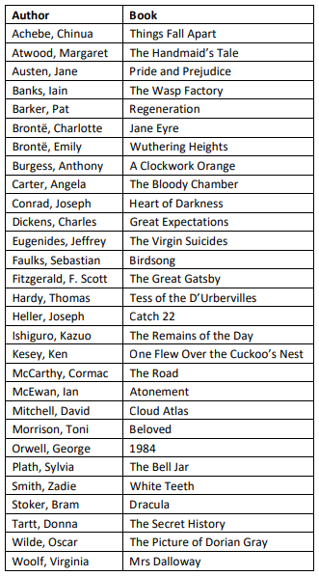  Poetry  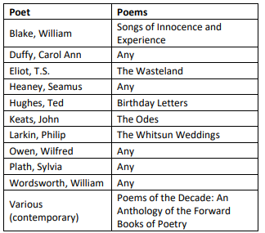  Drama  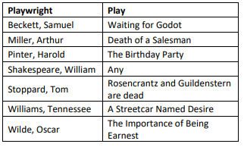 | There are good discussions of literary topics in the archive of the radio programme ‘In Our Time’, which is available on iPlayer  Check out Radio 4’s ‘Word of Mouth’ programme on the BBC iPlayer: https://www.bbc.co.uk/programmes/b006qtnz/episodes/player  Ted Talks:  https://www.ted.com/playlists/228/how_language_changes_over_time  https://www.ted.com/playlists/346/the_power_of_fiction_1  If you want to consider why we read and write, this is a quick (quite blistering) synopsis of why we study Literature: https://www.youtube.com/watch?v=MSYw502dJNY
Geography | Some good general geography sources:  Geography Review: http://www.philipallan.co.uk/geographyreview/index.htm  Geographical: http://www.geographical.co.uk/Home/index.html  Earth, An Intimate History (Fortey)  Globalism and Regionalism and Capitalism as if the Earth mattered (Porritt)  Future Shock (Tofler)  A Blueprint for Survival (The Ecologist and Penguin books)  Population Geography (Jones)  The Skeptical Environmentalist (Lomberg – indeed anything by him)  Jungle: A Harrowing True Story of Survival (Ghinsberg), Surviving Extremes (Middleton – he teaches Geog. at Oxford)  Earth From Space (Johnston)  Belching Out the Devil: Global Adventures with Coca-Cola (Thomas)  Anything by James Lovelock on Gaia and for the human and cultural side Tribe (Bruce Parry) or anything by the Prof. of Geog. at UCLA Jared Diamond.  Caesar’s Last Breath – the epic story of the air around us (Kean) and for geologists, Reading Rocks (Maddox)  Building Global Resistance (Pagett) is a searing critique of current development strategies  So You Think You Know About Britain (Danny Dorling)  Factfulness: Ten Reasons We're Wrong About the World – and Why Things Are Better Than You Think. By Hans Rosling, Ola Rosling, Anna Rosling Rönnlund | Become a junior member of the Royal Geographical Society  Useful websites:  http://www.philipallan.co.uk/geographyreview/index.h  http://www.nationalgeographic.com/  http://www.geographyalltheway.com/  http://www.gatm.org.uk/  Environmental Geography: http://www.mongabay.com/  http://www.gapminder.org/  www.facingthefuture.org  http://www.ted.com/  http://www.gogeo.ac.uk/  More specific articles and lectures that will broaden your geographical knowledge and understanding:  DON'T PANIC — Hans Rosling showing the facts about population: https://www.youtube.com/watch?v=FACK2knC08E&t=1583s  Interactive map of coastal map of the UK coastline:  https://www.gov.uk/check-plans-to-stop-coastal-erosion-in-your-area  What is happening to the plates?  https://www.newscientist.com/article/mg22329843-000-earths-tectonic-plates-havedoubled-their-speed  How can technology improve a country’s vulnerability? https://www.ted.com/talks/paul_conneally_digital_humanitarianism  What is a ‘global sense of place’? Why is this important to the understanding of ‘place’ as a concept? Massey, D (1991) http://banmarchive.org.uk/collections/mt/pdf/91_06_24.pdf
Government & Politics* | The Origins of Political Order (Fukuyama)  The Spectre At the Feast (Gamble)  The Establishment and how they get away with it (Owen Jones)  British Politics (Madgwick)  Mind The Gap (Mount)  The Politics Book (Kelly)  After Europe (Krastev)  Newspapers:  https://www.theguardian.com/uk  https://www.independent.co.uk/  https://www.telegraph.co.uk/  https://www.nytimes.com/  http://www.washingtonpost.com/  https://www.washingtontimes.com/ | http://www.ted.com/  http://www.politicsinspires.com/  https://www.bbc.co.uk/news/politics  TV and Radio, which can be accessed, respectively, via https://www.bbc.co.uk/iplayer  and http://www.bbc.co.uk/radio  and https://www.itv.com/hub/shows  (Be aware that these programmes are not all available throughout the year and that schedules may change):  Monday – Friday: PM Radio 4 17:00 – 18:00; Newsnight BBC2 22:30 – 23:15  Tuesday: The Mash Report BBC2 22:00  Thursday: Question Time BBC1 22:45 – 23:45; This Week BBC1 23:45 – 00:45  Friday: The News Quiz/The Now Show/Dead Ringers Radio 4 18:30 – 19:00;  Have I Got News For You BBC1 21:00 – 21:30; Tracey Breaks the News BBC1 21:30 – 22:00; Mock the Week BBC2 22:00 – 22:30  Saturday: The Week in Westminster Radio 4 11:00 – 11:30  Sunday: The Andrew Marr Show BBC1 09:00 – 10:00; Pienaar’s Politics Radio 5 10:00 – 11:00; Peston on Sunday ITV 10:00 – 11:00, repeated 22:20 – 23:20
Health and Social Care |  | Television Links:  Make me a Midwife - https://www.youtube.com/watch?v=wY8jAYUZc38  GP Behind Closed Doors. – Channel 5  Ambulance – BBC1 (a paramedic is part of the emergency services rather than health services)  Junior Doctors – Blood Sweat and Tears – BBC3  Hospital Series – Terror attack victims https://www.youtube.com/watch?v=0pjUNZSajuE  Childrens Hospital - https://www.youtube.com/watch?v=hYLG31fzfuY  Care Assistant - https://www.youtube.com/watch?v=FE1khfnuBvQ  Youth Work - https://www.youtube.com/watch?v=Nk3tB_yE9yY&t=22s
History | Component 1 – The Tudors 1485-1603  https://www.amazon.co.uk/Oxford-AQA-History-Level-1485-1603/dp/0198354606/ref=sr_1_1?dchild=1&keywords=aqa+a+level+tudors&qid=1634827993&qsid=257-1550928-6408542&sr=8-1&sres=0198354606%2C1471837580%2C0198421400%2C1316504328%2C1471876101%2C0198354711%2C1471883159%2C1447985435%2C0198354614%2C0198354576%2C0198421427%2C0198354584%2C1471876616%2C019842146X%2C0719574846%2C1510457887&srpt=ABIS_BOOK  Component 2 – Revolution and Dictatorship 1917-1953  https://www.amazon.co.uk/Oxford-AQA-History-Level-Dictatorship/dp/0198354584/ref=sr_1_3?dchild=1&keywords=aqa+a+level+dictatorship&qid=1634827935&qsid=257-1550928-6408542&sr=8-3&sres=1107587387%2C0198432526%2C0198354584%2C1471876136%2C1510459340%2C0198354576%2C1471837807%2C0198354606%2C0198421400%2C191372011X%2C1447985303%2C0198354673%2C0198421427%2C0198421443%2C151045795X%2C0198370105&srpt=ABIS_BOOK | Seneca  https://app.senecalearning.com/dashboard/courses/add?Price=Free&Subject=History&Exam+Board=AQA&Age+Group=A+Level  Russia Podcast  https://www.youtube.com/playlist?list=PL3z21sNm6oEO6OdODdD_AcbxIV-ujhnDL
IT | 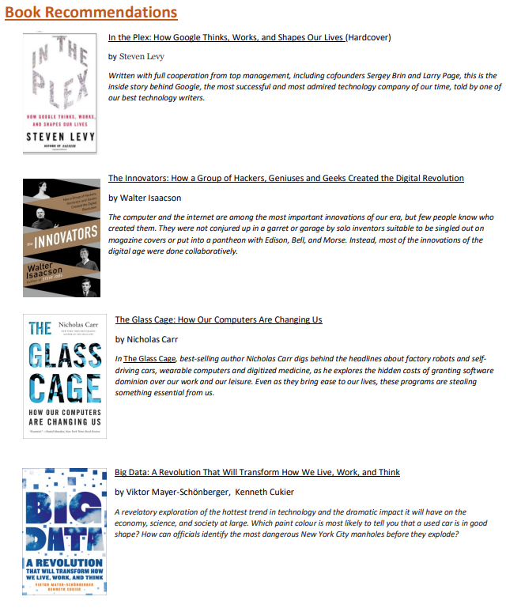  All units: Pearson BTEC National Information Technology Student Book, ISBN 9781292140414  Units 1 and 2 only:  Revise BTEC National Information Technology Revision Guide, ISBN 9781292230504 | 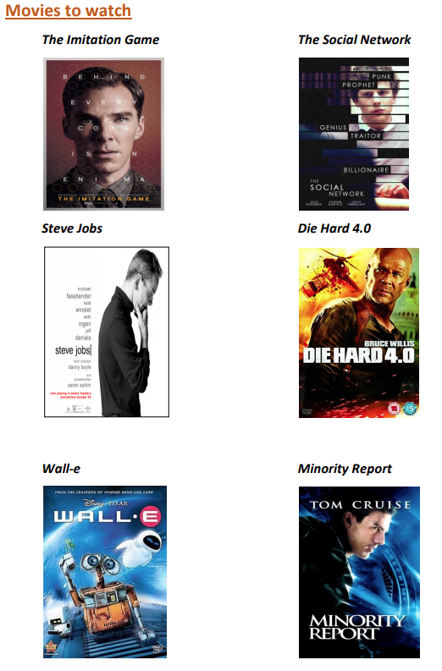  Videos to watch online:  How Machines Learn by CGP Grey https://www.youtube.com/watch?v=R9OHn5ZF4Uo  Forget Wi-Fi. Meet the new Li-Fi Internet by Harald Haas https://www.youtube.com/watch?v=iHWIZsIBj3Q  The Internet of Things by Jordan Duffy https://www.youtube.com/watch?v=mzy84Vb_Gxk  Unit 1: Information Technology Systems (exam unit)  Unit 2: Creating Systems to Manage Information (exam unit) Help with Access: https://www.techonthenet.com/access/index.php  Unit 3: Using social media in Business  Unit 6: Website Development  Students have access to the digital version of the student textbook which includes all units: https://www.pearsonactivelearn.com/app/Home
Law | The Justice Game by Robertson  Getting into Law (ed. Lygo)  The Search for Justice (Rozenburg)  Understanding Law (Adams and Brownsword)  Law and Modern Society (Atiyah)  On Evidence (Murphy)  The Rule of Law (Bingham)  Bonfire of the Liberties: New Labour, Human Rights (Ewing)  The Very Short Introduction to Human Rights (Clapham)  The Very Short Introduction to the Philosophy of Law (Wacks)  The New Penguin Guide to the Law | Radio Programmes (podcasts can be found on iPlayer):  Law in Action  Unreliable Evidence  http://www.ted.com/  http://www.lawstudent.tv%2Cwww.lawcom.gov.uk/  http://www.guardian.com/law/studying-law
Mathematics | Online textbooks can be found at:  https://www.pearsonactivelearn.com/app/Home  Textbooks for purchase:  Edexcel Year 1/AS Pure Mathematics  https://www.amazon.co.uk/Edexcel-level-Mathematics-Textbook-Further/dp/129218339X/ref=sr_1_1?crid=17VX9RY4WUXUD&dchild=1&keywords=pearson+a+level+maths&qid=1635781916&sprefix=pearson+a+l%2Caps%2C80&sr=8-1  Edexcel Year 1/AS Statistics and Mechanics https://www.amazon.co.uk/Edexcel-Mathematics-Statistics-Mechanics-Textbook/dp/1292232536/ref=sr_1_6?crid=17VX9RY4WUXUD&dchild=1&keywords=pearson+a+level+maths&qid=1635781952&sprefix=pearson+a+l%2Caps%2C80&sr=8-6  Edexcel Year 2 Pure Mathematics https://www.amazon.co.uk/Edexcel-level-Mathematics-Textbook-Further/dp/1292183403/ref=sr_1_4?crid=17VX9RY4WUXUD&dchild=1&keywords=pearson+a+level+maths&qid=1635781952&sprefix=pearson+a+l%2Caps%2C80&sr=8-4  Edexcel Year 2 Statistics and Mechanics https://www.amazon.co.uk/Edexcel-Mathematics-Statistics-Mechanics-Textbook/dp/1446944077/ref=sr_1_5?crid=17VX9RY4WUXUD&dchild=1&keywords=pearson+a+level+maths&qid=1635781952&sprefix=pearson+a+l%2Caps%2C80&sr=8-5  Fermat’s Last Theorem (Singh)  Does God Play Dice and Nature’s Numbers (Stewart)  Easy as Pi (Ivanov)  The Music of the Primes (du Sautoy)  Just Six Numbers (Rees)  In Code (Flannery)  Numbers, Sets and Axioms (Hamilton)  The Universe and the Teacup – the Maths of Truth and Beauty (K.C. Cole)  Algebra and Geometry (Beardon)  Hidden Connections, Double Meanings (Wells)  Elastic Fishponds. The Maths that governs our World (Elwes)  The Norm Chronicles (Blastland and Spitgethaltes)  Our Mathematical Universe (Te.g.mark)  Updates for 2018 are Beyond Infinity (Cheng)  Weapons of Math Destruction (O’Neill)  Ian Stewart’s 17 equations that changed the world and Thinking in Numbers (Temmet)  Chemists may be interested in The Periodic Table – a field guide to the elements (Parsons & Dixon) | Follow the ‘WATCH, THINK, DIG DEEPER, DISCUSS’ The Wizard standoff riddle.  https://ed.ted.com/lessons/can-you-solve-the-wizard-standoff-riddle-daniel-finkel  Follow the ‘WATCH, THINK, DIG DEEPER, DISCUSS’ Solve the false positive riddle. https://ed.ted.com/lessons/can-you-solve-the-false-positive-riddle-alex-gendler  Exam Solutions.net https://www.examsolutions.net/a-level-maths/edexcel/
Media Studies | Media, Gender and Identity by David Gauntlett  Feminism is for Everybody by bell hooks  Feminist Media Studies by Liesbet van Zoonen  Gender Trouble by Judith Butler  After Empire by Paul Gilroy  There Ain't No Black In The Union Jack Paul Gilroy  Media Regulation by Lunt and Livingstone  Here Comes Everybody by Clay Shirky  Cognitive Surplus: Creativity and Generosity in a Connected Age by Clay Shirky  Representation: Cultural Representations and Signifying Practices Edited by Stuart Hall  Power without Responsibility: Press, Broadcasting and the Internet in Britain by James Curran  The Cultural Industries by David Hesmondhalgh  Convergence Culture: Where Old and New Media Collide by Henry Jenkins | TED talks connected to the concepts explored within Media Studies:  https://www.ted.com/talks/alisa_miller_shares_the_news_about_the_news  https://www.ted.com/talks/johanna_blakley_social_media_and_the_end_of_gender  https://www.ted.com/talks/david_puttnam_what_happens_when_the_media_s_priority_is_  https://www.ted.com/playlists/21/media_with_meaning  The Media Guardian: https://www.theguardian.com/uk/media  EMC’s Media Magazine: https://www.englishandmedia.co.uk/media-magazine (well worth subscribing to)  British Film Institute: http://www.bfi.org.uk/  University Guide to Media courses:  https://www.topuniversities.com/courses/communication-media-studies/guide
BTEC Music Technology | All unit information/ specification accessible at https://qualifications.pearson.com/content/dam/pdf/BTEC-Nationals/Music-Technology/2016/specification-and-sample-assessments/BTEC-L3-Nat-Dip-in-Music-Technology-Spec.pdf  Music Technology from Scratch by Mortimer Rhind-Tutt | Watch the following clip of John Legend highlighting the importance of not giving up, and learning from failure:  https://www.youtube.com/watch?v=LUtcigWSBsw  Watch the following clips of some professional musicians giving advice on how to be successful as a musician: https://www.youtube.com/watch?v=6UqCb-_oqZY
3D Art & Design | Essential Maths Skills for AS/A Level Design and Technology  Originally published: 25 May 2018  Authors: Peter Warne, Chris Walker  Genre: Study guide  Mathematical skills are vital in design and technology. They are essential if you wish to continue your study beyond A Level into design – engineering related careers. This book covers all maths skills you are required to know which will be useful in exams and course work.  - 1000 Chairs: BU (Bibliotheca Universalis)  by Charlotte Fiell (Author), Peter Fiell (Author)  From Gerrit Rietveld and Alvar Aalto to Verner Panton to Eva Zeisel, from Art Nouveau to International Style, from Pop Art to Postmodernism, the phenomenon of the chair is so complex that it requires a reference work as comprehensive as this to do it full justice. They are all here: Thonet s bentwood chairs and Hoffmann s sitting-machines, Marcel Breuer s Wassily chair and Ron Arad s avant-garde armchairs.  The book devotes one page to each chair, displayed on its own as pure form, with biographical and historical information about the chairs and their designers. | Website link that covers all elements, tasks and specification within Design Technology. Here you will find animation explaining specific informations and activities to support and build skills.  http://www.technologystudent.com/  YouTube video links to specific skills:  https://www.creativebloq.com/illustration/how-draw-manga-11618810  https://www.youtube.com/watch?v=_05or04sGAo  https://www.youtube.com/watch?v=mBoVoj5jLfc  https://www.youtube.com/watch?v=Nmsrhm7-BQ0
Psychology / Applied Psychology | The Gendered Brain (Rippon)  Understand Psychology (Hayes)  Games People Play (Berne)  I’m OK, You’re OK (Thomas Harris)  The Serial Killers: the psychology of violence (Wilson)  50 Psychology Ideas you really need to know (Furnham)  Tricks of the Mind (Derren brown)  Anything by Oliver Sacks  Mindsight (Siegel)  The Skeleton Cupboard- the making of a clinical psychologis (Byron)  Psy-Q (Ambridge)  Predictably Irrational (Anely)  Bounce (Syed)  The Element (Ken Robinson)  Friend Request, 2018 by Laura Marshall  Born Evil, 2018 by Julia Derek  Lies, 2017 by T.M. Logan  Reaching Down the Rabbit Hole, 2016 by Allan Ropper and Brian David Burrell  Good Me Bad Me, 2017 by Ali Land  Selfie: How the West Became Self-Obsessed, 2018 by Will Storr  The Lucifer Effect: How Good People Turn Evil, 2008 by Philip Zimbardo  How to Survive the End of the World, 2018 by Aaron Gillies | Google ‘The Encyclopedia of Psychology’  https://simplypsychology.org/milgram.html  - Milgram  https://www.simplypsychology.org/zimbardo.html  - Zimbardo  https://www.canonsociaalwerk.eu/1971_stigma/1973%20Rosenhan%20Being%20sane%20in%20insane%20places%20OCR.pdf  – Rosenhan  https://www.simplypsychology.org/loftus-palmer.html  - Loftus and Palmer  https://www.simplypsychology.org/mary-ainsworth.html  - Ainsworth  http://www.holah.karoo.net/rainestudy.html  - Raine  https://www.youtube.com/watch?v=O3cOvLrixhY  – Trial of O.J. Simpson – BBC documentary. The collection of forensic evidence and investigation, including court cases.  https://www.ted.com/talks/petter_johansson_do_you_really_know_why_you_do_  https://www.ted.com/talks/laurel_braitman_depressed_dogs_cats_with_ocd  - What animal_madness_means_for_us_humans  https://www.ted.com/talks/elizabeth_loftus_the_fiction_of_memory  https://www.ted.com/talks/scott_fraser_the_problem_with_eyewitness_testimony  https://www.ted.com/talks/steven_pinker_chalks_it_up_to_the_blank_slate  https://www.ted.com/talks/philip_zimbardo_on_the_psychology_of_evil  https://www.ted.com/talks/ben_ambridge_10_myths_about_psychology_debunked  https://www.youtube.com/watch?v=_yT_F0dMZRU  (Part 1)  https://www.youtube.com/watch?v=B3rHTm1YLxA  (part 2) – Stephen Fry - The Secret Life Of The Manic Depressive. BBC 10)  https://www.youtube.com/watch?v=jhLuEKZj1oo  – The Fritzl affair. Real crime documentary.  https://www.youtube.com/watch?v=nJm7AhdGbDk  – Freud documentary (short)  https://www.youtube.com/watch?v=5XFjLdNO4FU  – The Nurture room – child psychology  https://www.youtube.com/watch?v=OON81IJ9yos  – Charles Whitman documentary  https://www.youtube.com/watch?v=L-DgV2vixSo  – Motivation and rewards in learning (Rats)
Physics | The Physics of the Impossible and Parallel Worlds (Kaku)  Hyperspace (Khan)  Smashing Physics: inside the world’s biggest experiment (Butterworth)  Seven brief lessons on Physics (Rovelli)  Chaos (Gleich), Quantum (Kumar)  How to teach Quantum Physics to your Dog (Orzel)  50 Physics Ideas You Really Need To Know (Baker)  The Ele.g.ant Universe (Greene)  Just Six Numbers (Rees)  About Time (Frank)  The Wonders of the Solar System (Brian Cox - anything by him is good)  An Astronaut’s Guide to Life on Earth (Hadfield)  A Space Traveller’s Guide to the Solar System (Thompson)  Ripples in Spacetime (Schilling)  Calculating the Cosmos (Stewart)  The Ascent of Gravity (Chown)  New Scientist  Scientific American  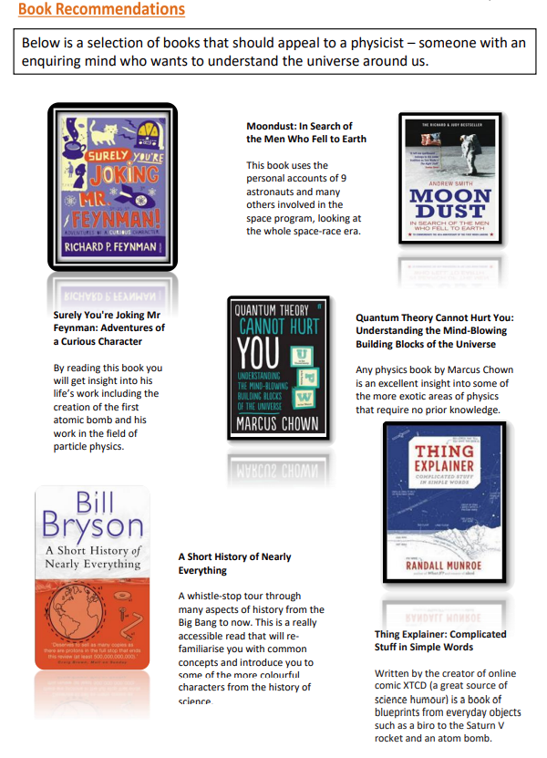 | The Infinite Monkey Cage is an excellent radio programme (on Radio 4 and iPlayer) featuring Brian Cox and Robin Ince and combining theoretical physics with stand up comedy (podcasts are available of all their programmes)  TV Series:  The Planets  The Big Bang Theory  Websites:  http://www.ted.com/  www.thenakedscientists.com  http://www.galaxyzoo.com/  http://www.isaacphysics.org/  https://home.cern/ - At CERN, the European Organization for Nuclear Research, physicists and engineers are probing the fundamental structure of the universe. They use the world's largest and most complex scientific instruments to study the basic constituents of matter – the fundamental particles  http://www.physics.org/abou - physics.org is brought to you by the Physics in Society team at the Institute of Physics. Their aim is to inspire people of all ages about physics. Let them be your guide and show you the best physics places on the web  http://www.antonine-education.co.uk/ - A website written by James Irvine, a retired teacher from Sheffield. Although the website is primarily written to support AQA, the material is also easily transferable to other exam boards  http://www.physicsandmaths/ - A website written by a practicing physics and maths tutor in London. @physicsandmathstutor is an Oxford physics graduate with a PGCE from Kings College London  https://www.youtube.com/c/ALevelPh - A YouTube channel you definitely want to watch. Y12 or AS Physics content is free to view, you will find hundreds of videos made to help you in your A Level physics studies  Physics on Social Media:  Follow on Twitter:  Commander Chris Hadfield – former resident aboard the International Space Station @cmdrhadfield  NASA’s Voyager 2 – a satellite launched nearly 40 years ago that is now travelling beyond our solar system @NSFVoyager2  Neil deGrasse Tyson – Director of the Hayden Planetarium in New York @neiltyson  The SETI Institute – The Search for Extra Terrestrial Intelligence, be the first to know what they find! @setiinstitute  Phil Plait – tweets about astronomy and bad science @badastronomer  Institute of Physics – The leading scientific membership society for physics @PhysicsNews  Scientific America – Journal sharing discoveries and insights into science that develops the world @sciam  SN Students – Science news for students @SNStudents  Find on Facebook:  National Geographic - since 1888, National Geographic has travelled the Earth, sharing its amazing stories in pictures and words  Science News Magazine - Science covers important and emerging research in all fields of science  BBC Science News - The latest BBC Science and Environment News: breaking news, analysis and debate on science and nature around the world  Institute of Physics - The Institute of Physics is a leading scientific membership society working to advance physics for the benefit of all  Chandra X-ray Observatory - NASA’s Chandra X-ray Observatory is a telescope specially designed to detect X-ray emission from very hot regions of the Universe such as exploded stars, clusters of galaxies, and matter around black holes  Interesting Engineering - Interesting Engineering is a cutting edge, leading community designed for all lovers of engineering, technology and science  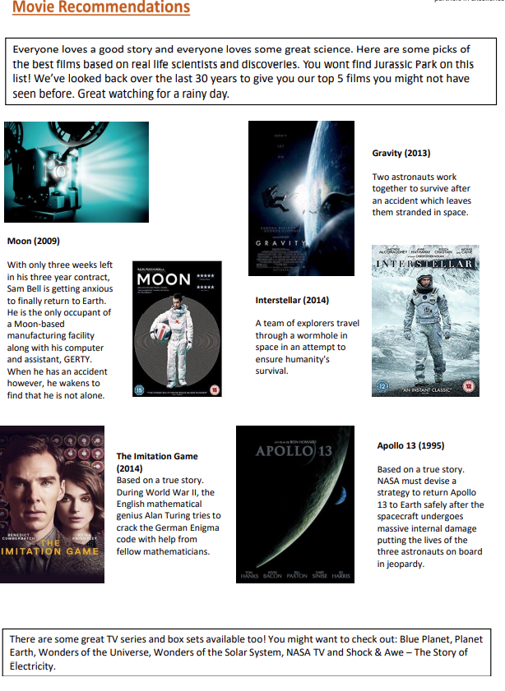  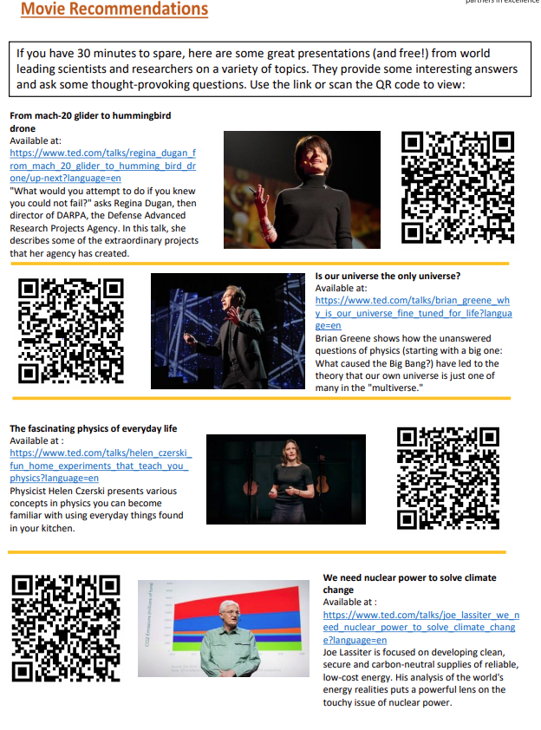
Sports Studies | Books:  S. Bointon, et al. 2016. Cambridge Technical Level 3 Sport and Physical Activity, 2016, Hodder Education - ISBN: 9781471874857 (main textbook – advised as the book to purchase)  Clegg, C. 1995. Exercise Physiology and Functional Anatomy. Feltham Press Walder, P. 1998. Mechanics and Sport Performance. Feltham Press  Honeybourne, J. 2006. Acquiring Skill in Sport: An Introduction. Routledge  Bean, A. 2017. The Complete Guide to Sports Nutrition. Bloomsbury Publishing  Scholarly Articles:  Polley, M. 2008. ‘The amateur rules’: Amateurism and professionalism in post-war British athletics  Contemporary British History, pages 81- 114  Quennerstedt, M. Ohman, M & Armour, K. 2014. Sport and exercise pedagogy and questions about learning Sport, Education and Society, pages 885-898.  Alexandris, K. Tsorbatzoudis, C. & Grouios, G. 2017. Perceived Constraints on Recreational Sport Participation: Investigating their Relationship with Intrinsic Motivation, Extrinsic Motivation and Amotivation, Journal of Leisure Research, pages 233-252.  Zaichkowsky, L. 2004. Arousal in Sport. Applied Psychology.  Weinberg, R. S. (2002) Goal setting in sport and exercise: Research to practice. Exploring sport and exercise psychology, pages 25-48. | Television:  Sports News Channel- This will support how you show your understanding by using current examples from sport  Hoop Dreams. 1994- A film regarding barriers to participation in sport  Live Sporting Events- This will support how you show your understanding by using current examples from sport  YouTube Clips:  Venous Return https://www.youtube.com/watch?v=J80hhCkLuaA  Stages of Learning https://www.youtube.com/watch?v=n7UcobScnck  Rational Recreation https://www.youtube.com/watch?v=SPrTPKj4O  NQ Newton’s Laws https://www.youtube.com/watch?v=MAm6LOUnJ80  Aggression in Sport https://www.youtube.com/watch?v=DlrTha8cbAI

