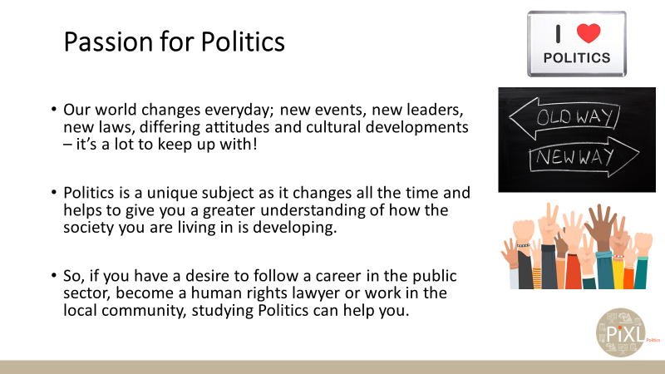
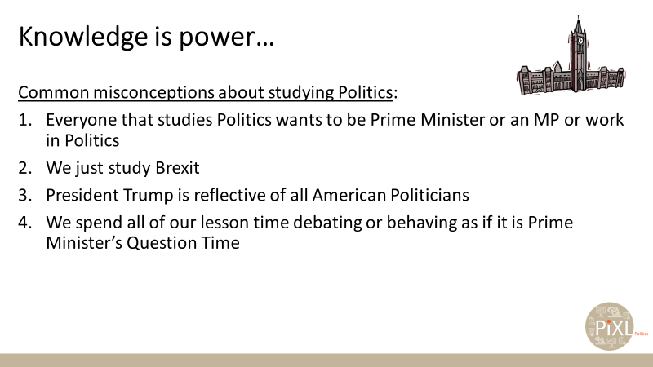
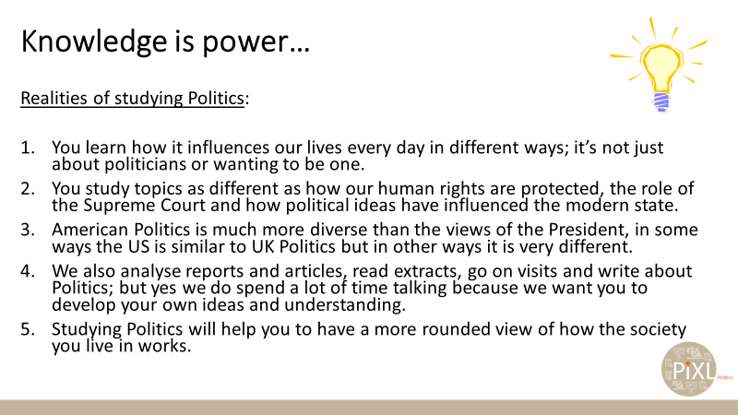
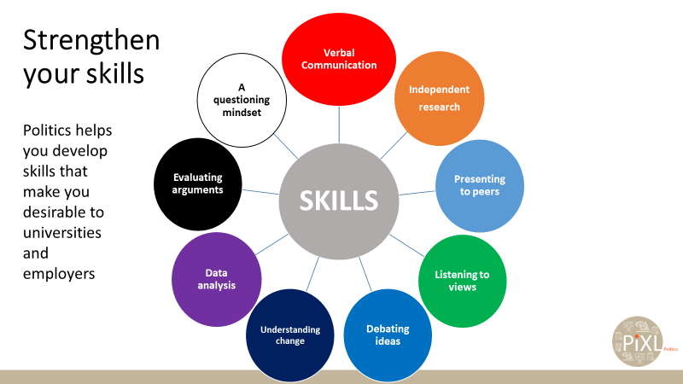
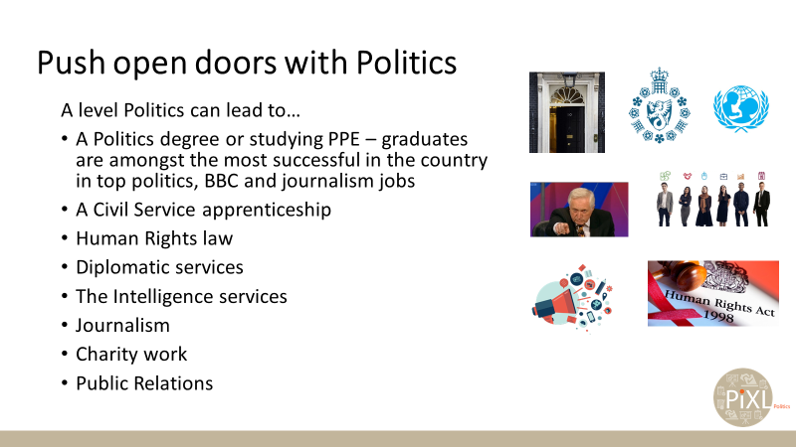
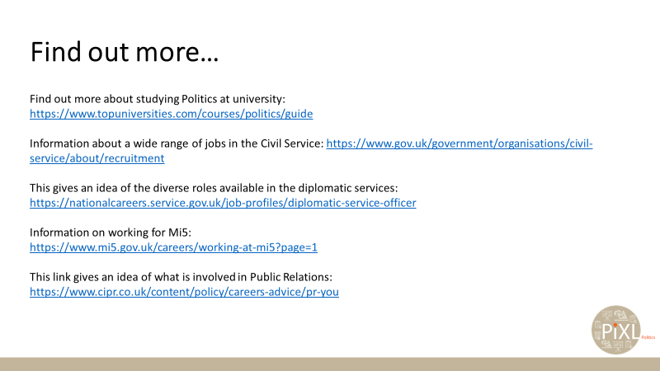

Find out more about studying Politics at university:
https://www.topuniversities.com/courses/politics/guide
Information about a wide range of jobs in the Civil Service: https://www.gov.uk/government/organisations/civil-service/about/recruitment
This gives an idea of the diverse roles available in the diplomatic services:
https://nationalcareers.service.gov.uk/job-profiles/diplomatic-service-officer

Information on working for Mi5:
https://www.mi5.gov.uk/careers/working-at-mi5?page=1
This link gives an idea of what is involved in Public Relations:
https://www.cipr.co.uk/content/policy/careers-advice/pr-you

