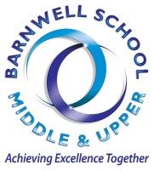

Week Beginning 24th September 2018
Macmillan Coffee Morning and ‘Great Barnwell Bake Off’ Competition

The sixth form will be hosting their annual Macmillan Coffee morning and Great Barnwell Bake Off on Friday 28th September.
We would like to invite you all to join us in the common room, anytime from 8.00am – 1.20pm on Friday 28th September where we will be selling a variety of hot drinks and scrumptious cakes! We will be joined at break time by Stephen McPartland, our local MP.
Please do join our ‘Great Barnwell Bake Off’ competition – bake a cake(s) of your choice which will be entered into our competition (prize for the winner). Alternatively, if you are not a budding ‘Mary Berry’, all cake donations would be very gratefully received.
Also on this day, to raise additional funds for this very worthwhile charity, the sixth from will have a ‘dress down’ day – should you wish to participate, we would request a £1 donation which will be added to the Macmillan fund.
Year 12 Extended Project Qualification
This year we are offering the EPQ (Extended Project Qualification) to students to all students in Year 12. The EPQ provides an opportunity for students to extend their abilities beyond the A-level syllabus, stand out and prepare for university or their future career. It can also be used to earn extra UCAS points.
To find out more about the EPQ and what it entails, there is a compulsory meeting for all Year 12 students, in the common room, on Monday 24th September from 1.30pm – 2.30pm where we will have a guest speaker from The University of Southampton ‘Learn with Us’ team who will provide you with full details of the project.
Learn 2 Live
We have organised for all Year 12 students to attend the annual Learn 2 Live event which will take place on Tuesday 25th September 2018.
Learn 2 Live is an auditorium based, hard hitting road safety event designed to increase student’s awareness of safe driving practices and potential consequences. After an initial introduction, a series of speakers, talk in turn about their experiences on Hertfordshire’s roads.

The speakers include someone from each of the emergency services, representation from Trading Standards and a victim and/or a family member of someone involved in fatal road traffic collisions.
There is no charge for this event. Students are to make their own way to the Gordon Craig Theatre, Stevenage, where teachers will meet them for registration at 10:00am prompt (Please note that this is a compulsory event and a register will be taken).

Students are then to make their own way back to school afterwards, during their lunch hour, in time for their Period 5 lesson.
Year 12 National Citizen Service
On Tuesday, all Year 12 students were given the opportunity to enrol on the NCS Autumn Programme which takes place over half term. This is an excellent opportunity to participate in a nationally recognised, accredited programme which will look amazing on your UCAS application / CV. For further details, please see below or visit https://www.ncsyes.co.uk/autumn
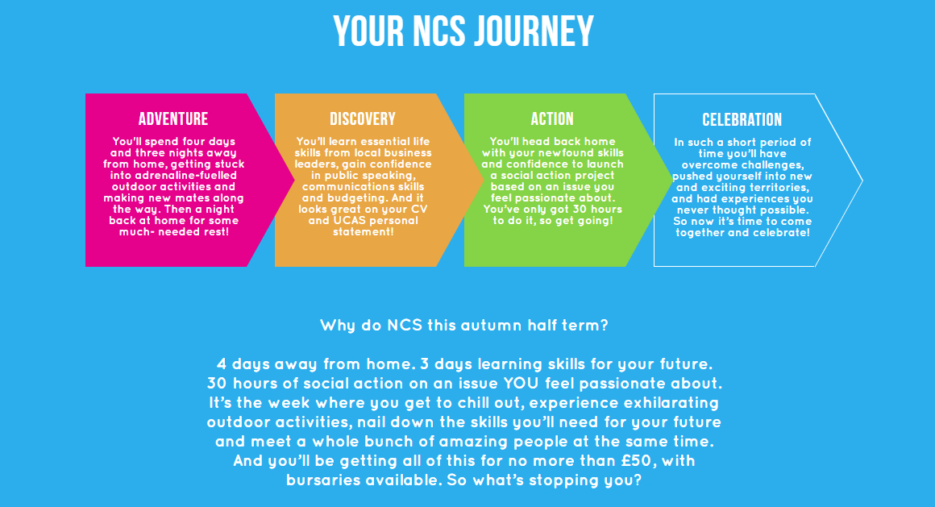
Year 12 Information Evening – Change of Arrangements
The above evening was scheduled to take place on Tuesday 3nd October from 6.00pm – 7.00pm on our Upper School Campus. This will now be replaced with a series of parental ‘drop in’ sessions where parents with specific questions / concerns can meet with Mrs Johnson to discuss these on a one to one basis (schedule to follow). We do hope you will find these of use.
Year 12 & 13 Folders
This week is ‘Folder Focus Week’. All students should have a folder for each subject that they study (as a minimum). These should contain 3 folder checksheets at the front (these can be found in both the sixth form common room and study room) and all work should be kept in an orderly fashion, using dividers to separate topics / homework / exam papers, etc.

Year 12 & 13 Intervention Programme

Our weekly intervention programme for students in Year’s 12 and 13 can be found below:

 | Monday | Tuesday | Wednesday | Thursday | Friday
Morning |  |  |  | Year 13 Psychology  TRT (L1) 8.00 – 8.30am | Dance  KB Week 2 P1 & 2  (Upper Campus DS)
Lunch |  | Year 12 & 13 Science Drop In  Science Office | Year 12 & 13 Science Drop In  Science Office | Year 12 & 13 Science Drop In  Science Office | Year 13 History  CF Week 2 (MN4)
After  school | GCSE Maths Re-sit  MS (C8)  3.15 – 4.30pm | English Lang / Lit  Week 1 JEV (C2) | English Lang / Lit  Week 2 JEV (C2) | Year 13 Maths  Week 1 PN (C10)  Week 2 KCL (C11) | Year 13 Music  (Middle Campus SM1/2)
After  school |  | Year 13 Biology  KD (D14) | BTEC Business  MTO (C4)  3.00-4.00pm | Year 13 Media Studies  PPE (A1) | Dance  (Upper Campus DS)
After  school |  | GCSE Maths Re-sit  MS (C8)  3.15pm – 5.00pm | Art  NT (A3)  3.00-4.00pm | Year 13 Applied Science  KD (D14) | Year 13 Drama  (Upper Campus M1)
 |  |  |  | GCSE English Re-sit  JEV (C2)  3.15pm – 4.30pm | Year 13Double CTEC Sport
Year 13 Psychology
TRT

- Year 13 Product Design – individual intervention has been arranged for each student and recorded on their timetable

- GCSE re-sit Maths & English – in addition to the publicised sessions above, individual intervention has been arranged for each student and recorded on their timetable

Year 12 University of Reading Scholars Programme

The Reading Scholars is the University of Reading's flagship widening participation programme for Year 12 students. Attending a series of three one-day activities and a three day residential, participating students choose one of ten subject strands to take part in. They will experience academic sessions within this strand, be mentored by one of our current students as well as receiving a range of information, advice and guidance sessions related to Higher Education.

The strands on offer are:

- Art and Design  - Business  - English Literature  - MFL (French, Spanish or German)  - History, Archaeology and Classics | - Biology  - Chemistry, Food Science and Pharmacy  - Mathematics  - Psychology  - Physical Geography and Environmental Science
All costs for participating students are covered - this includes transport to the university, all food and refreshments, and accommodation for the residential. Once they complete the programme, they are also able to take advantage of a guaranteed conditional offer or invite to interview should they apply to Reading. If they choose us as their first choice, they will receive a two grade drop on their offer for most courses, and can apply for a £1000 bursary once they start with us.

We have an excellent track record of supporting students from across the UK - last year we had participating students from as far afield as Aberdeen, Leeds and Brighton, and would encourage any interested student to apply no matter where they live, particularly if they had an interest in making an application to the University of Reading.

Comments received from last year’s cohort included:

'It really gave an insight into student life and I have now become more familiar to what a student life at university would look like' | 'It was truly amazing andwould 100% do it again if I had the opportunity' | 'Overall, I'm very very thankful to have been part of the programme, and I'm a lot less worried about going to university'

By clicking the links below, you are able to directly access the programme brochure and eligibility criteria - the programme is targeted at students who fall into the widening participation priority groups. Students are able to apply by completing the online application form found via the link below.

Further details of the programme can be found via the link below:
https://www.reading.ac.uk/web/files/ta/Reading_Scholars_2019.pdf?dm_i=4R68,1QLC,XWCKY,57MK,1

Eligibilty criteria:
https://www.reading.ac.uk/web/files/ta/Reading_Scholars_Selection_Criteria.pdf

Apply via the following link:
https://r1.dotmailer-surveys.com/f44r68cd-1338le2d?dm_i=4R68,1QLC,XWCKY,57ML,1

Year 13 UCAS

Students should be continuing to work on finalising their personal statements. Mrs Johnson and your tutors will be supporting you in making your application to University between now and the deadline date of 15th January 2019.

Please visit the UCAS website for additional support in writing your personal statement (link below):

https://www.ucas.com/undergraduate/applying-university/how-write-ucas-undergraduate-personal-statement

You should also be in the process of selecting your final five university places – you must book open days as a matter of urgency or this may result in a delay in your application being sent. Please email j.allingham@barnwell.herts.sch.uk if you are attending an open day during school time. Your registers will be updated accordingly.



Interested in Studying at a University in the USA?

USA College Day 2018 – Friday 28th September, 2018 (4.30 7.30pm) & Saturday 29th September (10.30am – 3.00pm).
USA College Day is the largest US University fair in Europe. The 41st year of College Day will see over 150 US universities exhibit at this free-to-attend event for prospective undergraduates and parents.
Please click on link below for event programme:
https://fulbrightcommission.sharepoint.com/advising/events/CD%202018/Forms/AllItems.aspx?id=%2Fadvising%2Fevents%2FCD%202018%2FWebsite%2FFor%20sharing%20with%20public%2FCollege%20Day%20Programme%20no%20printers%20marks%2Epdf&parent=%2Fadvising%2Fevents%2FCD%202018%2FWebsite%2FFor%20sharing%20with%20public&p=true&slrid=307e919e-80fd-7000-b95e-d7e2cf502b75

To register, please use the following link:

http://www.fulbright.org.uk/events/usa-college-day-2018

Profutsal London Ladies - Recruiting Now!


Futsal is an exciting, fast-paced small sided football game that originated from South America in the 1930s. The nature of the game places a large emphasis on technical skill and ability in situations of high pressure and is subsequently an excellent breeding ground for football competencies that can be translated into the 11-a-side format of the game.

The club's ethos is based around continuous learning and development and we want to keep building as a club. We finished third in the league last year and want to improve on that this year.

We play in the FA National Futsal League South division and will be holding open training sessions for the next four weeks (starting on the 20th of September), so anyone who is interested is welcome to come and try it out!

If you have any questions or need any more information, please contact the club administrator, Lara, using the details on the poster.

Forthcoming Important Dates

Year 12 EPQ Information – Monday 24th September 2018, 1.30 -2.30pm Sixth Form Common Room

Year 12 Learn 2 Live Event – Tuesday 25th September, 2018 10.00am – 12.30pm, Gordon Craig Theatre, Stevenage
McMillan Coffee Morning – Friday 28th September 2018
Year 12 Parents ‘Drop In’ week– commences Monday 2nd October 2018 (times tbc)
Post 16 Contact Details
Mrs Jackie Johnson j.johnson@barnwell.herts.sch.uk 01438 222500
Mrs Maria Chapman m.chapman@barnwell.herts.sch.uk 01438 744411

SCHOOL ABSENCE LINE 01438 744416

