Barnwell School Admission Arrangements for 2020/21
Barnwell School has a published admission number of 270.
Section 324 of the Education Act 1996 requires the governing bodies of all maintained schools to admit a child with an Education, Health and Care Plan (EHP) that names the school.
If there are fewer applications than places available at a school all applicants will be admitted. If there are more applications than places available, the criteria outlined below will be used to prioritise applications.

Oversubscription criteria
Rule 1 Children looked after and children who were looked after, but ceased to be so because they were adopted (or became subject to a child arrangement order or a special guardianship order).
Rule 2 Medical or Social: Children for whom it can be demonstrated that they have a particular medical or social need to go to the school.
A panel of HCC officers will determine whether the evidence provided is sufficiently compelling to meet the requirements for this rule. The evidence must relate specifically to the school applied for under Rule 2 and must clearly demonstrate why it is the only school that can meet the child’s needs.
Rule 3 Sibling: Children who have a sibling at the school at the time of application, unless the sibling is in the last year of the normal age-range of the school. Note: the ‘normal age range’ is the designated range for which the school provides, for example Years 7 to 11 in a 11-16 secondary school, Years 7 to 13 in a 11-18 school.
Rule 4 Children who live in the priority area for whom it is their nearest Hertfordshire maintained school or academy that is non-faith, co-educational and nonpartially selective. Note: Non-partially selective means that the school does not offer any places based on academic ability.
Rule 5 Children who live in the priority area who live nearest to the school (priority area 5).
Rule 6 Children living outside the priority area on the basis of distance, with those living nearest to the school given priority.
These rules are applied in the order they are printed above. If more children qualify under a particular rule than there are places available, a tiebreak will be used by applying the next rule to those children.
Please refer to Annex 1 for further details and definitions for Barnwell Schools admissions arrangements.
Tie break: Where there is a need for a tie-breaker where two different addresses measure the same distance from a school, in the case of a block of flats for example the lower door number will be deemed nearest as logically this will be on the ground floor and therefore closer. If there are two identical addresses of separate applicants, the tie break will be random.

Every child entered onto the HCC admissions database has an individual random number assigned, between 1 and 1 million, against each preference school. When there is a need for a final tie break the random number is used to allocate the place, with the lowest number given priority.

Priority Areas
The co-educational priority areas in the admission rules for Stevenage are based on the following parishes/unparished areas. These apply to Rules 4 and 5. Academies and foundation schools that will be retaining the county’s priority areas as part of their admission arrangements for 2020/21 have been included for information but are marked with an asterix*

5 | Stevenage | Aston, Benington, Datchworth, Graveley, Great Ashby, Knebworth, Stevenage, Walkern. | Barclay, Barnwell*,  Marriotts, Nobel*,  Thomas Alleyne*

Barnwell School will use the same definitions and measuring system as outlined in Hertfordshire County Council’s admissions literature, “Moving On”. A ‘straight line’ distance measurement is used in all home to school distance measurements. Distances are measured using a computerised mapping system to two decimal places. The measurement is taken from the AddressBase Premium address point of your child’s house to the address point of the school. AddressBase Premium data is a nationally recognised method of identifying the location of schools and individual residences. (Please note a further definition appears in the ‘Explanatory Notes’ which should be removed).

Appeals
At transfer time parents wishing to appeal who applied on line should log into their online application and click on the link 'register an appeal'. For those who did not apply on line, please contact the Customer Service Centre on 0300 123 4043 to request an appeal pack.

For in-year applications parents wishing to appeal should contact the Barnwell School directly in the first instance.

Continuing Interest
After places have been offered, the school’s continuing interest (waiting) list will be maintained by Hertfordshire County Council. A child’s position on the CI list will be determined by the admission criteria outlined above and a child’s place on the list can change as other children join or leave it. The county council, on behalf of the school’s governing body, will contact parents/carers if a vacancy becomes available and it can be offered to a child. Continuing interest lists will be maintained for every year group until the summer term (date to be confirmed). To retain a CI application after this time, parents must make an In Year application.

Appeal at Transfer
Parents wishing to appeal who applied through Hertfordshire’s online system should log in to their online application and click on the link “register an appeal”. Out of county residents and paper applicants should call the Customer Service Centre on 0300 123 4043 to request their registration details and log into www.hertfordshire.gov.uk/schoolappeals and click on the link “log into the appeals system”.

In Year Admissions
Barnwell School will remain part of the county council’s coordinated In Year admissions scheme. Parents can access all the necessary information at www.hertfordshire.gov.uk/admissions
Application forms can be accessed via www.hertfordshire.gov.uk or from the Customer Service Centre, 0300 123 4043. Parents should return the application form direct to Herts County Council (address on the form).

Following an application the county council will write to you with the outcome of your application and, if you have been unsuccessful, will include registration details to enable you to login and appeal online at www.hertfordshire.gov.uk/schoolappeals”

Fair Access
Barnwell School participates in the county council’s Fair Access protocol and will admit children under this protocol before children on continuing interest and over the Published Admission Number if necessary.

All admissions to Barnwell School are managed and decided through Hertfordshire County Council on behalf of the Governing Board of the School. All necessary information on how to make an application is found at www.hertfordshire.gov.uk/admissions

Date of birth | 01/09/2008 – 31/08/2009
School start date | September 2020
Applications open | 01 September 2019
Closing date for online applications to be submitted to the LA | 31 October 2019
Statutory deadline for receipt of paper applications | 31 October 2019
Allocation information despatched to parents | 02 March 2020
Date by which parents/carers may accept or reject place offered | 16 March 2020
Date by which parents/carers return appeal forms | March 2020  (Exact date TBC)

Sixth form arrangements

Minimum entry requirements:

Barnwell School has an inclusive Sixth Form, with entry criteria set on a subject by subject basis. These criteria are updated annually to reflect any changes in the demands of new syllabuses and are publicised on the school’s website.

We offer both Level 2 and Level 3 qualifications.

Each subject offered has its own entry requirements, so please refer to the Barnwell School website, Sixth Form page for details of the entry criteria for each subject and on how to apply to Barnwell Sixth Form. https://www.barnwellschool.co.uk/

If the school is oversubscribed, priority will first be given to: i) Children looked after or previously looked after
ii) Students in Priority Area 5. The Tie-break rule will be applied if there is a need to differentiate between students in Priority Area 5.

Admission to the Sixth Form:
The capacity for Year 12 is 150. Priority will be given to students already at the school. All internal students who meet the criteria are eligible for a place in the Sixth Form. Barnwell Schools will admit external students to its Sixth Form. A minimum of 30 places will be offered annually to external candidates who apply to the Sixth Form. Applications are made directly to the Sixth form, and details of how to apply are included on the Schools website.

Annex 1

Explanatory notes and definitions for the admission arrangements for Barnwell School for 2020/21

The following definitions apply to terms used in the admissions criteria:

Rule 1: Children looked after and children who were previously looked after, but ceased to be so because they were adopted (or became subject to a child arrangements order¹ or a special guardianship order²)

Places are allocated to children in public care according to Chapter 7, Section 2 of the School Admissions (Admission Arrangements and Co-ordination of Admission Arrangements) (England) Regulations 2012.
These children will be prioritised under rule 1.
Highest priority will also be given to children who were looked after, but ceased to be so because they were adopted, or became subject to a child arrangements order or a special guardianship order.
A “child looked after” is a child who is:
- in the care of a local authority, or
- being provided with accommodation by a local authority in the exercise of their social services functions (section 22(1) of The Children Act 1989)
All children adopted from care who are of compulsory school age are eligible for admission under rule 1.³
Children in the process of being placed for adoption are classified by law as children looked after providing there is a Placement Order and the application would be prioritised under Rule 1.
Children who were not “looked after” immediately before being adopted or made the subject of a child arrangement order or special guardianship order, will not be prioritised under rule 1. Applications made for these children, with suitable supporting professional evidence, can be considered under rule 2.
¹ Child arrangements order
Under the provisions of the Children and Families Act 2014, which amended section 8 of the Children Act 1989, residence orders have now been replaced by child arrangements orders which settle the arrangements to be made as to the person with whom the child is to live.
² Special guardianship order
Under 14A of The Children Act 1989, an order appointing one or more individuals to be a child’s special guardian or guardians.
³ This definition has been amended in accordance with paragraph 1.7 (footnote 17) of the School Admissions Code that came into force on 19 December 2014.

Rule 2: Children for whom it can be demonstrated that they have a particular medical or social need to go to the school

Rule 2 applications will only be considered at the time of the initial application, unless there has been a significant and exceptional change of circumstances within the family since the initial application was submitted.

All schools in Hertfordshire have experience in dealing with children with diverse social and medical needs. However, in a few very exceptional cases, there are reasons why a child has to go to one specific school.
Few applications under Rule 2 are agreed.
Applications for children adopted but previously looked after abroad will be considered under this rule and accepted if the child’s previously looked after status and adoption is confirmed. Hertfordshire’s “Virtual School” will be asked to verify all such applications.

All applications are considered individually but a successful application should include the following:
- Evidence that the child was previously cared for by the state abroad because he or she would not otherwise have been cared for
adequately and has been subsequently adopted OR
- Specific recent professional evidence that justifies why only one school can meet a child’s individual needs, and/or
- Professional evidence that outlines exceptional family circumstances making clear why only one school can meet the child’s needs.
- If the requested school is not the nearest school to the child’s home address clear reasons why the nearest school is not appropriate.
- For medical cases – a clear explanation of why the child’s severity of illness or disability makes attendance at only a specific school essential.
Evidence should make clear why only one school is appropriate. A Rule 2 application will generally not be upheld in cases where more than one school could meet the child’s need. In exceptional cases relating to a disability, where more than one school in the county can meet the child’s specific needs, a clear and compelling case can be made for the “nearest” school with the relevant facilities, environment or location. You must clearly explain why attendance at the “nearest” school with these facilities is essential.
Applications under Rule 2 can only be considered when supported by a recent letter from a professional involved with the child or family, for example a doctor, psychologist or police officer. The supporting evidence needs to demonstrate why only one named school can meet the social/medical needs of the child.
Applications for children previously “looked after” but not meeting the specific criteria outlined in Rule 1, may be made under this rule.

Definition of sibling

For applications to Barnwell School, a sibling is defined as: the sister, brother, half brother or sister, adopted brother or sister, child of the parent/carer or partner or a child looked after or previously looked after¹ and in every case living permanently² in a placement within the home as part of the family household from Monday to Friday at the time of this application.
A sibling must be on the roll of the named school at the time the younger child starts or have been offered and accepted a place.
If a place is obtained for an older child using fraudulent information, there will be no sibling connection available to subsequent children from that family.
¹ Children previously looked after are those children adopted or with a special guardianship order or child arrangements order. This definition was amended following a determination by the OSA in August 2014. ² A sibling link will not be recognised for children living temporarily in the same house, for example a child who usually lives with one parent but has temporarily moved or a looked after child in a respite placement or very short term or bridging foster placement.

Multiple births

Barnwell School, as the admission authority will admit over the school’s published admission number when a single twin/multiple birth child is allocated the last place at a school.

Home address

The address provided must be the child’s current permanent address at the time of application. “At the time of application” means the closing date for applications. “Permanent” means that the child has lived at that address for at least a year and/or the family own the property or have a tenancy agreement for a minimum of 12 months.

The application can only be processed using one address. If a child lives at more than one address (for example due to a separation) the address used will be the one which the child lives at for the majority of the time. If a child lives at two addresses equally, the address of the parent/carer that claims Child Benefit/Child Tax Credit will be considered as the child’s main residence.
If a family is not in receipt of Child Benefit/Tax Credit alternative documentation will be requested.
If a child’s residence is in dispute, parents/carers should provide court documentation to evidence the address that should be used for admission allocation purposes. If two different applications are received for the same child from the same address, e.g.
containing different preferences, the application from the parent in receipt of child benefit will be processed if the applications cannot be reconciled.

Fraudulent applications

Barnwell School and Hertfordshire County Council will do as much as possible to prevent applications being made from fraudulent addresses, including referring cases to the Shared Anti-Fraud service for further investigation as necessary.
Address evidence is frequently requested, monitored and checked and school places will be withdrawn when false information is deliberately provided. Hertfordshire County Council will take action in the following circumstances:
- When a child’s application address does not match the address of that child at their current school;

- When a child lives at a different address to the applicant;

- When the applicant does not have parental responsibility;

- When a family move shortly after the closing date of applications when one or more of the following applies:

ο The family has moved to a property from which their application was less likely to be successful;
ο The family has returned to an existing property;
ο The family lived in rented accommodation for a short period of time (anything less than a year) over the application period;
ο Official/public records show an alternative address at the time of the application
- When a child starts at the allocated school and their address is different from the address used at the time of application.

Parents/carers will need to show that they have relinquished residency ties with their previous property and they, and their child(ren) are permanently residing at the address given on the application form.

Definition of “nearest school” for Barnwell School admissions

For Barnwell School, the “nearest school” definition for rule 4 is “the nearest Hertfordshire maintained school or academy that is non-faith, co-educational, and non-partially selective”.
Note – non-partially selective means that the school does not offer any places based on academic ability.

Coeducational schools/academies which select partially on ability are:
- Dame Alice Owen’s School
- Parmiter’s School
- Queens’ School
- Rickmansworth School
- St Clement Danes School

Applications from children* from overseas

All children of compulsory school age (5 to 16 years) in England have a right of access to education. However, where a child is in England for a short period only, for example less than half a term, it may be reasonable to refuse admission to a school.
An application for a school place will only be accepted for such children currently overseas if, for In Year applications, proof is provided that the child will be resident in Hertfordshire within two weeks. In Year allocations are made on the assumption that the child will accept the school place and be on roll within that timescale.
For the Secondary transfer processes, applications will not normally be accepted from, nor places allocated to, an overseas address. The exception to this (for both In Year and transfer processes) is for children of UK service personnel and crown servants (and from military families who are residents of countries with a Memorandum of Understanding with the UK). In these cases Barnwell School will allocate a place in advance of the family arriving in the area provided the application is accompanied by an official letter that declares a relocation date and a HCC Unit postal address or quartering area address, for consideration of the application against oversubscription criteria.
Applications will also be considered, and places offered in advance for these families, if the application is accompanied by an official letter that declares a relocation date but does not provide a quartering or unit address because the family will be residing in private accommodation. In these cases, if the family does not already have a permanent private address in Hertfordshire, the military base or alternative “work” address in Hertfordshire will be used for allocation purposes. If the family already has an established alternative private address, that address will be used for admission purposes.
Barnwell School will also consider accepting applications from children* whose family can evidence intent to return to and/or permanently reside in Hertfordshire prior to the start of the new academic year. These applications, if accepted, will be processed from the overseas address until sufficient evidence is received to show the child is permanently resident in Hertfordshire. Evidence must be submitted at the time of application.
Evidence submitted after the date for late applications (4 December 2019 for secondary transfer) cannot be taken into account before National Allocation Day. Decisions on these applications will be made by a panel of senior officers and communicated with parents within 6 weeks of the closing date for applications.
If an applicant owns a property in Hertfordshire but is not living in it, perhaps because they are working abroad at the time of application, the Hertfordshire address will not be accepted for the purposes of admission until the child is resident at that address.
Other children, than those mentioned above, from overseas do not generally have automatic right of entry to the UK. An application for a school place will not therefore be accepted until they are permanently resident in Hertfordshire. Proof of residency such as an endorsed passport or entry visa will be required with the application, in addition to proof of Hertfordshire address, for example a council tax bill or 12 month rental agreement. *Children who hold full British Citizen passports (not British Dependent Territories or British Overseas passports), or have a UK passport describing them as a British citizen or British subject with the right of abode or are European Economic Area nationals normally have unrestricted entry to the UK.

Children Out of Year Group

Barnwell Schools policy is for children to be educated within their correct chronological year group, with the curriculum differentiated as necessary to meet the needs of individual children. This is in line with DfE guidance which states that “in general, children should be educated in their normal age group”.
If parents/carers believe their child(ren) should be educated in a different year group they should, at the time of application, submit supporting evidence from relevant professionals working with the child and family stating why the child must be placed outside their normal age appropriate cohort. DfE guidance makes clear that “it is reasonable for admission authorities to expect parents to provide them with information in support of their request – since without it they are unlikely to be able to make a decision on the basis of the circumstances of the case”.
The governing body of schools responsible for their own admissions (academies, voluntary aided and foundation schools) are ultimately responsible for making this decision for applications made to their school.

Please complete and return this application to the Sixth Form Office by Monday 14th September 2020

Name:

Contact Address:
Postcode:
Date of Birth:
Present School:
Home Telephone No.:
Student Mobile Number:
Parent Mobile Number:
Additional Support Needs:
GSCE Subject: | Estimated Grade | GCSE Subject: | Estimated Grade

Please complete and return this application to the Sixth Form Office by Monday 14th September 2020

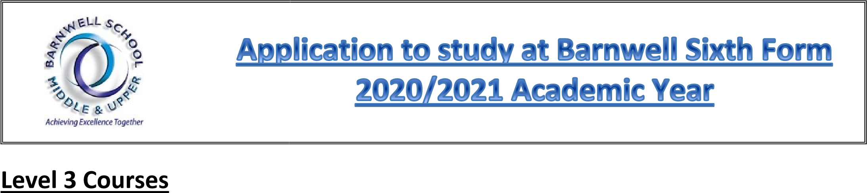
We aim to offer the courses listed below from September 2020. However, Barnwell School reserves the right to cancel, combine or move a course due to insufficient recruitment of students or staffing.

Entry Requirements

Please see Entry Requirement sheet at the back of this Application Form.

A LEVEL SUBJECTS BTEC SUBJECTS

 | L E V E L 3 O P T I O N S  2  YEAR PROGRAMME OF STUDY | Art & Design 3D (Product Design) | History | BTEC Applied Science
 |  | Art | Law | BTEC Business
 |  | Biology | Mathematics | BTEC Health & Social Care
 |  | Chemistry | Further Mathematics | BTEC I.T.
 |  | Computer Science | Media Studies | BTEC Music Technology
 |  | Dance | Photography | CTEC Sports
 |  | Drama & Theatre Studies | Psychology
 |  | Economics | Physics
 |  | English Literature | Sociology
 |  | English Literature & Language
 |  | Film Studies
 |  | French
 |  | Geography
 | Please complete and return this application to the Sixth Form Office by Monday 14th September 2020
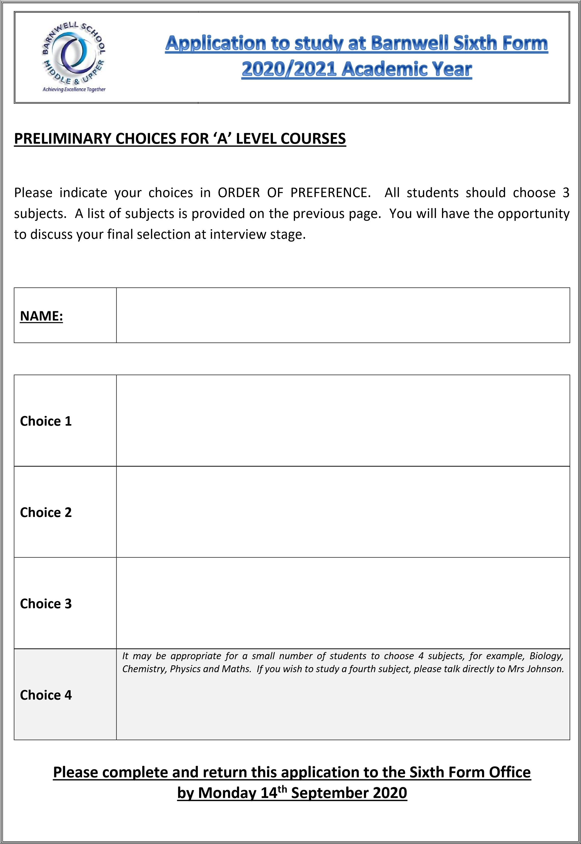
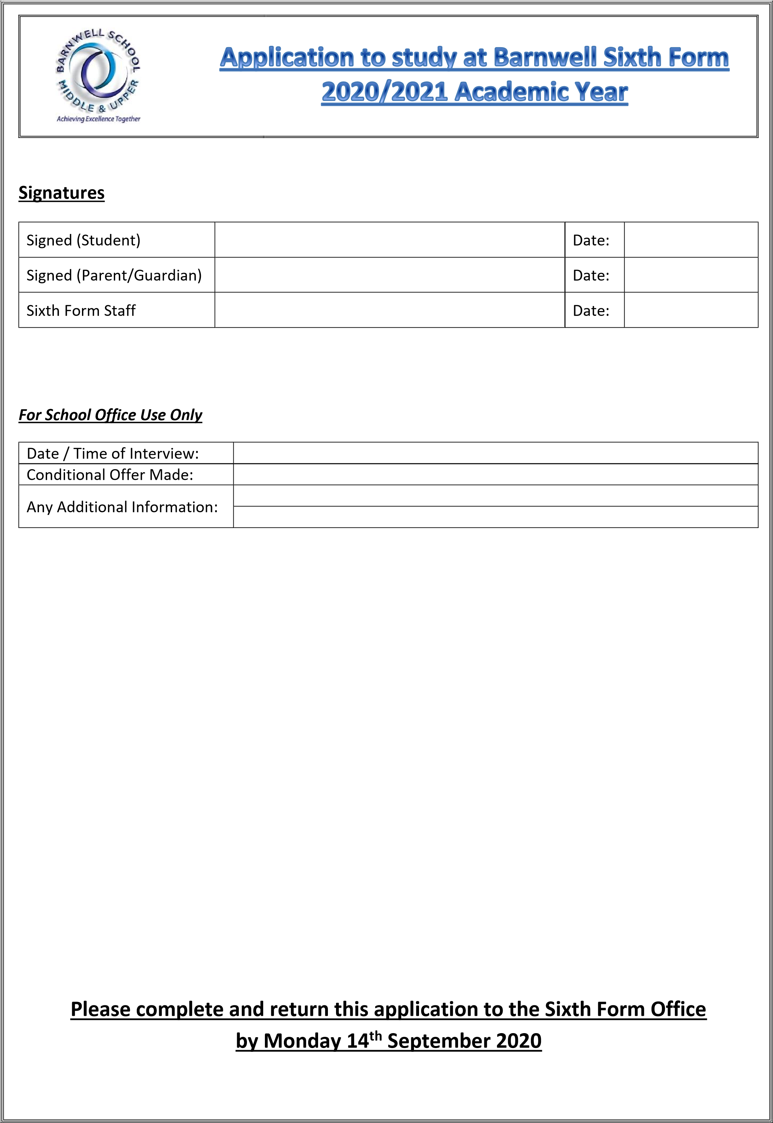

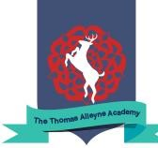
Barnwell School / Thomas Alleyne Academy
Sixth Form Entry Requirements

The entry criteria below are designed to ensure that students study courses which will allow them to be successful and realise their aspirations. However, prior to courses being finalised, we will always treat each application on an individual basis, taking into account any extenuating circumstances.

Academic Pathway Subjects
Students aspiring to study subjects listed in the Academic Pathway must meet the minimum average point score below, including a Grade 5 in English, and meet the individual subject entry criteria.
 | A Level Subjects | Min APS | Additional Entry Requirements
 | Biology | 5.6 | Grade 6 in Biology or Grade 7 in Core and Additional Science
 | Business | 5.0 | Grade 6 in Business if studied at GCSE
 | Chemistry | 5.6 | Grade 6 in Chemistry or Grade 7 in Core and Additional Science
 | Computer Science | 5.6 | Grade 6 in Computer Science if studied at GCSE
 | Economics | 5.6 | Grade 5 in Mathematics
 | English Language & Literature | 5.0 | Grade 5 in English Language or Literature
 | English Literature | 5.0 | Grade 6 in English Literature
 | French | 5.0 | Grade 6 in French
 | Geography | 5.0 | Grade 6 in Geography
 | German | 5.0 | Grade 6 in German
 | History | 5.0 | Grade 6 in History
 | Law | 5.0 | Grade 6 in English Lit / Lang
 | Mathematics | 5.6 | Grade 7 in Mathematics
 | Mathematics – Further | 5.6 | Grade 8 in Mathematics
 | Philosophy & Ethics | 5.0 | No additional entry criteria
 | Physics | 5.6 | Grade 6 in Mathematics.  Grade 6 in Physics or Grade 7 in Core and Additional Sci
 | Psychology | 5.0 | Grade 5 in Mathematics and Grade 5 in Core & Additional Sci
 | Sociology | 5.0 | Grade 6 in Sociology if taken at GCSE
 | Please note that these courses are subject to change as they are dependent on student uptake and staffing
Professional and Technical Pathway Subjects
Students aspiring to study subjects in the Professional/Technical Pathway must meet the minimum average point score below, including at least a Grade 4 in English, and must meet the individual subject entry criteria.
 | Subjects |  |  | Min  APS | Additional Entry Requirements
 | A level Art & Design, Art Graphics |  |  | 5.0 | Grade 6 in Art, Art Graphics or Art Textiles
 | A level Art Photography |  |  | 5.0 | Grade 6 in Art, teacher recommendation
 | A level Dance |  |  | 5.0 | Grade 6 in GCSE Dance if studied at GCSE
 | A level Drama & Theatre Studies |  |  | 5.0 | Grade 6 in GCSE Drama if studied at GCSE
 | A level Product Design |  |  | 5.0 | Grade 6 in GCSE Resistant Materials or Product Design
 | Applied Science |  |  | 4.0 | Grade 4 in Core & Additional Science
 | OCR Technical in Business (Single or Double) |  |  | 4.0 | Pass at Level 2 BTEC or a 4 in GCSE Business, if studied
 | BTEC Health & Social Care (Single or Double) |  |  | 4.0 | Level 2 Pass H&SC, if studied
 | BTEC Certificate IT (Single) |  |  | 4.0 | Grade 4 in GCSE Computing or Level 2 BTEC Merit if studied
 | Media Studies |  |  | 4.0 | No additional entry criteria

 | Film Studies | 4.0 | No additional entry criteria
 | L3 BTEC in Music Technology | 4.0 | No additional entry criteria
 | OCR Technical in Sport (Single or Double) | 4.0 | Merit at Level 2 BTEC, if studied
Please note that these courses are subject to change as they are dependent on student uptake and staffing
How to work out your Average Point Score (APS)
- For Barnwell / TAA Sixth Form your average points score (APS) is calculated using your best 6 grades
- Each grade is worth the number of points shown in the table below
- Add the 6 grades together and divide by 6
 |  |  |  | 9-1 Grade point values
Grade | 9 | 8 | 7 | 6 | 5 | 4 | 3 | 2 | 1
Points | 9 | 8 | 7 | 6 | 5 | 4 | 3 | 2 | 1

 |  |  | A*-G Grade point valu |  |  | es
Grade | A* | A | B | C | D | E | F | G
Points | 8.5 | 7 | 5.5 | 4 | 3 | 2 | 1.5 | 1

 |  | BTEC Grade point values
Grade | Dist* | Dist | Merit | Pass
Points | 8.5 | 7 | 5.5 | 4

Use the following to work out your Average Points Score (APS) for your best 6 subjects
Total points for best 6:
+_____ + _____+ ______+ _____+_____ = _______(Total)
Average points score:
(Total) ______÷ 6 =________ APS

Please complete and return this application to the Sixth Form Office by Monday 14th September 2020

