Barnwell Middle School
Shephall Green Stevenage Hertfordshire
SG2 9XT
Barnwell Upper School
Barnwell
Stevenage
Hertfordshire
SG2 9SW

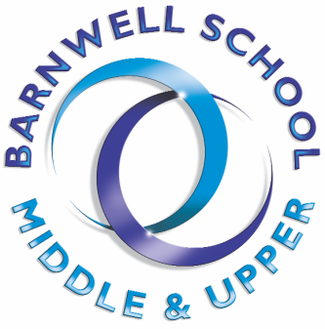

January 2022

Dear Parent/Carer

Year 11 Parents’ Evening - Wednesday 19 January 2022

I would like to invite you to attend our Year 11 Parents’ Evening on Wednesday 19 January 2022 from 4.00pm to 7.00pm. This is an important evening and provides you with an opportunity to participate in a video conferencing call with your child’s subject teachers to discuss your child’s progress. Due to current restrictions and social distancing measures the meetings will be held online via the online booking system.

The online booking system opens on Sunday 9 January at 7.00am and closes on Monday 17 January at 10.00pm. Please book your appointments early to avoid disappointment.

Please visit https://barnwell.parentseveningsystem.co.uk/ to book your appointments. A short guide on how to add your appointment has been attached with this email. To access the online booking system, you must login using the same information that we have on our school system, i.e. the same email address that was given to the school at the time of your child’s admission. If you experience any problems accessing the online booking system please contact the school as soon as possible.

Each appointment will last for 5 minutes, with the video call automatically timing out at the end of the allotted time. The time left for the appointment will display as a countdown on your screen. There is a very useful, short guide for parents explaining how to attend appointments over video call here for your information: https://support.parentseveningsystem.co.uk/article/801-video-parents-how-to-attend-appointments-over-video-call - a copy is also attached to this email for reference.

If you are unable to attend and would like feedback from a specific subject teacher, please email them directly. Staff contact details can be found via: Staff Contact Details

To make video calls you will need to have a device with a microphone and speaker and a compatible web browser. We recommend using a laptop or computer with a web cam or your smart phone with a front facing camera.

Compatible web browsers are:

- iPhone/iPad: Safari
- Android: Chrome or Firefox
- Windows: chrome, Firefox or Edge (latest version)
- Mac: Safari, Chrome or Firefox
If you are unable to make video calls, please email Mrs Collier at k.collier@barnwell.herts.sch.uk to request a telephone call with your child’s teachers.

Protocols for Online Meetings

These are the Barnwell School protocols for audio and audio/video live online meetings. It is essential that every student and parent/carer follows the protocols set out below:
- Parents/Carers must be present
- At no point, should any form of recording or photo of the meeting be taken
- Meetings should be held in a suitable environment and all parties should be suitably dressed to conduct the meeting
- At any point, if the teacher deems the meeting content or behaviour to be unsuitable, the meeting will be stopped and closed

We look forward to seeing you on Wednesday, 19 January 2022.

Yours faithfully

M Townsend

Miss Maria Townsend
Deputy Headteacher

