My top 5 barriers to good time management are

1

2

3

4

5

The subject (at the moment) I have the most work for is…….

The subject I am most concerned about is……

The study periods I have are…..

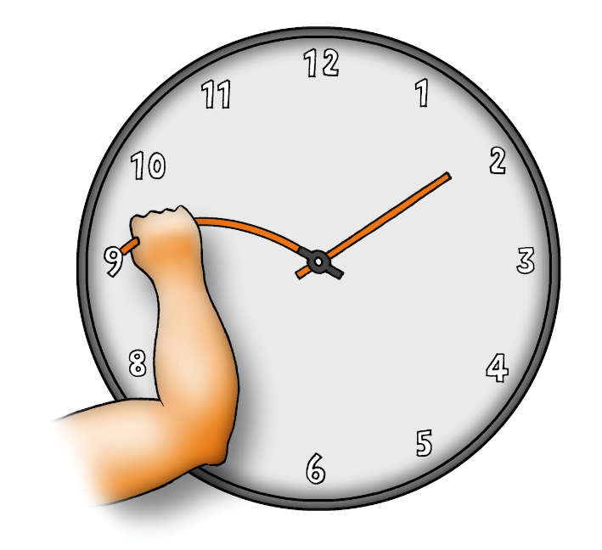

The time of day I am most productive is…….



I think the best **PLACE** for me to work is….

What am I going to do THIS week to make one change to improve my organisation and time management?