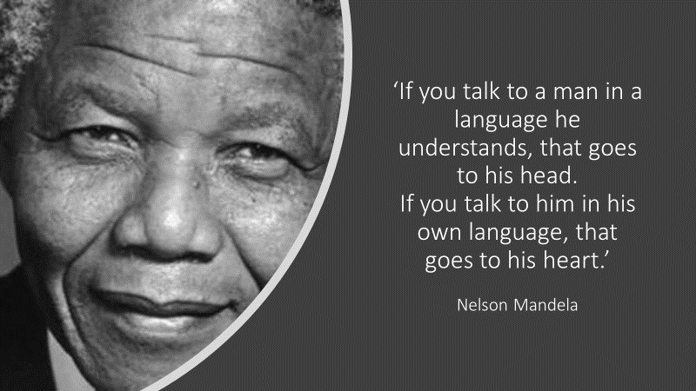
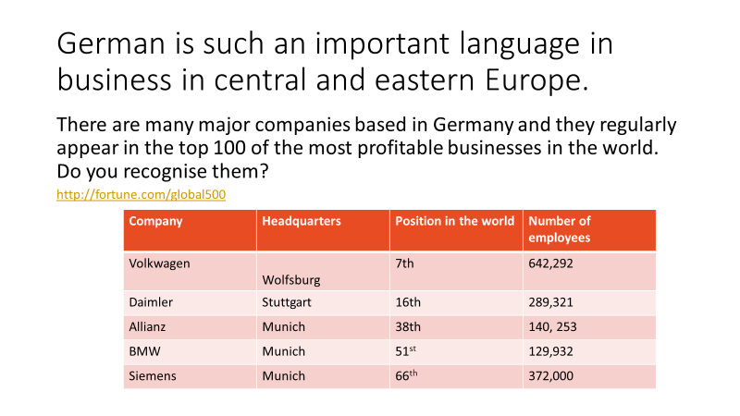
http://fortune.com/global500
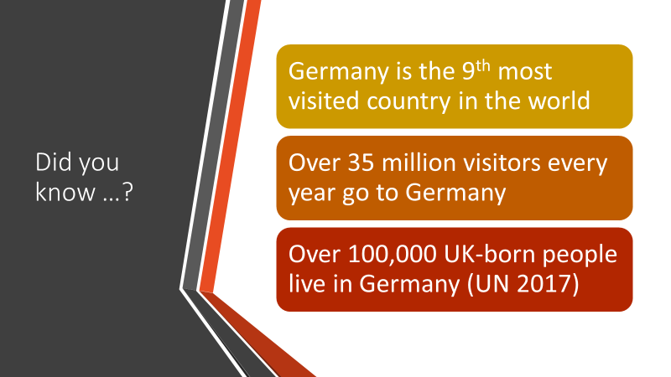
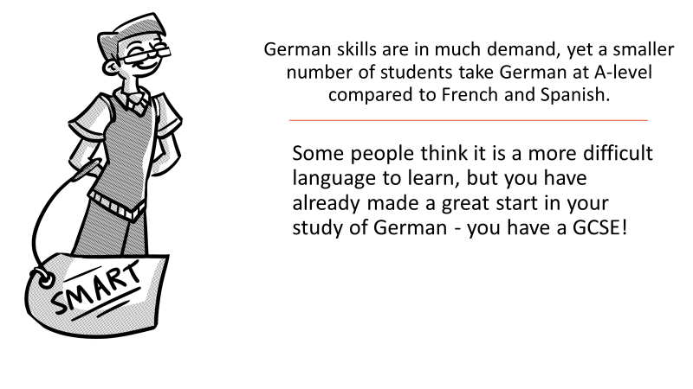
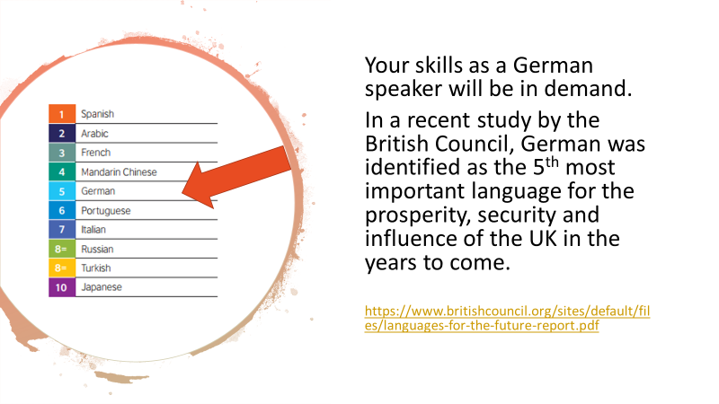
https://www.britishcouncil.org/sites/default/files/languages-for-the-future-report.pdf
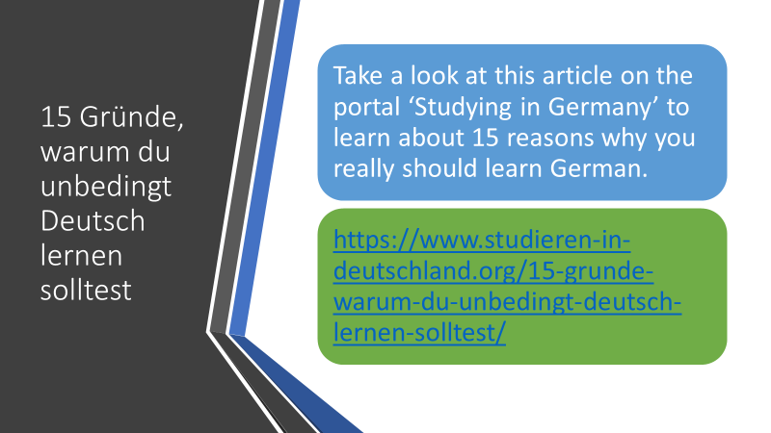
- https://www.studieren-in-deutschland.org/15-grunde-warum-du-unbedingt-deutsch-lernen-solltest/
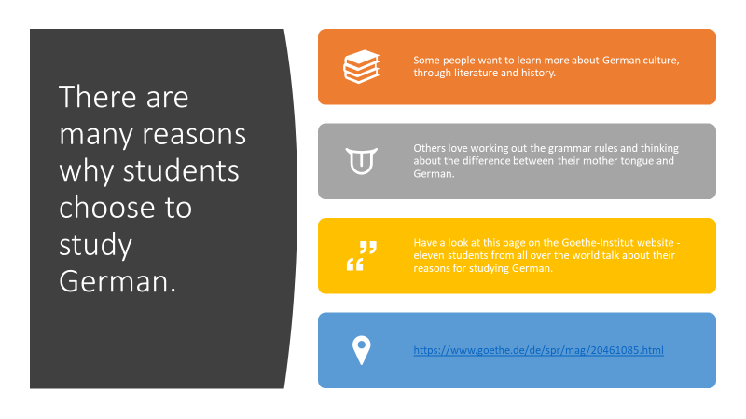
- https://www.goethe.de/de/spr/mag/20461085.html
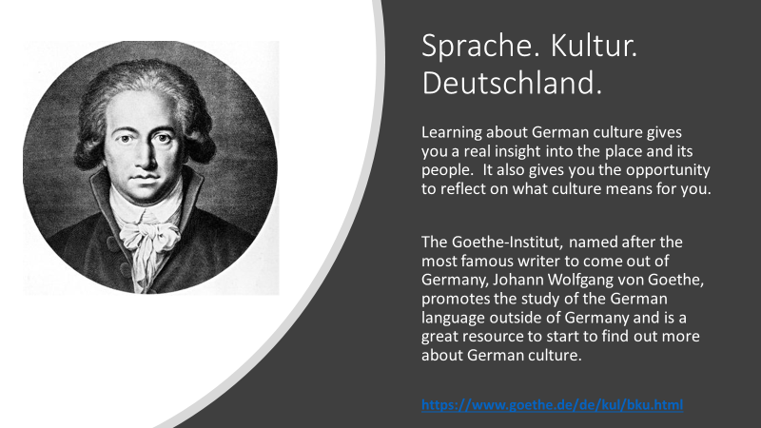
https://www.goethe.de/de/kul/bku.html
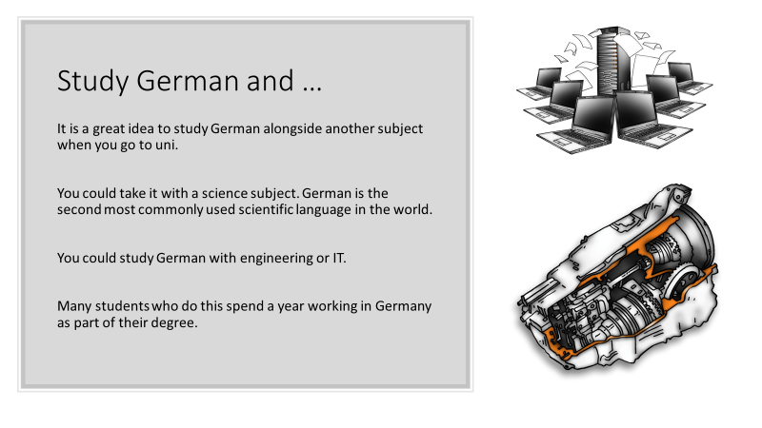
Listen to the short conversations on this webpage and guess the job!
https://www.goethe.de/de/spr/ueb/daa/all/br0/br1.html
INTERVIEW ZU ARBEITSZEITEN UND URLAUB IN DEUTSCHLAND
https://www.goethe.de/de/spr/ueb/daa/all/br0/br5.html
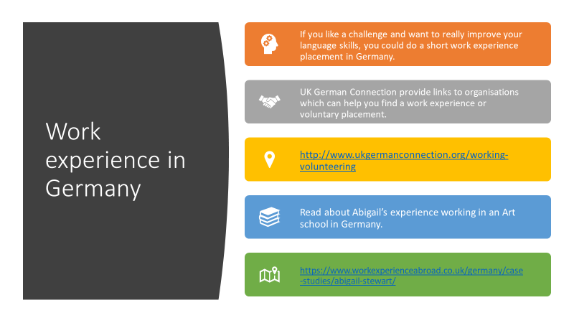
- http://www.ukgermanconnection.org/working-volunteering
- https://www.workexperienceabroad.co.uk/germany/case-studies/abigail-stewart/
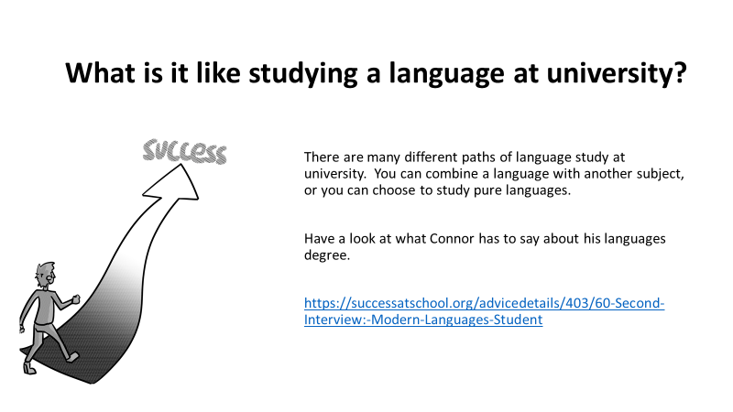
https://successatschool.org/advicedetails/403/60-Second-Interview:-Modern-Languages-Student
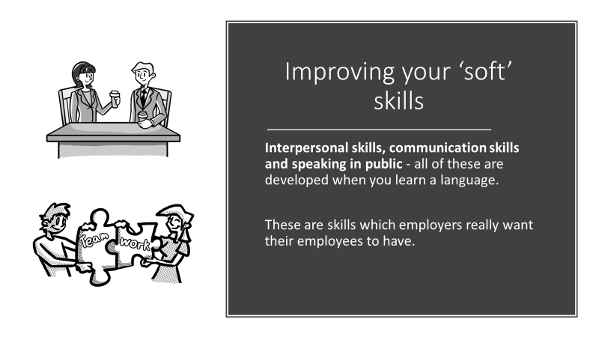
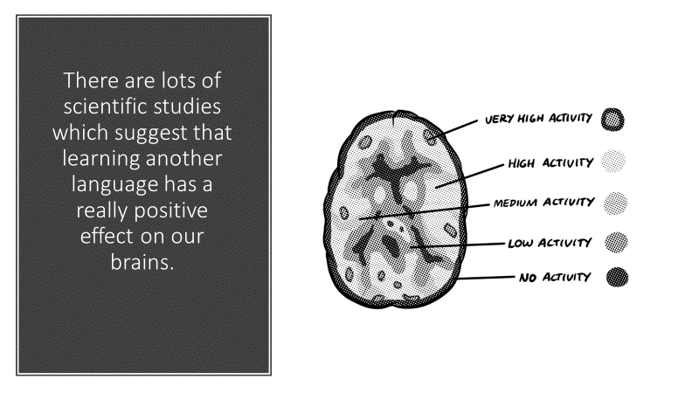
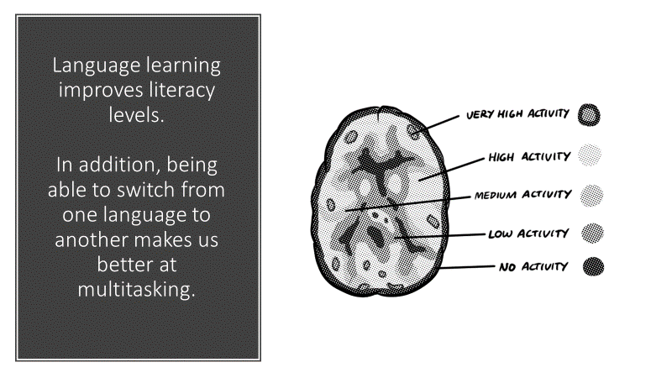
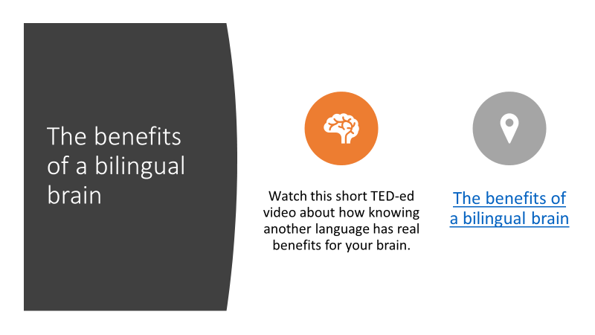
- The benefits of a bilingual brain
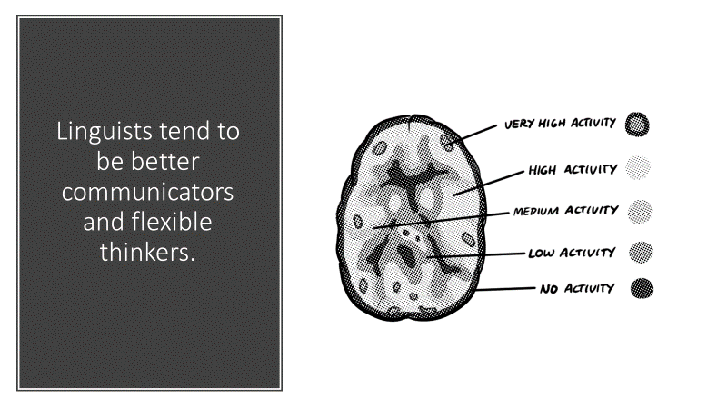
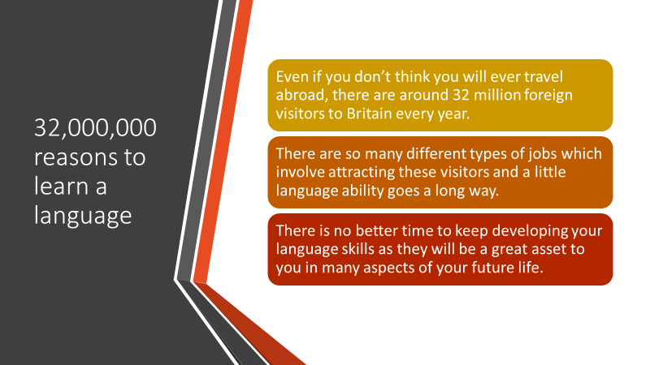
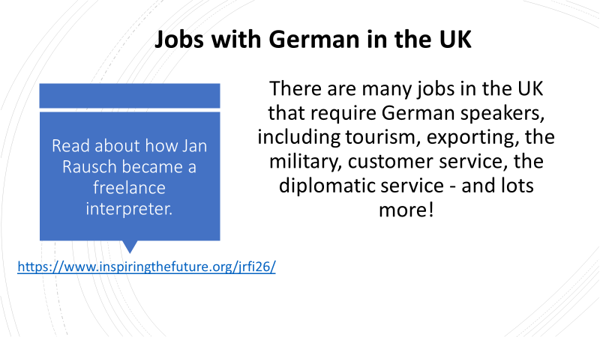
https://www.inspiringthefuture.org/jrfi26/
https://www.totaljobs.com/jobs/german?WT.mc_id=A_SE_Bing_TJ-GEN-DSA-Generic-NV_c_Jobs-Results-Page_/jobs_77515626805166_b_1240249148148478_dat-77515595364999:loc-188_
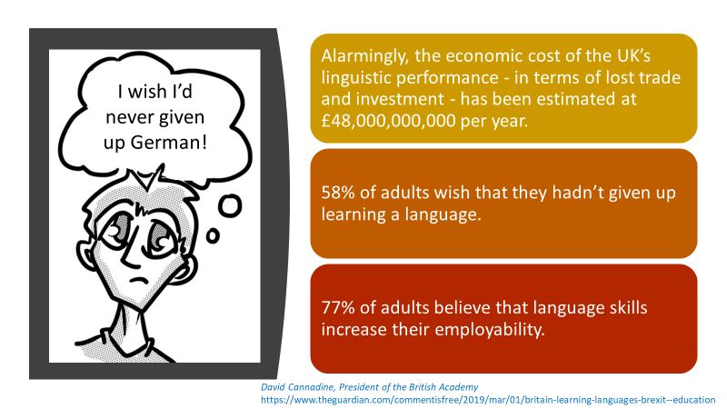
David Cannadine, President of the British Academy
https://www.theguardian.com/commentisfree/2019/mar/01/britain-learning-languages-brexit--education
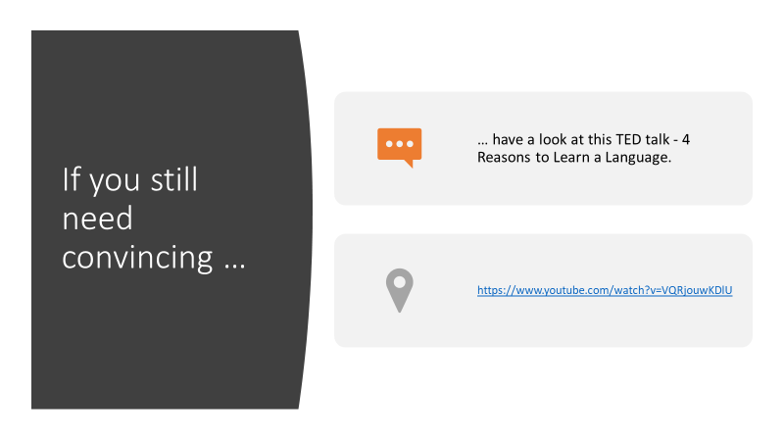
- https://www.youtube.com/watch?v=VQRjouwKDlU
