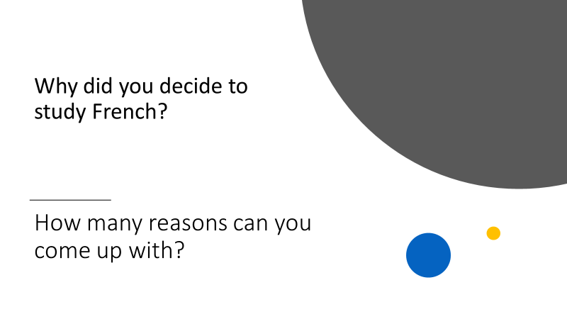
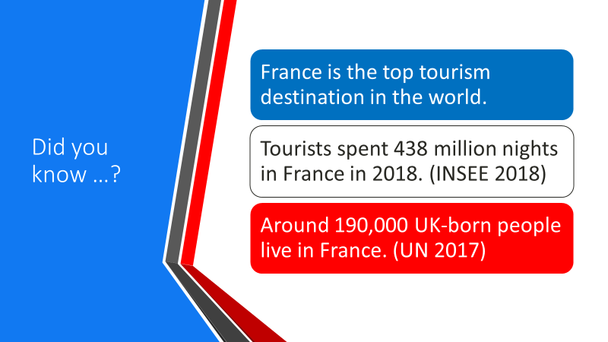
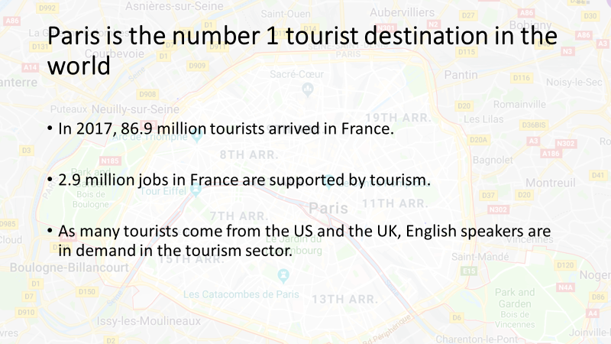
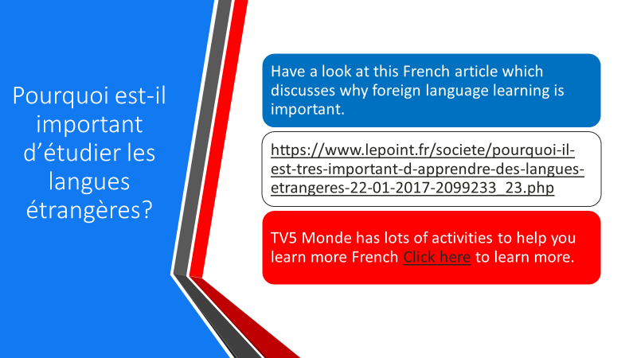
https://www.lepoint.fr/societe/pourquoi-il-est-tres-important-d-apprendre-des-langues-etrangeres-22-01-2017-2099233_23.php
https://langue-francaise.tv5monde.com/?utm_source=tv5monde&utm_medium=metanav&utm_campaign=langue-francaise
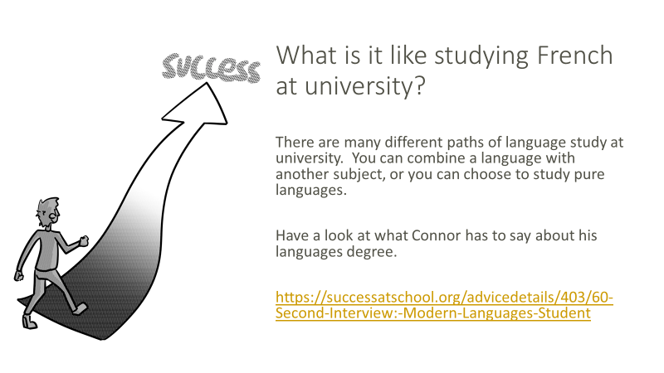
https://successatschool.org/advicedetails/403/60-Second-Interview:-Modern-Languages-Student
https://www.sorbonne-universite.fr/
https://successatschool.org/advicedetails/404/60-Second-Interview:-History-and-French-Student#
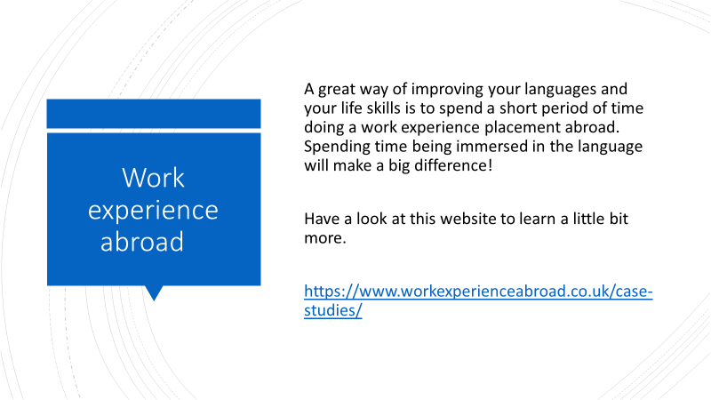
https://www.workexperienceabroad.co.uk/case-studies/
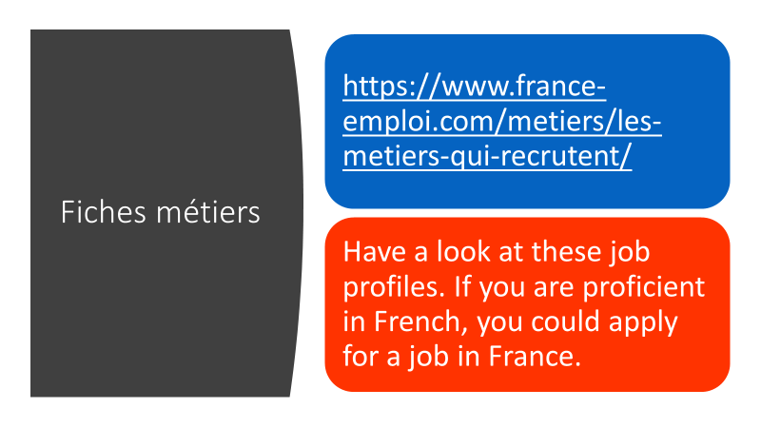
- https://www.france-emploi.com/metiers/les-metiers-qui-recrutent/
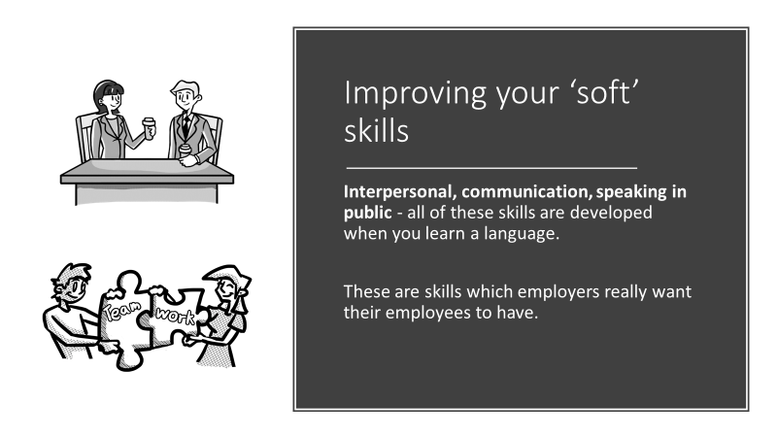
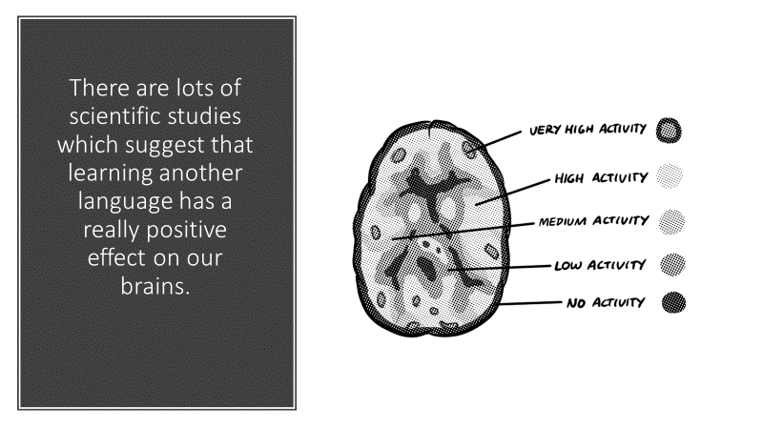
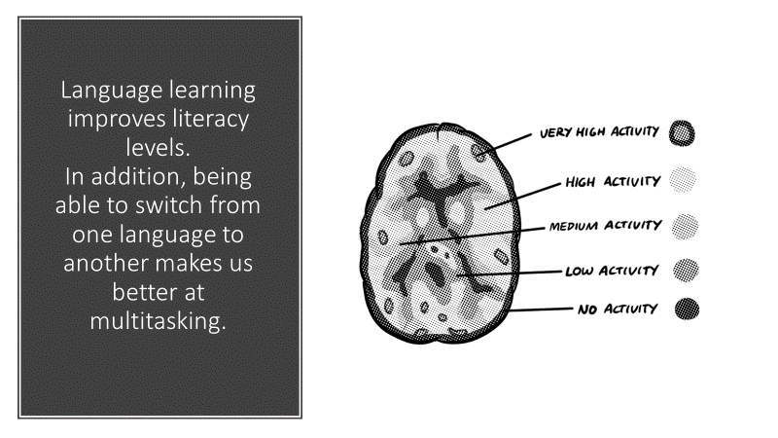
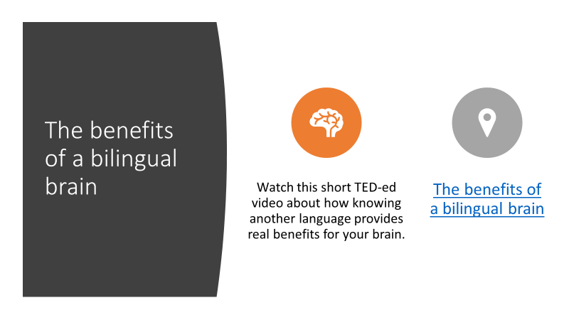
- The benefits of a bilingual brain
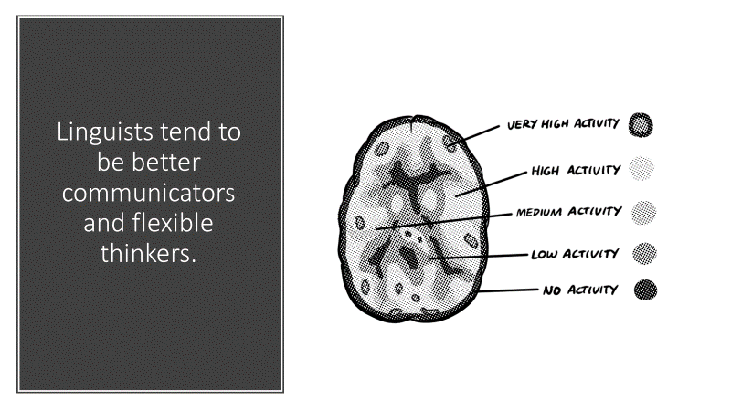
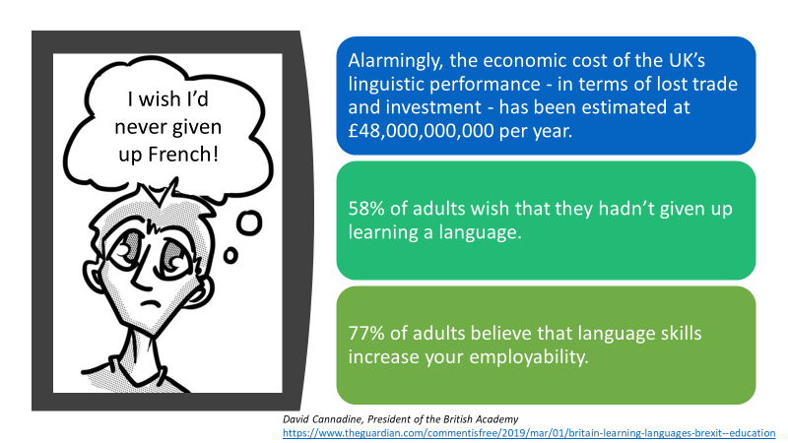
David Cannadine, President of the British Academy
https://www.theguardian.com/commentisfree/2019/mar/01/britain-learning-languages-brexit--education
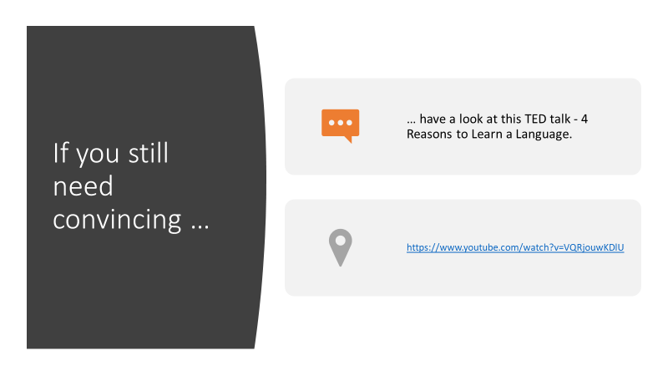
- https://www.youtube.com/watch?v=VQRjouwKDlU
