CRIMINOLOGY

AS LEVEL

INFORMATION PACK

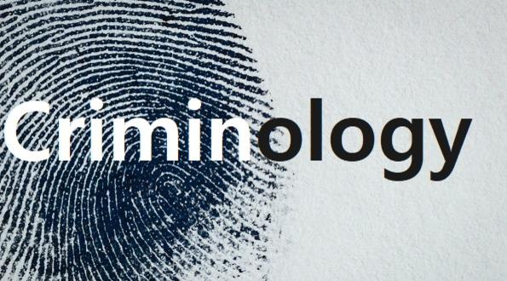

What is criminology?

Criminology is the scientific study of crime, including its causes, responses by law enforcement and methods of prevention.

It is a sub group of sociology which is the scientific study of social behaviour and society.
There are many fields of student that are used in the field of criminology including: anthropology, biology, economics, psychiatry, psychology and statistics.

Just as criminology is a sub-group of sociology criminology itself has several sub-groups which include:

- Bio-criminology – the student of the biological basis of criminal behaviour
- Criminalistics – the study of crime detection
- Feminist criminology – the study of women and crime
- Penology – the study of prisons and the prison systems.

The term crime refers to an individual criminal action (e.g. a burglary) and the response by society for the actions (e.g. a custodial prison sentence). By comparison the field of criminology includes and examines the broader knowledge about crime and criminals. Criminologists attempt to understand why some people are more likely to engage in criminal behaviour than others. Criminologists also attempt to explain differences in crime rates and the criminal code between society and the changes in rates of crime and laws in general over time. Some crimes that were once illegal have since been decriminalised whilst others have been criminalised. These are all areas dealt with under the bracket of criminology.

Course specifics:

This course is split into four sections:

UNIT | TITLE | INTERNAL | EXTERNAL
One | Changing awareness of crime | Yes
Two | Criminological Theories |  | Yes
Three | Crime Scene to Court Room | Yes
Four | Crime and Punishment |  | Yes

The nature of the course makes it synoptic ensuring everything that has been learnt during year 12 will be continued and expanded on in year 13.

Units 1 (year 12) and 3 (year 13) are internally moderated controlled assessment where learners are required to complete a timed piece of work under exam conditions. These are created from learner’s knowledge.

Unit 2 (year 12) and 4 (year 13) are external exam units. Exams take place in May each year. Exam papers are split into three sections of 25 marks each (75 marks in total). Exemplar material can be found on the WJEC website.
Unit 1: Changing Awareness of Crime

The purpose of this unit is for learners to plan campaigns for change relating to crime.

Not all types of crime are alike. What different types of crime take place in our society? What kinds of crime exist about which we know very little, or which are simply not reported to the police and the media? How do we explain people's reluctance to come forward about crimes of which they have been the victim? Some crimes which seem inoffensive, such as counterfeiting of designer goods, have actually been linked to the funding of more serious crime such as terrorism and people trafficking; so why do people turn a ‘blind eye’ to these 'mild' crimes? What methods have governments and other agencies used to raise social awareness of these crimes?

Many people learn about the fear and fascination of crime from the media, but is the media a reliable source of information? To what extent are we misled by our tastes in programmes and newspapers about crime? Who decides what behaviours should be against the law? Who gathers information about crime? Can this information be trusted? Can we trust our own instincts?

Humans tend to judge other's behaviour by a variety of moral principles, not all of which are consistent or based on accurate information. We gain our ideas of morality from a variety of sources and one of the most important is the mass media. Police gather information about crime; but the data can be inaccurate. Criminologists have developed procedures to learn about crime, but these too have their limitations.

Knowing about the wide range of different crimes and the reasons people have for not reporting such crimes will provide an understanding of the complexity of behaviours and the social implications of such crimes and criminality. At the end of this unit, you will have gained skills to differentiate between myth and reality when it comes to crime and to recognise that common representations may be misleading and inaccurate. You will have gained the skills to understand the importance of changing public perceptions of crime. You will be able to use and assess a variety of methods used by agencies to raise awareness of crime so that it can be tackled effectively. You will have gained the skills to plan a campaign for change in relation to crime; for example to raise awareness, change attitudes or change reporting behaviour.

Resources for Unit 1
Books
- Mirrlees-Black C et al The 1998 British Crime Survey: England and Wales (Home Office, 1998)
- Reiner (2002) Media Made Criminality Reiner, Robert and Maguire, Mike and Morgan, Rod, (eds.)
- The Oxford Handbook of Criminology. Oxford University Press, Oxford, UK, pp. 302-340. http://www.sociology.org.uk/as4mm4b.pdf
- Hobbs D (1995) Bad Business: Professional Crime in Modern Britain OUP
- Bowling B, Phillips C (2002) Racism, Crime and Justice (Longman Criminology Series)

Websites
Crime Statistics for England and Wales www.crimestatistics.org.uk
Crime Survey for England and Wales http://www.crimesurvey.co.uk BBC News story
http://news.bbc.co.uk/1/hi/uk/6224245.stm Glasgow Media Group
http://www.glasgowmediagroup.org

Journals
British Journal of Criminology
British Society of Criminology
Unit 2: Criminological Theories

The purpose of this unit is for learners to apply their understanding of the public perceptions of crime and campaigns for change studied in Unit 1 with criminological theories to examine how both are used to set policy. Unit introduction

How do we decide what behaviour is criminal? What is the difference between criminal behaviour and deviance? How do we explain why people commit crime? What makes someone a serial killer, or abusive to their own families? Criminologists have produced theoretical explanations of why people commit crime, but which is the most useful? Are these theories relevant to all types of crime? What can we learn from the strengths and weaknesses of each? How can these theories be applied to real life scenarios and real life crimes?

Knowing about the different types of crime and the criminological approaches to theory will give you a sharper insight into the kind of thinking used by experts and politicians to explain crime and criminality. Public law makers are informed by theory and apply these theories to their own solutions to the problem of crime. By undertaking this unit, you will learn to support, challenge and evaluate expert opinion and be able to support your ideas with reliable and factual evidence.

At the end of this unit you will have gained the skills to evaluate some criminological theories and know there are debates within the different theories. You will understand how changes in criminological theory have influenced policy. You will also have gained the skills to apply the theories to a specific crime or criminal in order to understand both the behaviour and the theory.

Resources for Unit 2

Books
- Wilson J Q and Herrnstein R J Crime & Human Nature: (1998) The Definitive Study of the Causes of Crime Free Press

- Muncie J and McLaughlin E (editors) (2001) The Problem of Crime Sage Publications Ltd

- Becker H S Outsiders: (1997) Studies in Sociology of Deviance Simon & Schuster Ltd

- Swale J (2007) Sociology of Crime & Deviance Philip Allan Updates

Websites
YouTube explanations of social views of crime:
http://www.youtube.com/watch?v=XU-nWtmXnKE

http://www.youtube.com/watch?v=r-UBjL1zlgM

Criminological Theory (Florida State University) www.criminology.fsu.edu

Psychology of crime http://www.holah.karoo.net/alevel/crime.htm

Blogs and articles on psychology of crime http://www.psychologytoday.com/topics/law-andcrime

Other resources
The Crime and Deviance Channel http://www.sociology.org.uk/cc_channel_subscriptions.htm

Unit 3: Crime Scene to Court Room

Through this unit, learners will develop the understanding and skills needed to examine information in order to review the justice of verdicts in criminal cases. Unit introduction

What are the roles of personnel involved when a crime is detected? What investigative techniques are available to investigators to help to identify the culprit? Do techniques differ depending on the type of crime being investigated? What happens to a suspect once charged by the police and the Crown Prosecution Service (CPS)? What safeguards are in place to ensure a suspect has a fair trial?

The criminal trial process involves many different people and agencies. Learning about the roles of these will give you a clearer insight into what happens once a crime is detected and the process that leads to either a guilty or non-guilty verdict. There are strict rules as to how evidence is collected from a crime scene and also strict rules governing the giving of evidence in court; learning about these rules will allow you to review the trial process and assess whether the aims of the criminal justice system have been met. You may be familiar with the role of the jury in the Crown Court, but you may not be aware of the many different factors that influence jury decision-making. By undertaking this unit, you will be able to assess the use of lay people in determining the fate of a suspect and evaluate the criminal trial process from crime scene to courtroom.
A miscarriage of justice occurs when an innocent person goes to prison and when the guilty person is still free and unpunished. At the end of this unit you will have gained the skills to review criminal cases, evaluating the evidence in the cases to determine whether the verdict is safe and just.

Resources for Unit 3

Books
- Gardner R and Bevel T (2009) Practical Crime Scene Analysis and Reconstruction (Practical Aspects of Criminal & Forensic Investigations) Taylor and Francis group

- Ebisike, Norbert (October 2008) Offender Profiling in the Courtroom: The Use and Abuse of Expert Witness Testimony Greenwood Publishing Group.

Websites
http://www.exploreforensics.co.uk Explore Forensics

Unit 4: Crime and Punishment

The purpose of this unit is for learners to develop skills in order to evaluate the effectiveness of the process of social control in delivering policy in practice. Unit introduction

Why do most of us tend to obey the law even when to do so is against our own interests? What social institutions have we developed to ensure that people do obey laws? What happens to those who violate our legal system? Why do we punish people? How do we punish people? What organisations do we have in our society to control criminality or those who will not abide by the social rules that most of us follow? We spend a great deal of taxpayers' money on social control, so how effective are these organisations in dealing with criminality?

Most people in our society are law-abiding and unwilling to break laws. Law-breaking is frequently of the petty variety, so serious crime and repeat offending is often restricted to a few people who cannot or will not abide by the rules that most of us consider to be so important. Society has had to develop a complex system of mechanisms, processes and organisations to ensure that people do not break the law. If they do commit crime, society needs to be protected from their behaviour. These social institutions each have different mechanisms, ideologies and policies. You will learn something of their variety, how they work and their effectiveness in preventing and protecting us from criminality.

Through this unit, you will learn about the criminal justice system in England and Wales and how it operates to achieve social control. You will have gained an understanding of the organisations which are part of our system of social control and their effectiveness in achieving their objectives. As such, you will be able to evaluate the effectiveness of the process of social control in delivering policy in different contexts.

Resources for Unit 4

Books

- Kelling L and Coles C M (1998) Fixing Broken Windows: Restoring Order and Reducing Crime in Our Communities Simon and Schuster Inc,

- Martin Innes (2003) Understanding social control: Deviance, crime and social order McGraw Hill

Websites
http://www.antisocialbehaviour.org.uk/news-worthy/2006/respect_agenda.php Anti-Social Behaviour
www.civitas.org.uk The Institute for the Study of Civil Society

Journals
Civil Liberties Review

General Resources

Here are a list of general resources you might find useful for the next few years.

The specified books for the year are either the WJEC endorsed ‘Criminology’ by Carole Henderson or the Napier press Criminology: book one. Both are relevant but have different depth of detail.
There is a revision companion to the WJEC endorsed textbook also.

Others books in the list are for general knowledge building and interesting reads.

BOOKS | 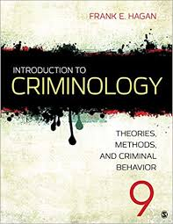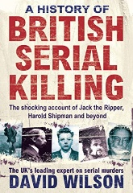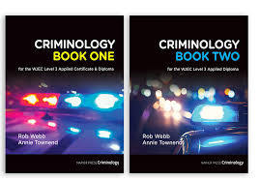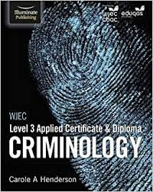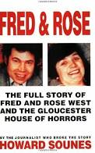  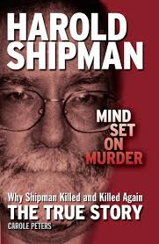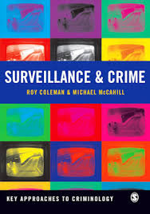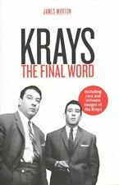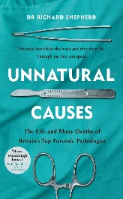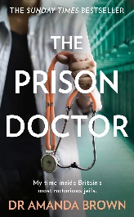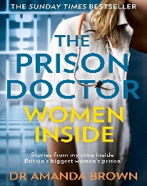

Magazines  TV | 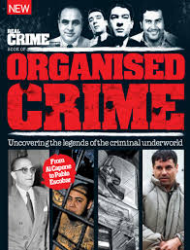

The ‘Real Crime’ magazine can be found in general shops. I usually purchase mine from WH Smith. There are various magazines on offer, some of which show you a theoretical knowledge behind famous cases such as Levi Bellfield.

FILMS | 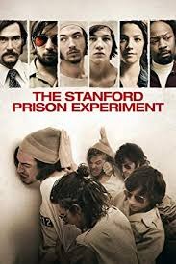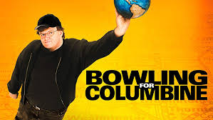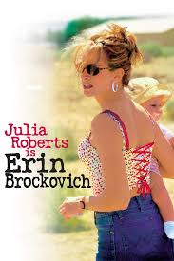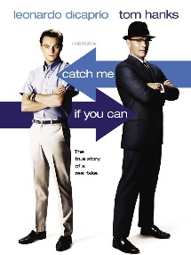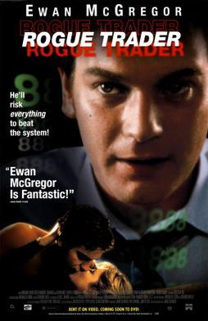

Most of these films listed are based on real life cases such as Bowling for Columbine, however this has more of a documentary feel to it. At times crime can become trivialised or glamourized for the big screen but these have more of a realism to them and make you think about the types of crime being committed. Some films (such as Rogue Trader and The Wolf of Wall Street) are ones we discuss in class for white collar crime.

Documentaries | Amanda Knox https://www.youtube.com/watch?v=erla7Ley4Tw  Any of the documentaries in the BBC series- Love and Hate crime https://www.bbc.co.uk/programmes/p05r3vw3/episodes/player  Mods & Rockers https://www.youtube.com/watch?v=rFL54R9g5Io  Jamie Bulger https://www.youtube.com/results?search_query=jamie+bulger+documentary  There’s a number on this case  Young gunman Panorama https://www.youtube.com/watch?v=h3O3bh59dRA  Hillsborough - https://www.youtube.com/watch?v=MU5b7kfwVkA  OJ Simpson - https://www.youtube.com/watch?v=ugdTdHiVfYI&t=3s  Barry George https://www.youtube.com/watch?v=cP__n6s4lZU | if you have Netflix, please watch https://www.netflix.com/gb/title/80083977  Damilola Taylor - https://www.youtube.com/watch?v=JA8669b7gKk&t=2s  Stephen Lawrence https://www.youtube.com/watch?v=ZsHwKPE0mjU&t=28s -  Timothy Evans (10 Rillington Place) https://www.youtube.com/watch?v=YSL_zNIxM-k  Sally Clark https://www.youtube.com/watch?v=7F03Wf3Ivzs  Babies behind bars https://www.youtube.com/watch?v=nErmW89_hr0

Twitter accounts
The following would be a good starting point for Twitter accounts to follow:

British Criminology @BritSocCrim
For academics and other professionals engaged in any aspect of work, teaching, research or public education about crime, criminal behaviour and the CJS in the UK.

Critical Criminology @CriticalCrimBSC
British Society of Criminology Critical Criminology Network.

Cardiff Criminology @CUCriminology
Official account of Cardiff University Criminology department. Crime, Security & Justice Research Group. News and updates from all Criminology staff.

Policing and Criminology Glyndwr University @CCJglyndwr
Policing, Criminology, Justice

Justice Committee @CommonsJustice
We are a cross-party group of MPs appointed by @HouseofCommons to scrutinise @MoJGovUK and associated bodies

HMI Prisons @HMIPrisonsnews
Independent inspectorate which reports on conditions for and treatment of those in prison, young offender institutions and immigration detention facilities.

INQUEST @INQUEST_ORG
INQUEST combines specialist support for bereaved people following a state related death, with the influence to achieve change in legislation, policy & practice.

Prof David Wilson @ProfDavidWilson
Emeritus Professor of Criminology Birmingham City University; Chair Friends of Grendon; VP New Bridge. Author & TV presenter.

Prison Reform Trust @PRTuk
The Prison Reform Trust is an independent UK charity working to create a just, humane and effective penal system.

The Howard League for Penal Reform @TheHowardLeague
Less crime, safer communities, fewer people in prison.

Where can criminology take me?

There are opportunities to undertake a number of degrees such as:

BSc Criminology
BA Criminology
BA Criminology and Criminal Justice
BSc (Hons) Criminology and Psychology
LLB (Hons) Law with Criminology
BA (Hons) Criminology and Sociology
BA (Hons) Criminology
BSc (Hons) Psychology and Sociology
BSc Criminology with Law

Alternatively, this subject can lead you to gain the required understanding and skills to be able to consider employment within some aspects of the Criminal Justice System, e.g. the National Probation Service, the Courts and Tribunals Service or the National Offender Management Service.

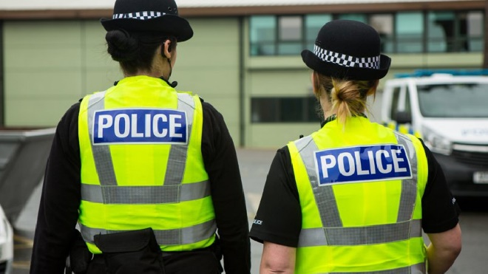

NB: If you wish to join the Police from 2020 you will need to undertake a Degree in Policing.

